POSITIVE PARTNERSHIPS · PROFESSIONAL LEARNING
Facilitator Guide
Education Support Staff
SESSION  1 | SESSION  2 | SESSION  3 | SESSION  4 | SESSION  5 | SESSION  6

One page for every slide. Each page shows the slide, what it is for, what to do and say, the activity and how long to spend.
Workshop day 8:30 - 4:00 · Timings are indicative · PHASE 5 DRAFT

How to use this guide
The guide follows the six slide decks exactly. Every visible slide has its own page, in deck order, so you can keep the guide open beside the presenter view and turn one page per slide.
Each session opens with a planning page: the intent, what participants will leave with, what to prepare, and a run sheet with clock times.
EVERY SLIDE PAGE HAS
Header strip | The session colour, the session name and the slide number in the deck.
Slide and facts | A picture of the slide, the suggested minutes, the running clock, the grouping, and the Participant Guide page if there is one.
Purpose | One line on why the slide is there.
What to do | Numbered steps, in order.
Key messages | What participants should take from the slide.
You might say | Wording you can use or adapt, where the team has written it.
Activity card | Format, grouping, time, the prompt, steps, how to bring the room back and how to close.
Keep in mind | Cautions and what to avoid.
Background and thread | Context for you, and how the slide links to other sessions.

SESSION COLOURS
Each session keeps the colour used in the Participant Guide, so the page a participant has open matches the colour on your page.

The day at a glance
Time | Session |  | Slides | Page
8:30 - 9:45 | 1 | The Lens | 17 slides | p. 5
9:45 - 10:45 | 2 | Understanding Autistic Experience  Sensory and Thinking | 23 slides | p. 23
10:45 - 11:00 |  | Morning tea
11:00 - 12:30 | 3 | Autistic Experience at School  Communication, Connection and Identity | 27 slides | p. 47
12:30 - 1:00 |  | Lunch
1:00 - 2:15 | 4 | Learning Design  Support that builds independence | 22 slides | p. 75
2:15 - 3:15 | 5 | Working in Partnership  Who should I involve in this journey? | 19 slides | p. 99
3:15 - 4:00 | 6 | Flourishing & Full Circle  One change, one purposeful conversation | 11 slides | p. 119

The thread through the day
Participants hold two or three real, different students in mind from Session 1 onwards. Several Participant Guide pages carry forward:
- Session 1: Think about your students and My starting point (returned to in Session 6).
- Session 3: the school-day map, the audit across settings and the Carry into design card (brought to Session 4).
- Session 4: One step up the ladder and the private My students check.
- Session 5: Bridge to the next family conversation (brought to Session 6).
- Session 6: Start · Continue · Reconsider and Plan the next conversation.

Ways of working
- Keep the students participants have in mind anonymous. Initials or roles only, in the room and on paper.
- Discuss systems, routines and environments, not identifiable students, families or colleagues.
- Every activity has an option to pass. Participants may move, write, listen or step out as they need.
- Look at the environment, task and routine before asking a student to change.
- Include strengths, interests and joy alongside barriers and support needs.
- Treat observations as questions to explore with the student and family, not conclusions about what a student feels.
- Participants write in their Participant Guide. Page numbers are on every slide page of this guide.

Before the day
☐ Local Traditional Custodians name confirmed and Acknowledgement of Country prepared in your own words.
☐ Student voice video tested with sound, captions on and transcript available.
☐ Participant Guides (Session summary p. 3; activities pp. 4 - 5), pens and plain paper.
☐ Venue details for housekeeping: exits, facilities, quiet space, breaks and feedback arrangements.
☐ Whiteboard or chart paper to capture recurring words and questions.
☐ Tables set for small-group discussion.
☐ Overwhelm and sensory joy video clips cued and tested with sound
☐ Autistic thinking video clip cued (once sourced)
☐ Participant Guide open at p. 6 - 9
☐ Pens, and Participant Guide p. 7 for the sensory activity
☐ Small groups set up for the sensory activity
☐ Participant Guide for every participant (pp. 10 - 16)
☐ Purple, blue and orange Post-it notes on each table
☐ Wall or board space for Post-it notes, grouped by colour
☐ Communication experiences video cued, with accurate edited captions and a transcript available
☐ Masking video cued, with captions
☐ Participant Guide p. 13 (day map), or large paper
☐ Pens or markers in at least two colours (costs and lightens)
☐ Participant Guide p. 15 (audit across settings)
☐ Closing image for slide 27 in place
☐ Carry into design card (PL Support Staff - Session 3 - Carry into design card): one per participant, if using the printed card as well as Participant Guide p. 16
☐ Signs for three corners of the room: In class, Between settings, Breaks and play.

SESSION  1 | 8:30 - 9:45 · 75 MINUTES · 17 SLIDES  The Lens

SESSION INTENT
Welcome participants, centre student voice and establish a neurodiversity-affirming, strengths-based approach. Participants bring two or three different students to mind and begin examining the assumptions that shape school experience, using an environment-first lens.
PARTICIPANTS LEAVE WITH
- Hold two or three different students in mind as a reference point for the day.
- Use consistent language for neurodiversity, neurodivergence and autism.
- Describe a neurodiversity-affirming, environment-first lens and the idea of dynamic disability.
- Identify assumptions in one familiar school routine and how curiosity could change the next response.

RUN SHEET
Clock | Segment | Slides | Minutes
8:30 - 8:36 | Opening and acknowledgements | 1-4 | 6
8:36 - 8:45 | Welcome, introductions and housekeeping | 5-6 | 9
8:45 - 9:05 | Students in mind and student voice | 7-9 | 20
9:05 - 9:18 | The lens: language, affirming stance, social model | 10-12 | 13
9:18 - 9:33 | Look again at school | 13-14 | 15
9:33 - 9:40 | DSE and dynamic disability | 15-16 | 7
9:40 - 9:45 | Today's workshop and transition | 17 | 5

PREPARE
☐ Local Traditional Custodians name confirmed and Acknowledgement of Country prepared in your own words.
☐ Student voice video tested with sound, captions on and transcript available.
☐ Participant Guides (Session summary p. 3; activities pp. 4 - 5), pens and plain paper.
☐ Venue details for housekeeping: exits, facilities, quiet space, breaks and feedback arrangements.
☐ Whiteboard or chart paper to capture recurring words and questions.
☐ Tables set for small-group discussion.

SESSION 1 | The Lens | SLIDE 1 of 17

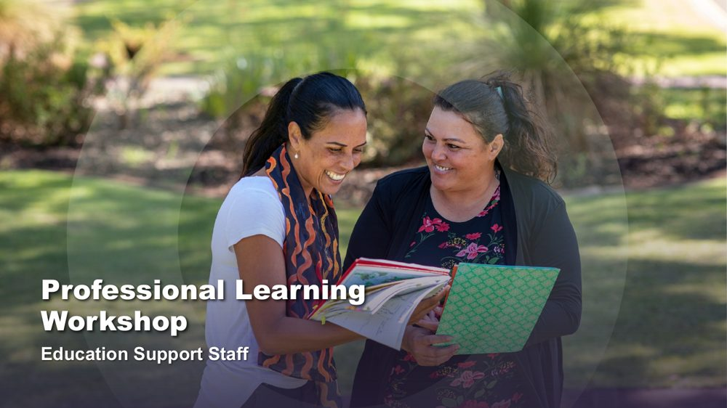 | Professional Learning Workshop - Education Support Staff  SUGGESTED TIME  2 min  CLOCK  8:30 - 8:32

Introduce the shared starting point for the day: how educators understand students and school.
WHAT TO DO  - Have the title slide on screen as participants arrive and settle.  - Welcome participants and introduce the delivery team.  - Name this as professional learning about understanding Autistic experience and improving access, belonging and partnership.  - Frame the day around curiosity and support, not fixing students or making them appear less Autistic.  - Keep this opening brief so the student reflection and student voice retain enough time. | KEY MESSAGES  - The day begins with the lens educators bring to students and school.  - Curiosity will connect the six sessions.

SESSION 1 | The Lens | SLIDE 2 of 17

 | Acknowledgement of Country  SUGGESTED TIME  2 min  CLOCK  8:32 - 8:34

Acknowledge the Traditional Custodians of the land on which the workshop is taking place.
WHAT TO DO
- Deliver the Acknowledgement of Country in your own words, following organisational protocol.
- Name the Traditional Custodians of the land where the workshop is being held, where this has been confirmed.
- Allow a brief pause before moving on.

KEEP IN MIND
- Do not read a generic script you have not prepared; take time before the day to learn the local Country and custodians.
- Keep the Acknowledgement respectful and unhurried, even if the session is running late.

SESSION 1 | The Lens | SLIDE 3 of 17

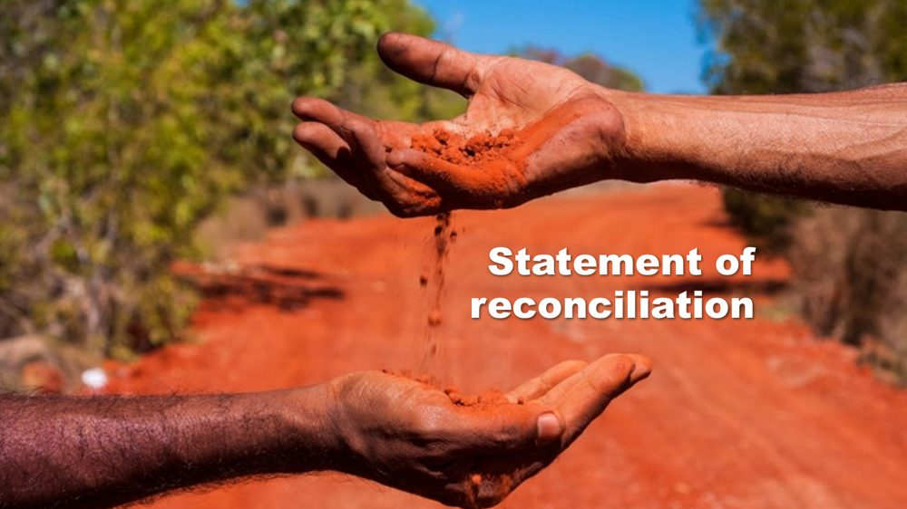 | Statement of reconciliation  SUGGESTED TIME  1 min  CLOCK  8:34 - 8:35

Share the organisation's commitment to reconciliation.
WHAT TO DO
- Share the organisation's statement of reconciliation as provided, following organisational protocol.
- Move on without adding commentary or discussion.

SESSION 1 | The Lens | SLIDE 4 of 17

 | First Nations advisory  SUGGESTED TIME  1 min  CLOCK  8:35 - 8:36

Advise First Nations participants that the workshop may contain images and voices of people who are no longer with us.
WHAT TO DO
- Read the advisory aloud or leave it on screen long enough for everyone to read it.
- Move on without further comment.

SESSION 1 | The Lens | SLIDE 5 of 17

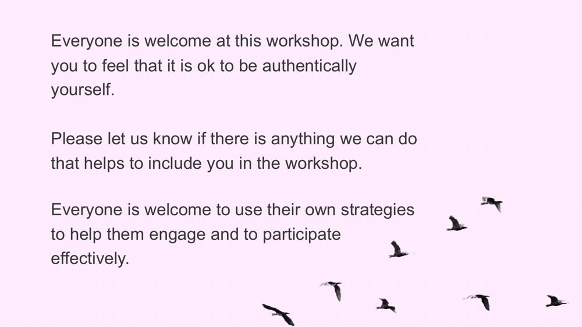 | Everyone is welcome  SUGGESTED TIME  6 min  CLOCK  8:36 - 8:42  GROUPING  Whole room

Welcome participants, establish an accessible way of working together and invite brief introductions.
WHAT TO DO  - Read or paraphrase the welcome: everyone is welcome to be authentically themselves and to use their own strategies to engage.  - Tell participants they may move, regulate, write, speak, listen or pass as needed.  - Invite participants to let the team know, at any time, if there is anything that would help include them.  - Invite brief introductions using first name, professional role and one hope for the day.  - Do not ask participants to identify a student, school or diagnosis. | KEY MESSAGES  - Different ways of participating are welcome.  - Participants bring useful knowledge and questions from their own settings.

ACTIVITY | Brief introductions with an option to pass whole room · 4 minutes
Your first name, your role and one thing you hope to understand better today.
- Model a concise introduction.
- Keep the round moving so no participant is pressured to give personal detail.
- Group the hopes into broad themes without naming individual students or schools.
Close: Let participants know where their themes sit across the six sessions.

KEEP IN MIND
- In a large room, use table introductions rather than a full-room round so the timing holds.

SESSION 1 | The Lens | SLIDE 6 of 17

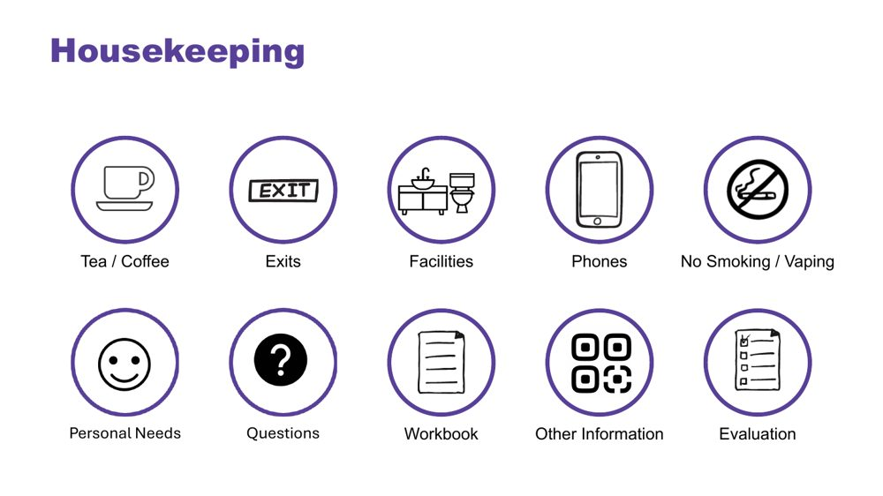 | Housekeeping  SUGGESTED TIME  3 min  CLOCK  8:42 - 8:45

Cover facilities, personal needs, questions and local arrangements.
WHAT TO DO
- Cover exits, facilities, breaks, phones, questions, participant materials, local arrangements and feedback plans.
- Point out any quiet or low-sensory space available at the venue.
- Explain how and when questions can be asked, including in writing.
- Cover venue-specific information here.

SESSION 1 | The Lens | SLIDE 7 of 17

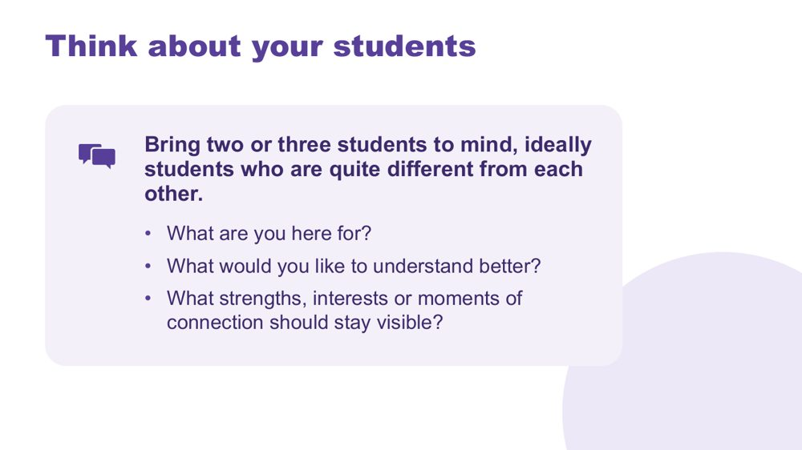 | Think about your students  SUGGESTED TIME  7 min  CLOCK  8:45 - 8:52  GROUPING  On your own  PARTICIPANT GUIDE  Page 4 - Think about your students

Give every participant a student-centred point of reference for the day.
WHAT TO DO  - Invite participants to bring two or three students to mind, ideally students who are quite different from each other.  - Suggest they might differ in age, communication or what school feels like for them.  - Ask participants to note initials or roles only, with no names or identifying details.  - Use the questions on screen to support private reflection.  - Give quiet thinking time before inviting any optional sharing.  - If participants share, redirect descriptions away from labels and towards what they want to understand.  - Ask participants to return to the same students during later mapping and design activities. | KEY MESSAGES  - See each student as a whole person, with strengths and interests as well as needs.  - Holding several different students builds a broad, mixed picture of Autistic experience.  - Questions can remain open while participants gather a fuller picture.

ACTIVITY | Private reflection on your own · 5 minutes
What are you here for? What would you like to understand better? What strengths, interests or moments of connection should stay visible?
- Ask participants to write without using students' names or school.
- Invite them to include strengths, interests or moments of connection as well as questions.
- Keep sharing optional.
Close: Ask participants to keep the reflection available for the rest of the day.

Thread The students brought to mind here return in the school-day mapping (Session 3), classroom design (Session 4) and final reflection (Session 6).

SESSION 1 | The Lens | SLIDE 8 of 17

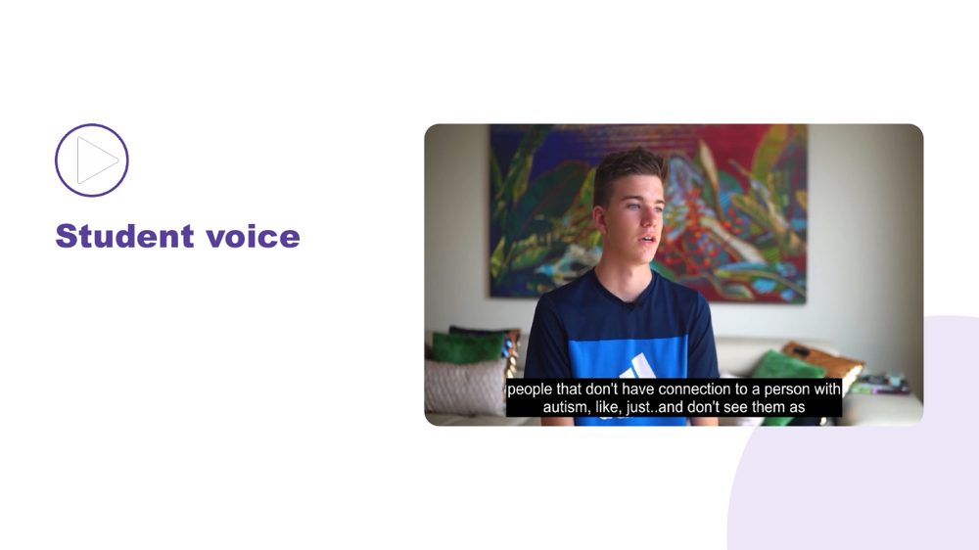 | Student voice  SUGGESTED TIME  6 min  CLOCK  8:52 - 8:58

Make space for Autistic young people to be heard in their own words.
WHAT TO DO  - Introduce the video as an opportunity to listen rather than diagnose, compare or extract a single lesson.  - Ensure captions are on and a transcript is available.  - Play the video without interrupting. | KEY MESSAGES  - Student voice is part of the workshop evidence.  - Each speaker's account is their own.

SESSION 1 | The Lens | SLIDE 9 of 17

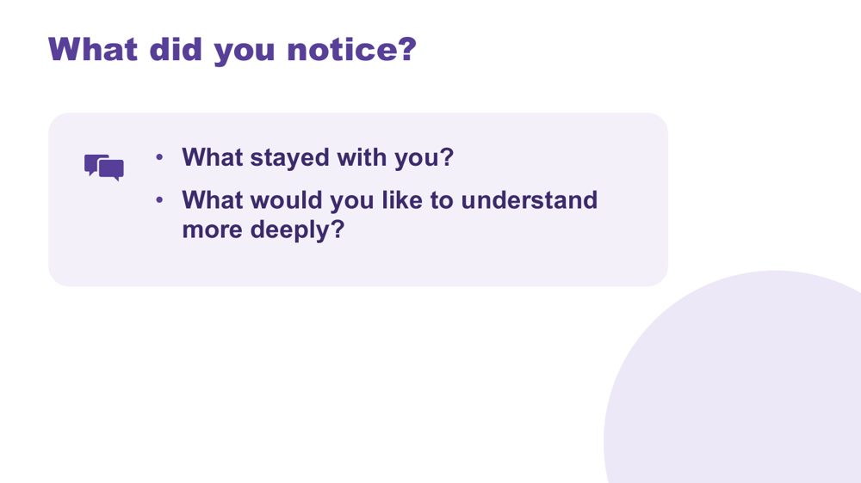 | What did you notice?  SUGGESTED TIME  7 min  CLOCK  8:58 - 9:05  GROUPING  On your own  PARTICIPANT GUIDE  Page 4 - What did you notice?

Support reflection on the student voice material.
WHAT TO DO
- Invite brief private reflection on the questions before discussion.
- Invite observations grounded in what speakers said rather than interpretations of appearance or behaviour.
- Avoid asking participants to compare a speaker with a student they teach.
- Record a few recurring words or questions without forcing consensus.
- Record questions that need follow-up through the appropriate program or local channel.

ACTIVITY | Think, write and optional share on your own · 6 minutes
What did you notice? What stayed with you? What would you like to understand more deeply?
- Give a minute or two of quiet writing time.
- Invite a few optional contributions from the room.
- Capture recurring words or questions where everyone can see them.
Close: Link participants' questions to the sensory, thinking, communication and school-day content that follows.

SESSION 1 | The Lens | SLIDE 10 of 17

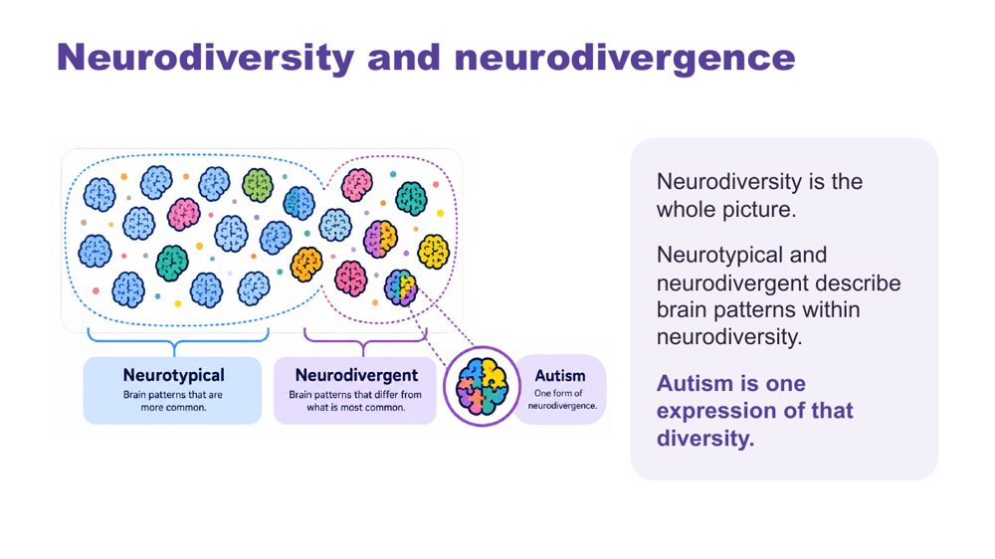 | Neurodiversity and neurodivergence  SUGGESTED TIME  4 min  CLOCK  9:05 - 9:09

Introduce the language for neurodiversity and neurodivergence.
WHAT TO DO  - Explain neurodiversity and neurodivergence using the workshop definitions on the slide.  - Keep the explanation brief and connected to the student-centred curiosity established earlier.  - Respect the language individuals use for themselves. | KEY MESSAGES  - Neurodiversity includes everyone.  - Neurotypical and neurodivergent describe brain patterns within neurodiversity; autism is one expression of that diversity.  - Use one consistent language frame across the workshop.  - Terminology should support dignity and curiosity rather than categorising students by worth.

SESSION 1 | The Lens | SLIDE 11 of 17

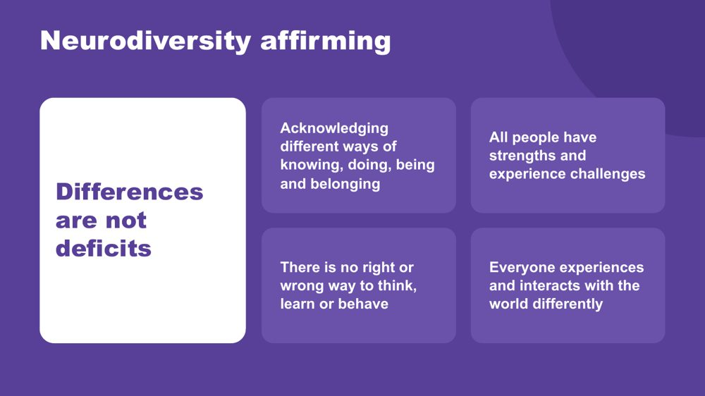 | Neurodiversity affirming  SUGGESTED TIME  5 min  CLOCK  9:09 - 9:14

Establish the practical, strengths-based stance participants will use throughout the day.
WHAT TO DO  - Walk through the principles on the slide.  - Connect the principles to the students participants brought to mind earlier.  - Ask what becomes visible when strengths, interests, joy and ways of connecting are included.  - Clarify that a strengths-based approach does not erase difficulty, access needs or fluctuating capacity.  - Model language that describes the environment and support needed without blaming the student. | KEY MESSAGES  - Begin with the person.  - Include strengths and joy alongside barriers and support needs.  - Stay curious about access and support.

SESSION 1 | The Lens | SLIDE 12 of 17

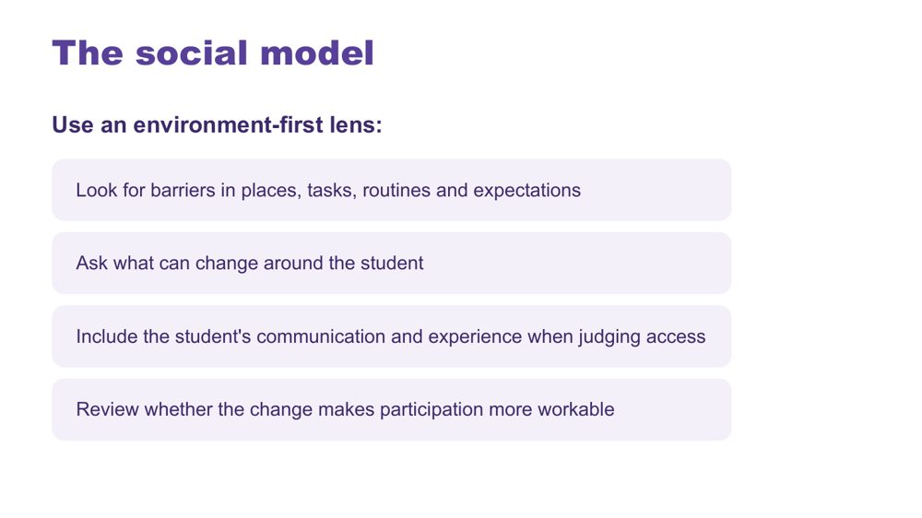 | The social model  SUGGESTED TIME  4 min  CLOCK  9:14 - 9:18

Connect the workshop lens with an environment-first view of barriers.
WHAT TO DO  - Explain the social model through barriers in places, tasks, routines and expectations.  - Walk through the environment-first steps on the slide.  - Direct discussion towards what can change around the student.  - Emphasise including the student's communication and experience when judging access. | KEY MESSAGES  - Look for barriers before asking the student to change.  - Environment and support are part of the experience being examined.

KEEP IN MIND
- Avoid implying that all difficulty disappears when an environment changes.

SESSION 1 | The Lens | SLIDE 13 of 17

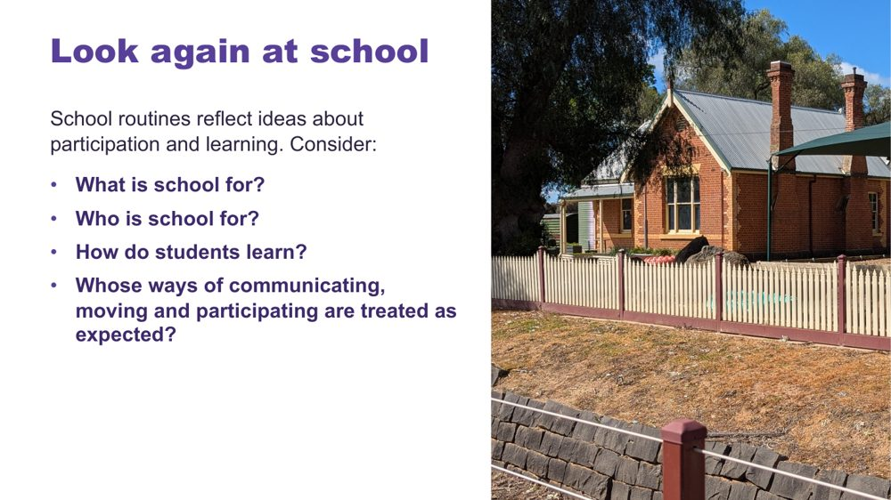 | Look again at school  SUGGESTED TIME  5 min  CLOCK  9:18 - 9:23  PARTICIPANT GUIDE  Page 5 - Look again at school

Help participants notice assumptions about the purpose, audience and methods of school.
WHAT TO DO  - Use the school questions to open reflective thinking; there is no single correct answer.  - Give a short moment of private thinking on the four questions.  - Invite participants to notice assumptions built into everyday routines, expectations and decisions. | KEY MESSAGES  - Assumptions shape what schools notice, reward and change.

KEEP IN MIND
- Keep the tone reflective rather than blaming individual educators.

SESSION 1 | The Lens | SLIDE 14 of 17

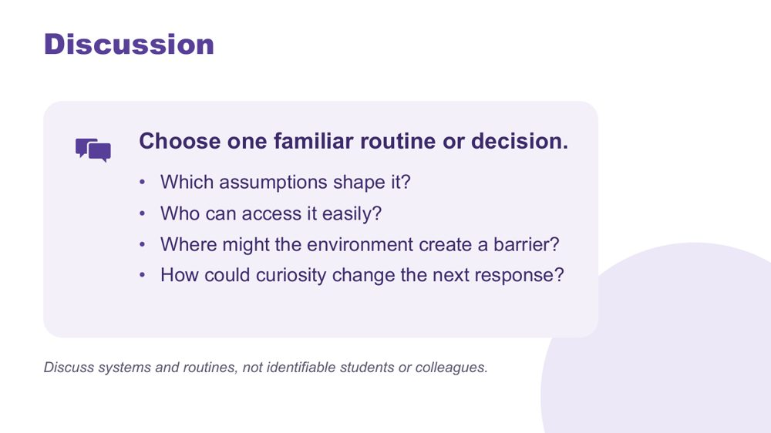 | Discussion  SUGGESTED TIME  10 min  CLOCK  9:23 - 9:33  GROUPING  Small groups  PARTICIPANT GUIDE  Page 5 - Look again at school (discussion)

Apply the questions to one familiar routine or decision and consider how curiosity could change the next response.
WHAT TO DO  - Move participants into small groups.  - Give each group one of the school questions to begin with, then the discussion prompts on screen.  - Ask groups to choose one familiar routine or decision to examine.  - Remind groups to discuss systems and routines, not identifiable students or colleagues.  - When examples become student-focused, ask what the environment, task or expectation contributed.  - Invite one concise observation from each group. | KEY MESSAGES  - Being curious gives us time to change the environment or task before placing more demands on a student.

ACTIVITY | Small-group discussion small groups · 10 minutes
Choose one familiar routine or decision. Which assumptions shape it? Who can access it easily? Where might the environment create a barrier? How could curiosity change the next response?
- Give each group one question to begin with.
- Ask groups to discuss systems and routines rather than naming individual students or colleagues.
- Invite one concise observation from each group.
Bring the room back
- Invite one example where curiosity could change the next response.
Close: Point out that the discussion has moved from assumptions about students to questions about access, environment and learning design.

KEEP IN MIND
- Keep the tone reflective rather than blaming individual educators.

SESSION 1 | The Lens | SLIDE 15 of 17

 | Disability Standards for Education (DSE) 2005  SUGGESTED TIME  3 min  CLOCK  9:33 - 9:36

Point participants to the Disability Standards for Education 2005 and the Department of Education resources that support them.
WHAT TO DO
- Introduce the Disability Standards for Education 2005 briefly as part of the context for access and adjustments.
- Point participants to the three Department of Education resources listed below.
- Note that the workbook is written for parents and carers, so educators know what families may be reading.
- Refer detailed or school-specific questions to the appropriate program or local channel.

KEEP IN MIND
- Do not give legal advice or add legal claims beyond the published resources.

RESOURCES
- Getting started - Department of Education, Australian Government - https://www.education.gov.au/disability-standards-education-2005/resources/getting-started
- Advocating with and for your child: A workbook for parents and carers - Department of Education, Australian Government - https://www.education.gov.au/disability-standards-education-2005/resources/advocating-and-your-child-workbook-parents-and-carers
- Milestones and transitions - Department of Education, Australian Government - https://www.education.gov.au/disability-standards-education-2005/resources/milestones-and-transitions

SESSION 1 | The Lens | SLIDE 16 of 17

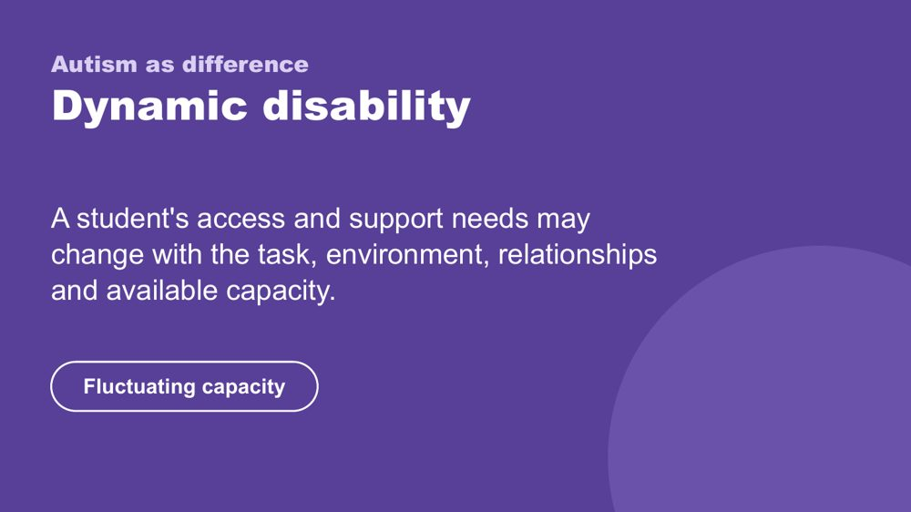 | Autism as difference - dynamic disability  SUGGESTED TIME  4 min  CLOCK  9:36 - 9:40

Introduce the framing of autism as difference and dynamic disability.
WHAT TO DO  - Explain how access and support needs can vary with the task, environment, relationships and available capacity.  - Name fluctuating capacity: what a student can do one day or in one setting may not be available in another.  - Connect the concept back to the need for curiosity across settings and days. | KEY MESSAGES  - Support should respond to the student and context rather than a fixed assumption.  - Strengths and substantial support needs can both belong in the picture.

KEEP IN MIND
- Avoid presenting one pattern of ability, need or capacity as universal.
- Do not add clinical, diagnostic or legal claims.

SESSION 1 | The Lens | SLIDE 17 of 17

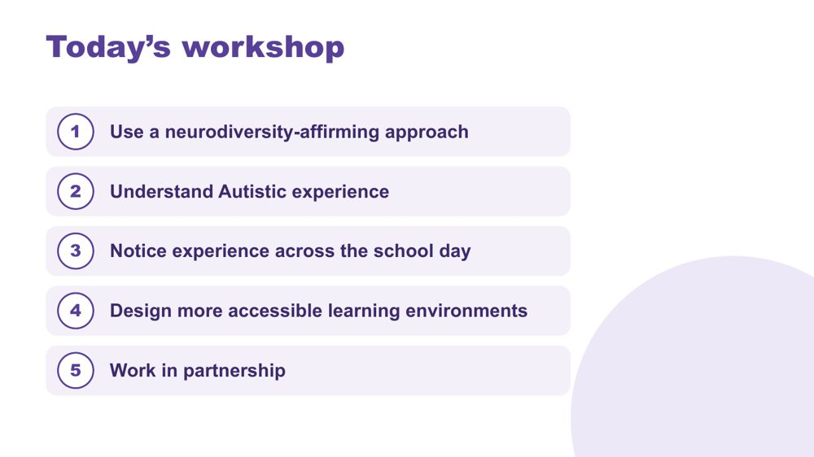 | Today's workshop  SUGGESTED TIME  5 min  CLOCK  9:40 - 9:45  PARTICIPANT GUIDE  Page 5 - My starting point

Orient participants to the learning progression across the full day.
WHAT TO DO  - Walk through the five aims on the slide without turning it into a detailed agenda.  - Explain that Sessions 1 and 2 build a shared understanding and that the school-day application becomes explicit from Session 3, with examples from primary and secondary settings.  - Point out morning tea at 10:45 - 11:00 and lunch at 12:30 - 1:00.  - Remind participants that timings are indicative.  - Invite participants to complete My starting point in the Participant Guide; it returns in Session 6.  - Preview that Session 2 explores sensory processing, Autistic thinking and internal signals. | KEY MESSAGES  - The day moves from lens and understanding to school-day experience, classroom design and partnership.  - Belonging, capacity and joy remain visible across the whole sequence.

Thread My starting point is revisited in Session 6 (Flourishing & Full Circle).

SESSION  2 | 9:45 - 10:45 · 60 MINUTES · 23 SLIDES  Understanding Autistic Experience  Sensory and Thinking

SESSION INTENT
Build a picture of the students participants have in mind through three lenses: sensory processing, Autistic thinking and internal signals. The session is strengths-based, includes first-person Autistic voices, and keeps attention on environments, task demands and support rather than treating any single pattern as universal.
PARTICIPANTS LEAVE WITH
- describe the eight senses and four sensory response patterns, including sensory joy and stimming
- look at the sensory and task demands of a classroom routine before the student's response
- name detail-first processing, deep focus (monotropism) and executive functioning as lenses for inquiry, and connect them to the students they have in mind
- consider early signs of overwhelm and who else needs to know them

RUN SHEET
Clock | Segment | Slides | Minutes
9:45 - 9:47 | Opening frame | 1 | 2
9:47 - 10:05 | Sensory processing, voices and profiles | 2-9 | 18
10:05 - 10:13 | Sensory activity | 10 | 8
10:13 - 10:26 | Autistic thinking | 11-17 | 13
10:26 - 10:35 | Thinking discussion | 18 | 9
10:35 - 10:44 | Internal signals and reading the signs | 19-22 | 9
10:44 - 10:45 | Close and tea | 23 | 1

PREPARE
☐ Overwhelm and sensory joy video clips cued and tested with sound
☐ Autistic thinking video clip cued (once sourced)
☐ Participant Guide open at p. 6 - 9
☐ Pens, and Participant Guide p. 7 for the sensory activity
☐ Small groups set up for the sensory activity

SESSION 2 | Understanding Autistic Experience | SLIDE 1 of 23

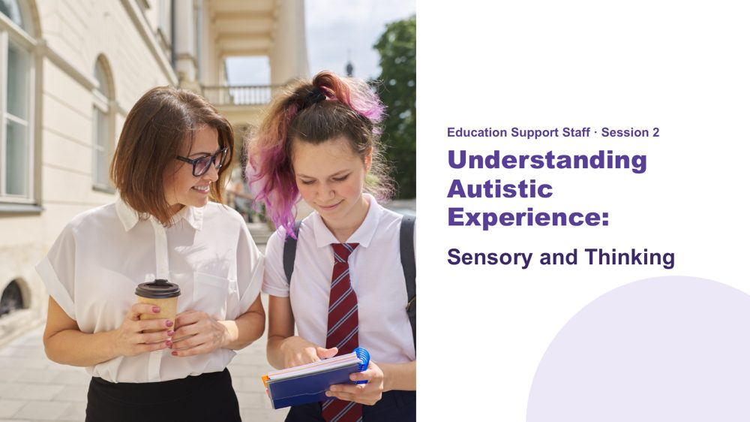 | Understanding Autistic Experience: Sensory and Thinking  SUGGESTED TIME  2 min  CLOCK  9:45 - 9:47  PARTICIPANT GUIDE  Page 6 - Session 2 summary

Orient the room to Session 2 and reconnect participants with the students they brought to mind in Session 1.
WHAT TO DO  - Orient the room before starting.  - Name the opening activity from Session 1: bringing two or three students to mind.  - Ask participants to keep those students in mind for the whole session.  - Name the three parts of the session: sensory processing, Autistic thinking and internal signals.  - Explain that the session offers areas to be curious about. It is not a checklist for deciding what a student experiences. | KEY MESSAGES  - This session is strengths-based.  - The three lenses are not deficit labels - they are tools for understanding.  - The goal is recognition and shared understanding of the Autistic experience.  - Common areas for inquiry do not replace knowing the individual student.  - Ask what the environment and task demand as well as what the student may need.

YOU MIGHT SAY
In this session we are going to build a picture of the students you have in mind. Not a list of what is hard, and not a catalogue of traits. A picture.
Each idea we look at is a piece. As we move through Session 2 and Session 3, the picture will be clearer.
Keep those students in mind as we go. This session is about them.

KEEP IN MIND
- Keep examples grounded in access and support.

Thread This is the opening frame. The "coming into focus" image logic starts here - fragments that build into a whole. Return to this at the close of Session 3.

SESSION 2 | Understanding Autistic Experience | SLIDE 2 of 23

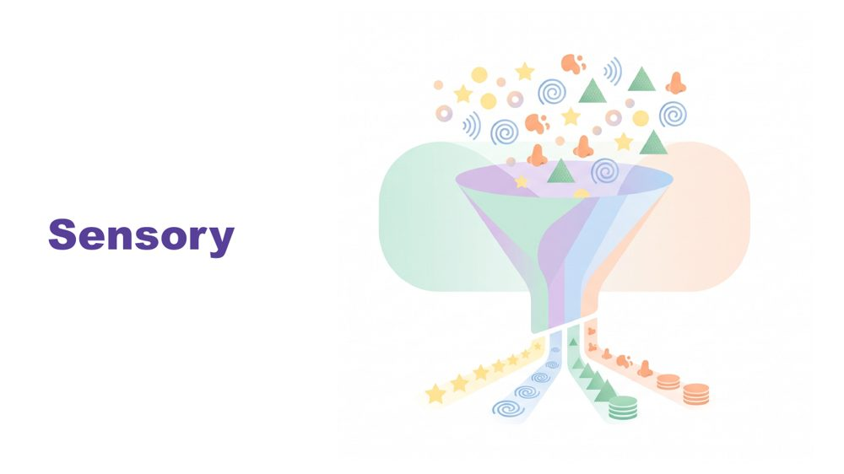 | Sensory  SUGGESTED TIME  1 min  CLOCK  9:47 - 9:48

Set sensory experience as the foundation for everything that follows.
WHAT TO DO  - Introduce sensory as the starting point, before thinking, communication or connection.  - Pause briefly.  - Move to the senses. | KEY MESSAGES  - Sensory inquiry should include joy and authentic expression as well as discomfort or overload.  - Observation is a starting point for curiosity, not proof of what a student feels.  - Context matters.

YOU MIGHT SAY
Before we talk about thinking, or communication, or connection - we start here. With the senses.
Because before a student has thought a single thought, the world has already arrived. And how it arrives matters.

KEEP IN MIND
- Avoid a long content lecture before the sensory activity.

Thread Sensory is the foundation. Later in the day, name explicitly that thinking, communication and connection all flow from this starting point.

SESSION 2 | Understanding Autistic Experience | SLIDE 3 of 23

 | What is sensory processing?  SUGGESTED TIME  1 min  CLOCK  9:48 - 9:49

Establish a shared definition of sensory processing.
WHAT TO DO
- Ask the room: What is sensory processing?
- Take one or two quick answers.
- Give the definition.

YOU MIGHT SAY
Sensory processing is the way the brain receives, processes and responds to information from the senses.

SESSION 2 | Understanding Autistic Experience | SLIDE 4 of 23

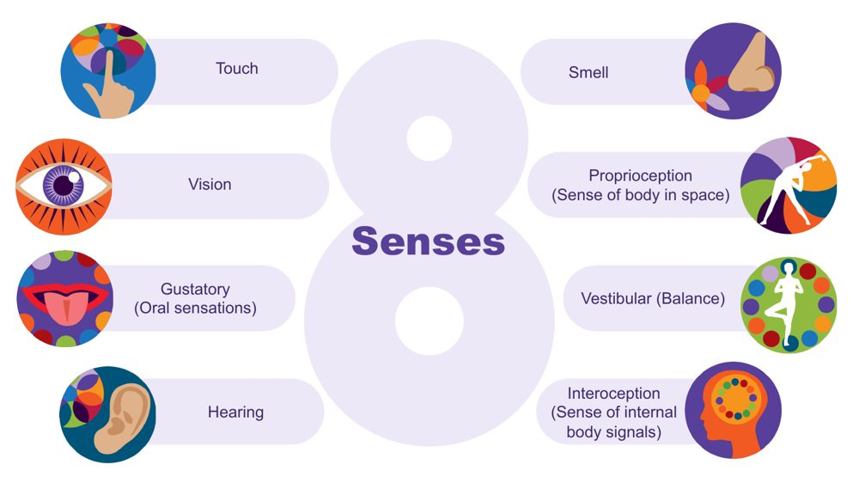 | The eight senses  SUGGESTED TIME  3 min  CLOCK  9:49 - 9:52

Extend the familiar five senses to eight and introduce interoception to return to later.
WHAT TO DO  - Start from the five senses many of us were taught: touch, vision, taste, hearing and smell.  - Ask the room to name the three less well known senses. Give time to respond.  - Name them: proprioception, vestibular and interoception.  - Describe proprioception and vestibular with a school example for each.  - Name interoception and park it: say you will come back to it.  - Connect the senses to everyday school environments. | KEY MESSAGES  - There are 8 senses, not 5.  - The hidden three are often where Autistic differences are most significant.  - Interoception is flagged here and developed in depth later - plant that seed.

YOU MIGHT SAY
Proprioception is the sense of where the body is in space. Students who crash into things, seek heavy pressure, or need to feel their body may be seeking proprioceptive input.
Vestibular is balance and movement. A student who needs to rock, spin, or keep moving in class may be regulating through this sense.
Interoception is the body's inside sense - and it is one of the most important for understanding a student's experience at school. Park it for now.
We will come back to interoception, it connects to a lot of what follows.

Background Touch (tactile) gives information about texture, pain, pressure and temperature. Vision gives depth, colour, size, shape and position. The gustatory sense includes taste and other oral sensations such as texture, temperature and how much pressure is needed when chewing. Hearing (auditory) tells us how far away, how loud and how familiar a sound is, and its pitch. Smell (olfactory) can link strongly to emotional memory. Proprioception comes through joints, muscles, ligaments and deep in the skin; differences may mean bumping into things. The vestibular sense sits in the middle ear, tracks speed and direction of head movement and supports balance; a student may love spinning, or may feel off balance on stairs. There is lots of crossover between the senses: in any situation we use all or most of them.
Thread Interoception returns as a full section in the internal signals slides at the end of this session.
RESOURCES
- Interoception webinar recording and resources on the Positive Partnerships website

SESSION 2 | Understanding Autistic Experience | SLIDE 5 of 23

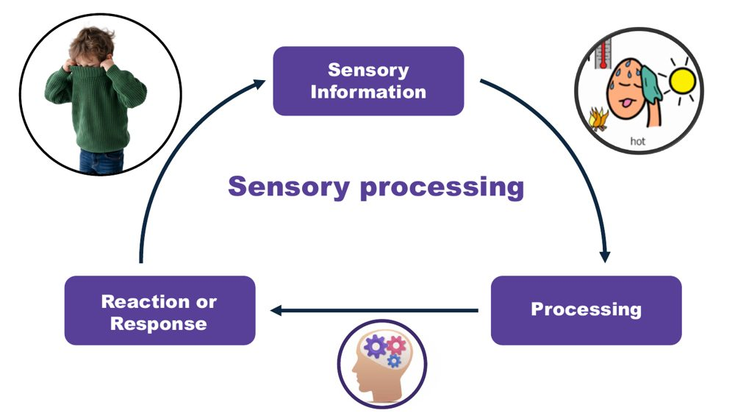 | Sensory processing: information, processing, response  SUGGESTED TIME  2 min  CLOCK  9:52 - 9:54

Show the three steps of sensory processing and that the response is not a choice.
WHAT TO DO  - Walk through the three steps using the jumper example.  - List what sensory processing helps us do.  - Finish on the point that the response is not a choice. | KEY MESSAGES  - The way the brain processes and responds to sensory information is not a choice.

YOU MIGHT SAY
Think about what is involved in someone taking their jumper off when they get too hot. First, sensory information is received to tell them they are getting too hot. This is processed and related to previous experiences. A response is generated - taking the jumper off.
Sensory processing helps us stay safe, keep track of what our body is doing, understand our environment, learn, and filter out information so we can pay attention and engage.
The way our brain processes sensory information and responds is not a choice.

SESSION 2 | Understanding Autistic Experience | SLIDE 6 of 23

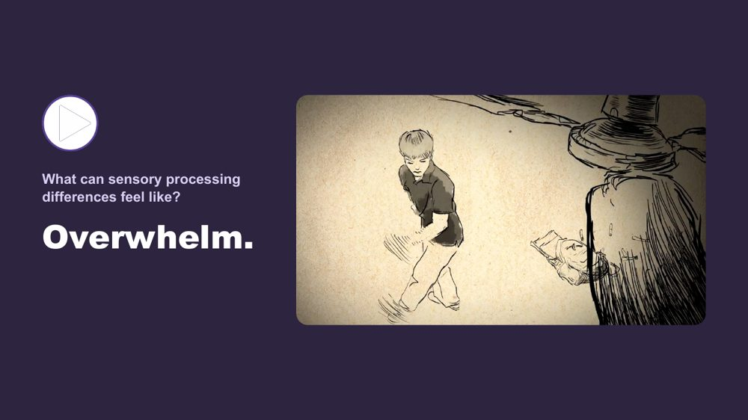 | What can sensory processing differences feel like? Overwhelm  SUGGESTED TIME  3 min  CLOCK  9:54 - 9:57

Help participants understand what sensory overload can feel like, through a first-person account.
WHAT TO DO
- Introduce the two short clips before playing the first.
- Name the pattern: at a few points today we stop and hear from Autistic people directly.
- Play the overwhelm clip.
- After the clip, give a moment. Do not speak immediately.

YOU MIGHT SAY
We are going to watch two short clips. One shows what sensory overload can feel like from the inside. One shows sensory joy - what it is like when the senses are working with you rather than against you. Both are real. Both belong in the room.
We do this in a few places today - we stop and hear from Autistic people directly. That is not an add-on. It is the evidence.
Some of you will have seen something you recognised. Some of you may not have. Both responses are fine.

Thread This video does the same job as the thinking video and the communication video later in the day - it shifts the room from intellectual understanding to felt recognition.

SESSION 2 | Understanding Autistic Experience | SLIDE 7 of 23

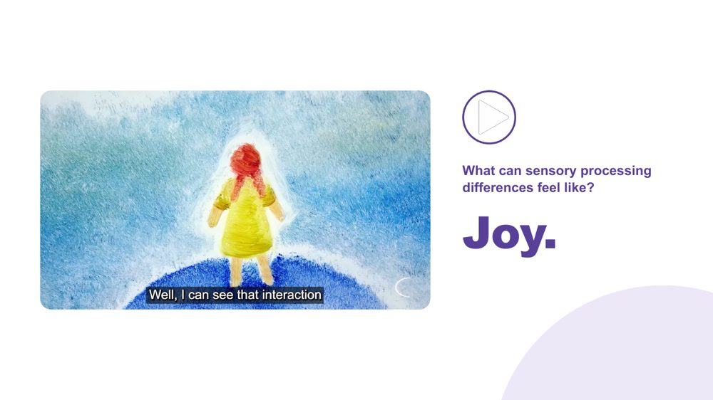 | What can sensory processing differences feel like? Joy  SUGGESTED TIME  3 min  CLOCK  9:57 - 10:00

Balance the overwhelm clip with sensory joy so sensory experience is not framed only through distress.
WHAT TO DO  - Play the joy clip.  - Name that sensory experience is a source of richness as well as difficulty. | KEY MESSAGES  - Sensory experience includes both difficulty and joy.  - First-person accounts are more powerful than any explanation.  - Recognition - not information - is the goal here.

YOU MIGHT SAY
Sensory experience is not only a source of difficulty. For many Autistic people, it is also a source of richness, depth, and genuine pleasure.
The same nervous system that can be overwhelmed by sound can be transported by music. Both are true.

SESSION 2 | Understanding Autistic Experience | SLIDE 8 of 23

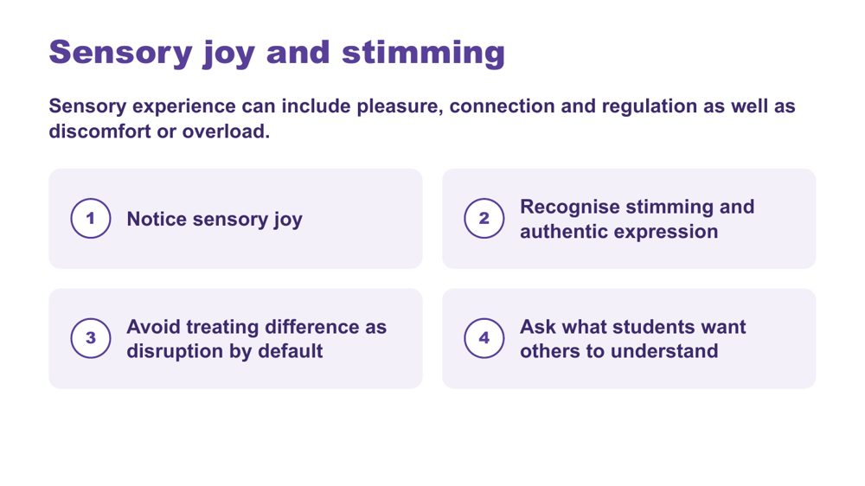 | Sensory joy and stimming  SUGGESTED TIME  2 min  CLOCK  10:00 - 10:02

Recognise sensory joy, stimming and authentic expression as part of sensory experience.
WHAT TO DO  - Read the framing line: sensory experience can include pleasure, connection and regulation as well as discomfort or overload.  - Walk through the four points on the slide.  - Ask participants where they see sensory joy in the students they have in mind. | KEY MESSAGES  - Sensory inquiry should include joy and authentic expression as well as discomfort or overload.  - Stimming can be pleasure, connection, regulation and authentic expression.  - Ask what students want others to understand.

KEEP IN MIND
- Do not discourage harmless stimming.
- Do not frame typical-looking behaviour as the goal.
- Avoid treating difference as disruption by default.

SESSION 2 | Understanding Autistic Experience | SLIDE 9 of 23

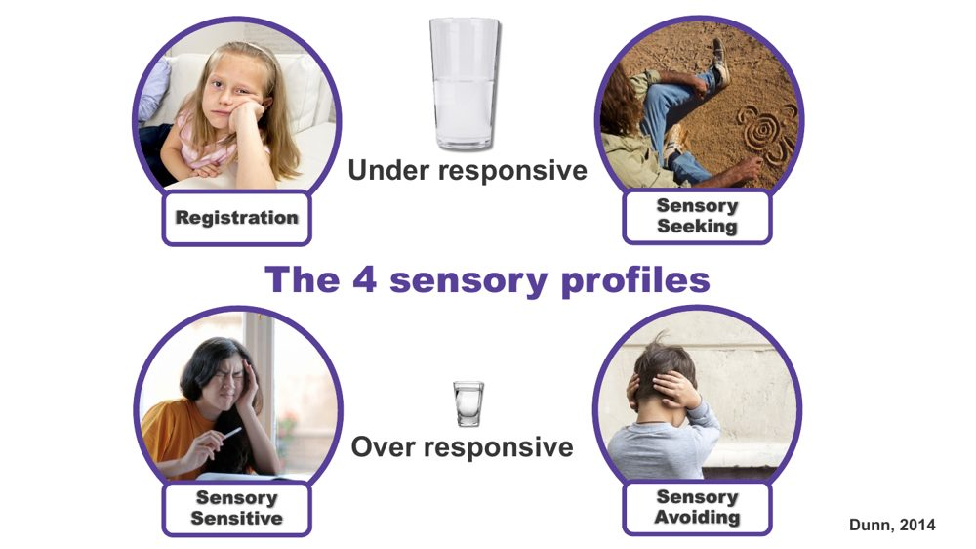 | The 4 sensory profiles  SUGGESTED TIME  3 min  CLOCK  10:02 - 10:05

Introduce four patterns of sensory response as a way to understand a student, not as labels.
WHAT TO DO  - Explain that these are patterns of sensory response, not types of autism.  - Talk through each pattern briefly.  - Name that a student can be seeking in some senses and avoiding in others.  - Mention where educators may meet this framework: occupational therapy reports or a Sensory Profile questionnaire such as the School Companion form. | KEY MESSAGES  - Four patterns: registration, seeking, sensitive, avoiding.  - Students can show different patterns across different senses.  - Patterns can shift with load and context.  - All patterns are the nervous system doing what it needs.  - A sensory profile is not a choice.

YOU MIGHT SAY
Registration (under-responsive): doesn't notice what others notice. May seem to miss cues others respond to.
Sensory seeking: actively looks for more input. Movement, touch, sound. The body asking for what it needs.
Sensory sensitive (over-responsive, passive): notices everything. Distracted, finds busy environments very hard, but does not necessarily act on it.
Sensory avoiding (over-responsive, active): actively works to reduce input. Covers ears, avoids crowds, avoids certain textures.
This is a map, not a label.

KEEP IN MIND
- Treat observations of seeking or avoiding as a starting point for curiosity, not certainty about internal experience.

Background These four profiles are part of a sensory processing framework developed by Professor Winnie Dunn, an occupational therapist at the University of Missouri. The profiles are also called seeker, bystander (registration), avoider and sensor. Everyone has a different comfort level (a different sized cup) for sensory information, and a person may have a different sized cup for different senses, so they can show several profiles. A student may show more than one pattern, and it may shift with the day, the environment or the load they are already carrying. Understanding how sensory differences affect individuals in all environments is critical to supporting success.

SESSION 2 | Understanding Autistic Experience | SLIDE 10 of 23

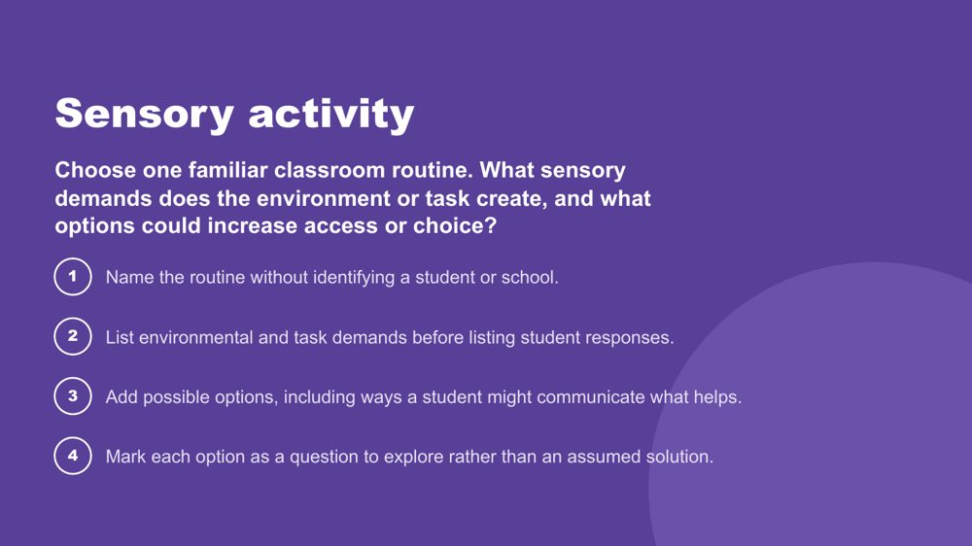 | Sensory activity  SUGGESTED TIME  8 min  CLOCK  10:05 - 10:13  GROUPING  Small groups  PARTICIPANT GUIDE  Page 7 - Sensory activity

Apply an environment-first sensory lens to a familiar classroom routine, without simulating Autistic experience.
WHAT TO DO  - Set up small groups.  - Read the prompt on the slide.  - Run the four steps.  - Ask participants to identify options and choice rather than one support for every student.  - Bring the room back and ask what educators can change, offer or investigate. | KEY MESSAGES  - Look at environmental and task demands before student responses.  - Options are questions to explore, not assumed solutions.

ACTIVITY | Environment-first sensory review small groups · 8 minutes
Choose one familiar classroom routine. What sensory demands does the environment or task create, and what options could increase access or choice?
- Name the routine without identifying a student or school.
- List environmental and task demands before listing student responses.
- Add possible options, including ways a student might communicate what helps.
- Mark each option as a question to explore rather than an assumed solution.
Bring the room back
- What could educators change, offer or investigate before increasing demands on the student?
Close: Ask what educators can change, offer or investigate before increasing demands on the student.

KEEP IN MIND
- Do not run an autism simulation.
- Keep students and schools unidentifiable.
- Treat lighting, sound, movement, proximity, transitions and materials as participant-generated examples, not universal triggers.

SESSION 2 | Understanding Autistic Experience | SLIDE 11 of 23

 | Thinking  SUGGESTED TIME  1 min  CLOCK  10:13 - 10:14

Move from sensory into Autistic thinking.
WHAT TO DO
- Name the shift from how the world arrives to how the mind works with it.
- Remind participants to keep the students they have in mind.

KEEP IN MIND
- Do not present these thinking concepts as universal features of every Autistic student.

SESSION 2 | Understanding Autistic Experience | SLIDE 12 of 23

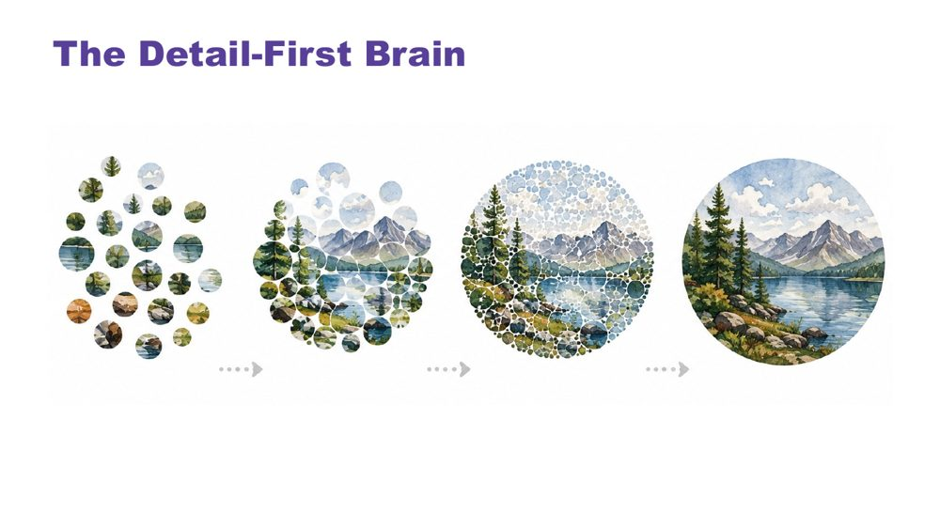 | The Detail-First Brain  SUGGESTED TIME  3 min  CLOCK  10:14 - 10:17  PARTICIPANT GUIDE  Page 8 - Strengths I can see

Introduce bottom-up, detail-first processing and the strengths it produces.
WHAT TO DO  - Open with the contrast between filtering first and taking in what is actually there.  - Name this as bottom-up processing.  - Connect it to sensory intensity, literal language, pattern recognition and deep focus.  - Move through the strengths slowly: pattern recognition, systems thinking, deep memory, logical precision, honesty and directness, depth of connection, intense engagement.  - For each strength, invite the room to connect it to the students they have in mind.  - Invite participants to note strengths for Student A, B and C on p. 8 - Strengths I can see, now or during the thinking discussion. | KEY MESSAGES  - Autistic cognition builds from detail up - bottom-up processing.  - This connects to sensory intensity, literal language, and everything that follows.  - The strengths listed are genuine features, not compensations.  - Educators who leave with vocabulary for these strengths will notice and build on them in the classroom.

YOU MIGHT SAY
Most brains filter first - they predict what is there based on expectation and fill in the rest. The detail-first brain does not filter first. It takes in what is actually there. Then it builds the whole picture from those pieces upward. That is bottom-up processing.
This is the architecture that connects sensory intensity, literal language, pattern recognition, and deep focus. They are not a list of separate Autistic traits. They are features of the same way of taking in the world.
Pattern recognition - where do you see this in class, and in which student?
Deep memory - what does one of them know by heart? Does it look different in another?
Honesty and directness - how does this show up at school?
These are not future potential. They are present now.

KEEP IN MIND
- Some educators may be used to a deficit or "despite" lens ("despite X they can Y"), a consolation prize approach. These are genuine features of how this brain works.
- Avoid turning the content into a deficit list.

Background Bottom-up processing is supported by neuroimaging research showing stronger bottom-up signalling in Autistic brains, with less dominant top-down filtering. The environment is registered more fully, more specifically and less pre-organised before reaching conscious awareness. This produces precision and depth. It also produces load: the same fuller intake that supports pattern recognition can also lead to sensory overload. A student may pick up a tiny change in routine, a background sound, or an inconsistency in what someone said. They are not being pedantic. They are seeing accurately. The educator who names a student's pattern recognition as a strength is doing something meaningful for that student's identity and sense of self, and for how peers see them.

SESSION 2 | Understanding Autistic Experience | SLIDE 13 of 23

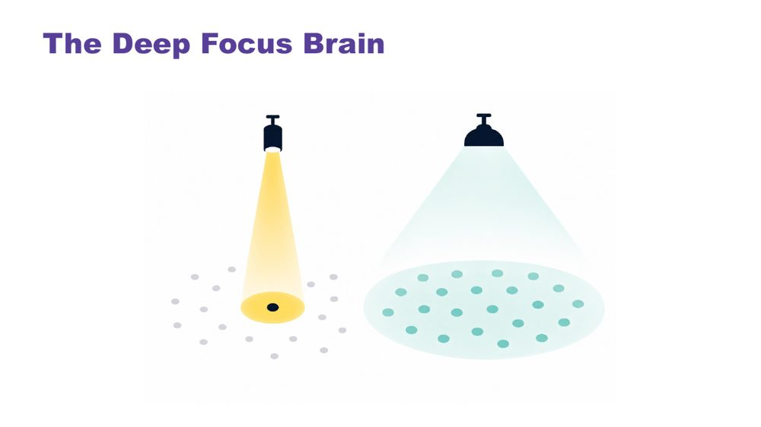 | The Deep Focus Brain  SUGGESTED TIME  3 min  CLOCK  10:17 - 10:20

Introduce monotropism: deep focus, deep interests, transitions and flow.
WHAT TO DO  - Open with a question: do your thoughts travel across many topics, or go deep on one?  - Give the room a moment to reflect.  - Move to the definition, using the visual on the slide.  - Name the key ideas: deep interests, transitions, flow.  - Use the recess example to show the cost of switching. | KEY MESSAGES  - Monotropism: deep focus on fewer things at a time, not distraction or obsession.  - Deep interests are the brain's most reliable route to learning, memory, and genuine engagement.  - Transitions have a real neurological cost - the attention is genuinely invested.  - Flow is the positive expression of this architecture - the brain at its best.  - Developed and extended with Autistic people.

YOU MIGHT SAY
Torch and floodlight: the non-Autistic brain tends to spread attention across many things at once, like a floodlight. The Autistic brain tends to channel it fully into one thing at a time, like a torch beam. Neither is wrong. They illuminate different things.
Tendril theory: the tendrils extend into whatever the mind is focused on. Switching means retracting all of them. That takes time and costs something.
River: the branching river spreads across many channels - broad, covering ground, but shallower in each stream. The single deep river goes all the way in one direction. Neither is wrong. The Autistic thinking brain tends to be the deep river, not scattered, not unfocused, going somewhere completely.
Deep interests are not obsessions or fixations. They are the brain's most natural access to learning, memory, and joy.
Transitions are hard not because the student is being difficult - but because the attention is genuinely, neurologically invested. The river does not change course quickly. With warning and scaffolding this becomes more manageable. The cost is always real.
Flow - full absorption, time disappearing - is this brain at its most powerful. It is worth protecting.
Asking a student absorbed in a construction task, reading about space, drawing or researching a topic they love to stop and pack up for recess is not a simple request. Their attention is fully in that task.

KEEP IN MIND
- Many educators will recognise this in themselves. That is fine to acknowledge, but keep the focus on the students.

Background Monotropism was developed as a framework by Dinah Murray, Mike Lesser and Wenn Lawson, and has been extended by Autistic community voices. It proposes that the core feature of Autistic attention is channelling into fewer things with greater depth, rather than distributing broadly. This explains deep interests, transition difficulty and the experience of flow.
Thread This connects directly to the detail-first brain: the same processing style, one explaining how the world arrives, one explaining where attention goes once it has.
RESOURCES
- Tendril theory comic - https://eisforerin.com/2015/08/10/tendril-theory/

SESSION 2 | Understanding Autistic Experience | SLIDE 14 of 23

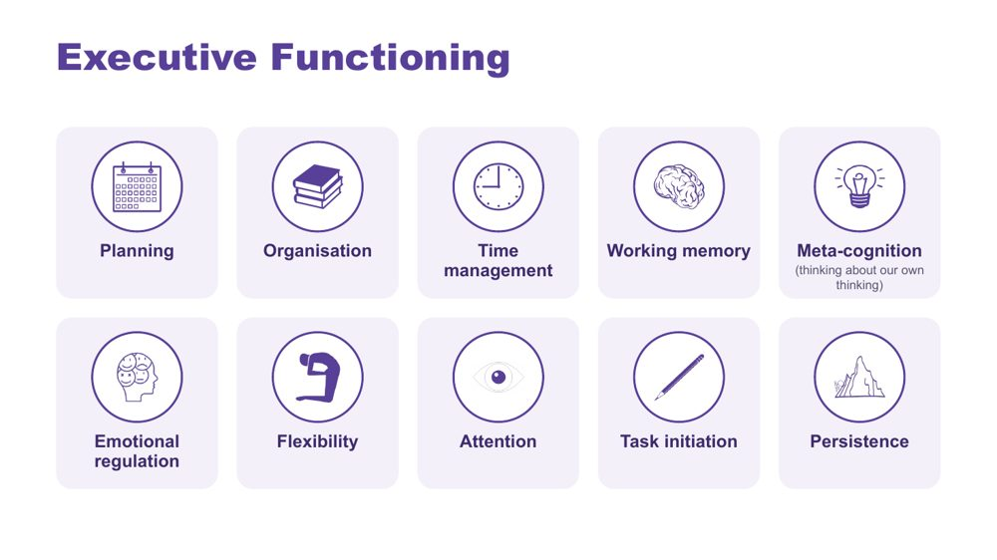 | Executive Functioning  SUGGESTED TIME  2 min  CLOCK  10:20 - 10:22

Name the ten areas of executive functioning and link each to the demands of a school day.
WHAT TO DO  - Name the ten areas on the slide.  - Ask what a task asks the student to plan, start, remember, sequence, organise, switch and complete.  - Ask participants where each area shows up across an ordinary school day for the students they have in mind. | KEY MESSAGES  - The terms are lenses for inquiry, not a checklist.  - Task design, timing and support can affect access.  - Explain each term before applying it.

YOU MIGHT SAY
Useful support responds to the specific demand rather than assuming a lack of effort or motivation. Different demands may need different kinds of support.

KEEP IN MIND
- Consider how instructions, interruptions, switching, starting, sequencing and task completion are organised in the setting, without claiming a single cause.
- Keep the focus on matching support to the individual student and context.

SESSION 2 | Understanding Autistic Experience | SLIDE 15 of 23

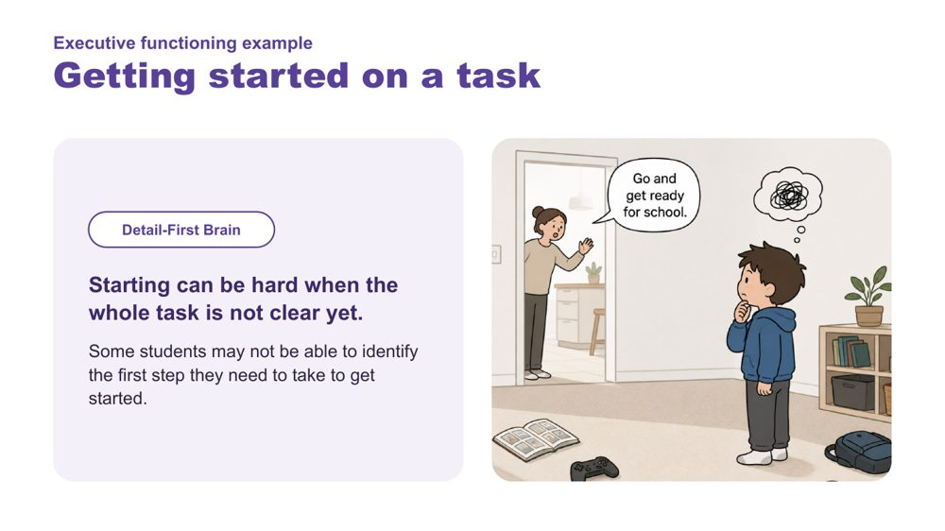 | Executive functioning example: Getting started on a task  SUGGESTED TIME  1 min  CLOCK  10:22 - 10:23

Link the detail-first brain to difficulty getting started.
WHAT TO DO  - Read the example.  - Link it back to the detail-first brain: starting can be hard when the whole task is not clear yet. | KEY MESSAGES  - Some students may not be able to identify the first step they need to take to get started.

SESSION 2 | Understanding Autistic Experience | SLIDE 16 of 23

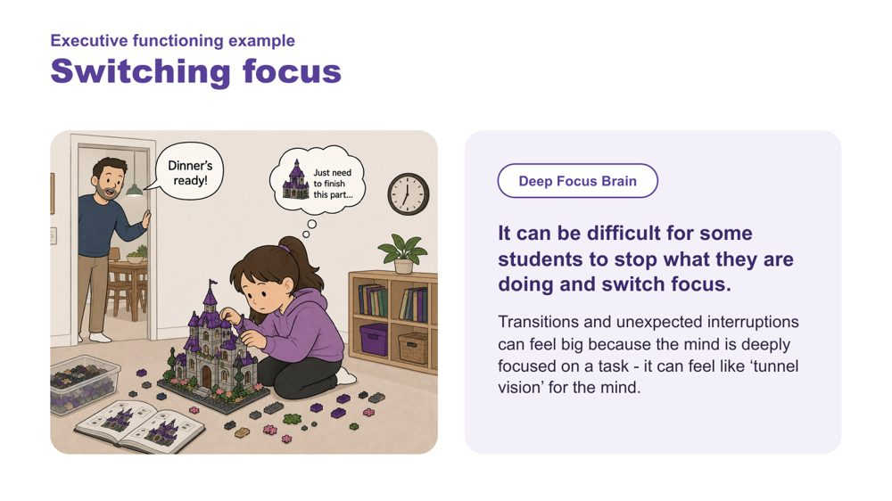 | Executive functioning example: Switching focus  SUGGESTED TIME  1 min  CLOCK  10:23 - 10:24

Link the deep focus brain to difficulty switching focus.
WHAT TO DO  - Read the example.  - Link it back to the deep focus brain and the recess example. | KEY MESSAGES  - Transitions and unexpected interruptions can feel big because the mind is deeply focused on a task - it can feel like 'tunnel vision' for the mind.

SESSION 2 | Understanding Autistic Experience | SLIDE 17 of 23

 | How can Autistic thinking feel?  SUGGESTED TIME  2 min  CLOCK  10:24 - 10:26

Hear directly from an Autistic young person about deep focus and transitions.
WHAT TO DO  - Play the clip.  - Give a moment before moving on. | KEY MESSAGES  - Hearing from Autistic people directly is a central part of the learning.

Thread Same pattern as the sensory videos: from intellectual understanding to felt recognition.

SESSION 2 | Understanding Autistic Experience | SLIDE 18 of 23

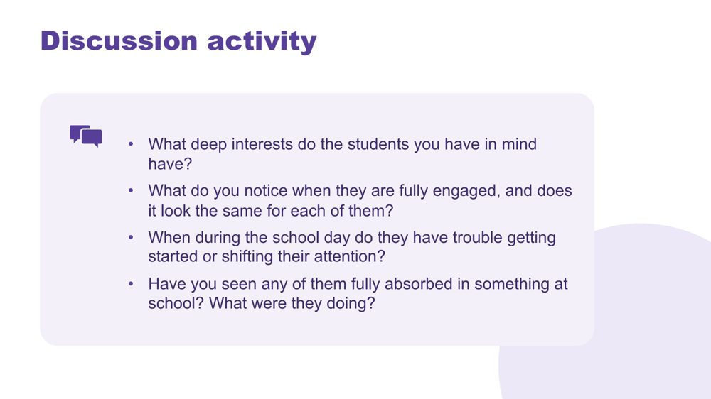 | Thinking discussion  SUGGESTED TIME  9 min  CLOCK  10:26 - 10:35  GROUPING  Pairs  PARTICIPANT GUIDE  Page 8 - Thinking discussion

Consolidate the thinking concepts through personal recognition of the students participants have in mind.
WHAT TO DO  - Direct people to the four questions on the slide.  - Give 8 minutes in pairs.  - Bring the room back and take 2-3 responses.  - Hold the space rather than adding more content.  - Optional extension if time allows: a task-demand review. Ask what a classroom task asks the student to notice, start, hold, switch, sequence or complete. Write the task in neutral language, list its demands in order, mark where the environment or instruction could reduce unnecessary demand, and write one question to explore with the student or team. | KEY MESSAGES  - This activity personalises the concepts: participants move from "I understand this" to "I can see this in the students I have in mind".  - The questions connect to the concepts: deep interests, starting and shifting, and flow.  - Educators who can name these things in a student leave the room with something practical to use in the classroom.  - The activity surfaces strengths alongside challenges: flow and deep interests sit alongside starting and shifting.

YOU MIGHT SAY
Everything you have just described, that IS the thinking brain at work. Noticing it is the beginning of working with it rather than against it.

ACTIVITY | Discussion pairs · 8 minutes
Think about the students you have in mind.
- What deep interests do the students you have in mind have?
- What do you notice when they are fully engaged, and does it look the same for each of them?
- When during the school day do they have trouble getting started or shifting their attention?
- Have you seen any of them fully absorbed in something at school? What were they doing?
Bring the room back
- What came up for people?
Close: Everything you have just described, that IS the thinking brain at work. Noticing it is the beginning of working with it rather than against it.

KEEP IN MIND
- You do not need to comment extensively on each response; the room hearing each other is the consolidation.
- Separate what a task requires from what the student appears to do; avoid inferring internal processes from behaviour alone.

Background The activity follows the same pattern as the sensory activity. The purpose is consolidation through personal recognition, not information transfer. What participants say to each other will likely do more work than the preceding slides.
Thread The last question, flow, sets up a question for Session 3: what happens to that focus when the student tries to communicate or connect?

SESSION 2 | Understanding Autistic Experience | SLIDE 19 of 23

 | Internal signals  SUGGESTED TIME  1 min  CLOCK  10:35 - 10:36

Introduce the final part of the session: what is happening inside.
WHAT TO DO  - Return to interoception, parked earlier in the sensory section.  - Name that internal experience may not be visible to an observer. | KEY MESSAGES  - Internal experience may not be visible to an observer.

Thread Interoception was named with the eight senses; this is where it comes back.

SESSION 2 | Understanding Autistic Experience | SLIDE 20 of 23

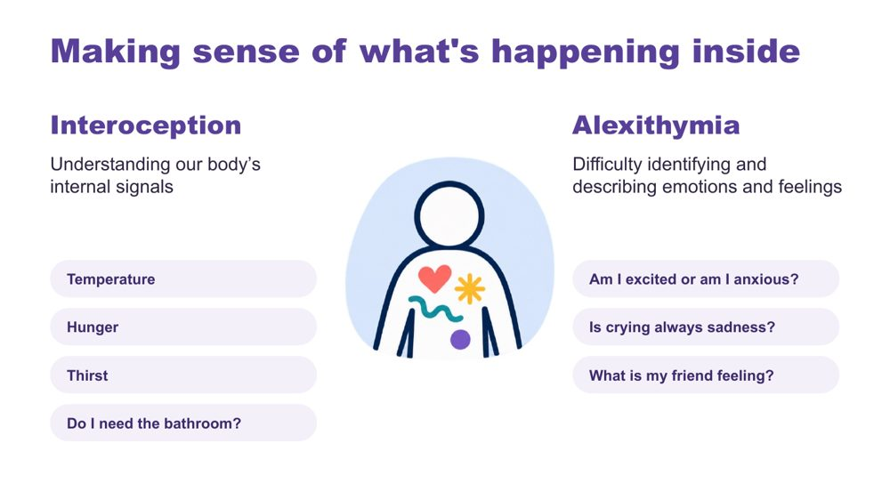 | Making sense of what's happening inside  SUGGESTED TIME  2 min  CLOCK  10:36 - 10:38

Introduce interoception and alexithymia using the examples on the slide.
WHAT TO DO  - Introduce interoception: understanding our body's internal signals (temperature, hunger, thirst, needing the bathroom).  - Introduce alexithymia: difficulty identifying and describing emotions and feelings.  - Use the slide's questions as examples: Am I excited or am I anxious? Is crying always sadness? What is my friend feeling? | KEY MESSAGES  - Interoception helps answer the question "how am I doing?"  - Internal experience may not be visible to an observer.

KEEP IN MIND
- Name interoception and alexithymia without improvising definitions.
- Do not assume a student's internal state from outward behaviour.

Background Interoception is needed for knowing when to go to the toilet; knowing when you are tired, hungry or thirsty; knowing if you are hot or cold; being aware that you are becoming angry or upset. It plays a part in being able to self-regulate.

SESSION 2 | Understanding Autistic Experience | SLIDE 21 of 23

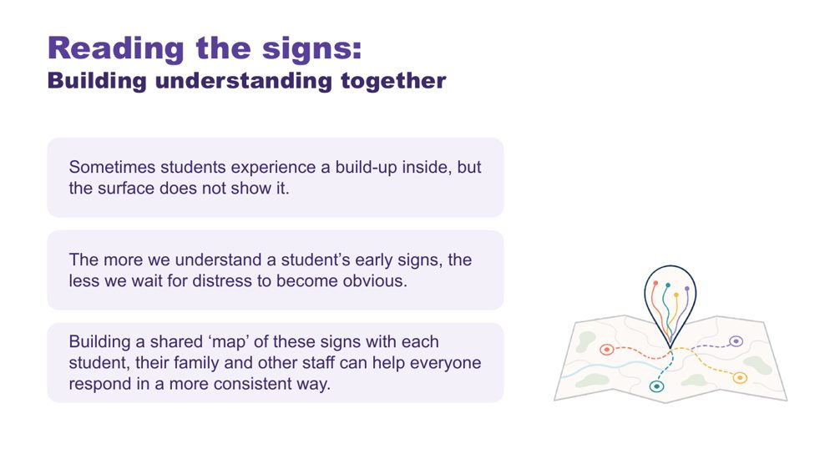 | Reading the signs: building understanding together  SUGGESTED TIME  2 min  CLOCK  10:38 - 10:40

Show why understanding a student's early signs, together, matters.
WHAT TO DO  - Read the three points on the slide.  - Name who builds the shared map: each student, their family and other staff. | KEY MESSAGES  - Sometimes students experience a build-up inside, but the surface does not show it.  - The more we understand a student's early signs, the less we wait for distress to become obvious.  - A shared map of signs helps everyone respond in a more consistent way.

KEEP IN MIND
- Analogies and observations support discussion but do not replace the student's own communication.

SESSION 2 | Understanding Autistic Experience | SLIDE 22 of 23

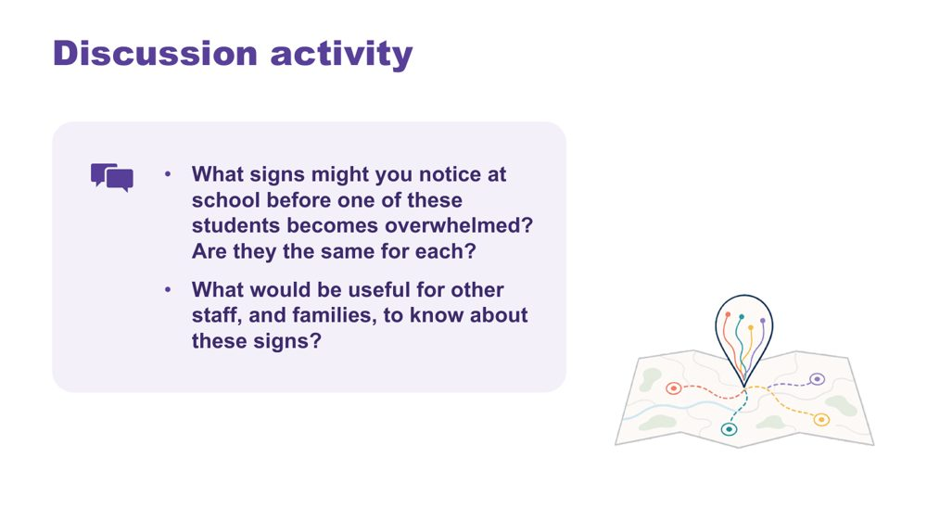 | Reading the signs discussion  SUGGESTED TIME  4 min  CLOCK  10:40 - 10:44  GROUPING  Pairs  PARTICIPANT GUIDE  Page 9 - Reading the signs

Help participants think about early signs of overwhelm at school and who needs to know them.
WHAT TO DO  - Read the two questions on the slide.  - Give pairs a few minutes.  - Take one or two responses. | KEY MESSAGES  - Signs may differ between students.  - Families and other staff are part of reading the signs.

ACTIVITY | Discussion pairs · 3 minutes
What signs might you notice at school before one of these students becomes overwhelmed? Are they the same for each?
- Note the signs you might see at school for each of the students you have in mind.
- Compare: are they the same for each?
- Discuss what would be useful for other staff, and families, to know about these signs.
Bring the room back
- What would be useful for other staff, and families, to know about these signs?

KEEP IN MIND
- Do not assume a student's internal state from outward behaviour.
- Use initials or roles only.

Thread Invite participants to consider how students can communicate capacity and what the environment can do with that information. This sets up the partnership work in Session 5.

SESSION 2 | Understanding Autistic Experience | SLIDE 23 of 23

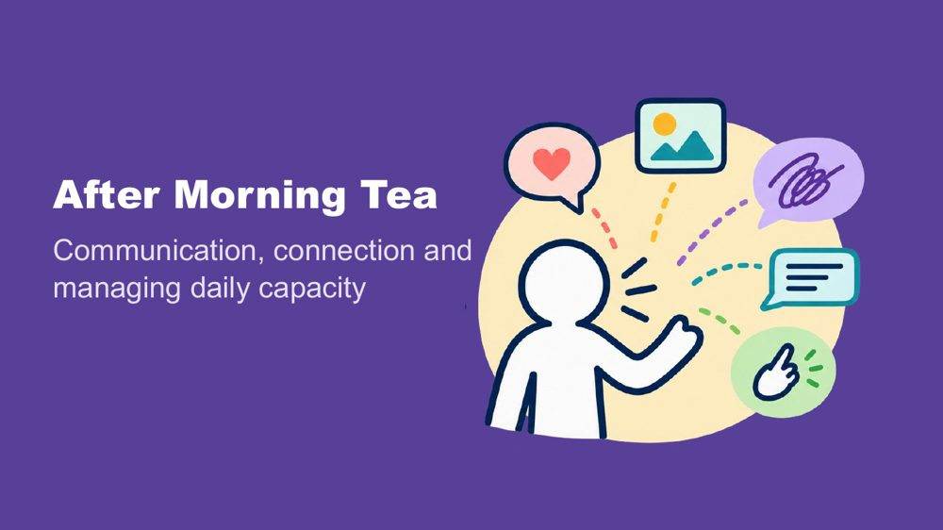 | After Morning Tea  SUGGESTED TIME  1 min  CLOCK  10:44 - 10:45

Close Session 2, confirm the tea break and preview what comes next.
WHAT TO DO  - Confirm the tea break (10:45 - 11:00).  - Preview Session 3: communication, connection and managing daily capacity across a school day. | KEY MESSAGES  - The next session maps demand and capacity through a school day.

SESSION  3 | 11:00 - 12:30 · 90 MINUTES · 27 SLIDES  Autistic Experience at School  Communication, Connection and Identity

SESSION INTENT
Connect communication, connection, capacity, masking, identity and belonging to the school day as support staff see it, across every room and space. Participants map the day of a student they support, practise observing and sharing what they see, consider support in the moment within their role and school policy, audit what changes across settings, and choose a focus to carry into design after lunch.
PARTICIPANTS LEAVE WITH
- recognise that communication is multimodal and that how much a student speaks does not show how much they understand
- use double empathy to ask whose expectations shape an interaction, and name the many ways students connect
- map the day of a student they support, through every room and space, marking what costs, what lightens and what is not yet known
- write a short, factual observation and share it with the teacher in the way their school agrees
- describe low-demand ways to support a student who is overwhelmed, within their role and school policy
- audit what changes for one student across settings and choose one thing to keep, reduce and explore in Session 4

RUN SHEET
Clock | Segment | Slides | Minutes
11:00 - 11:02 | Welcome back | 1 | 2
11:02 - 11:24 | Communication | 2-9 | 22
11:24 - 11:36 | Connection and double empathy | 10-13 | 12
11:36 - 11:41 | Managing daily capacity | 14-16 | 5
11:41 - 11:55 | Map the school day: costs and lightens | 17-19 | 14
11:55 - 12:05 | Masking | 20-22 | 10
12:05 - 12:17 | Observing and sharing; in the moment | 23-24 | 12
12:17 - 12:27 | Audit across settings and carry into design | 25-26 | 10
12:27 - 12:30 | Close: positive Autistic identity | 27 | 3

PREPARE
☐ Participant Guide for every participant (pp. 10 - 16)
☐ Purple, blue and orange Post-it notes on each table
☐ Wall or board space for Post-it notes, grouped by colour
☐ Communication experiences video cued, with accurate edited captions and a transcript available
☐ Masking video cued, with captions
☐ Participant Guide p. 13 (day map), or large paper
☐ Pens or markers in at least two colours (costs and lightens)
☐ Participant Guide p. 15 (audit across settings)
☐ Closing image for slide 27 in place
☐ Carry into design card (PL Support Staff - Session 3 - Carry into design card): one per participant, if using the printed card as well as Participant Guide p. 16

SESSION 3 | Autistic Experience at School | SLIDE 1 of 27

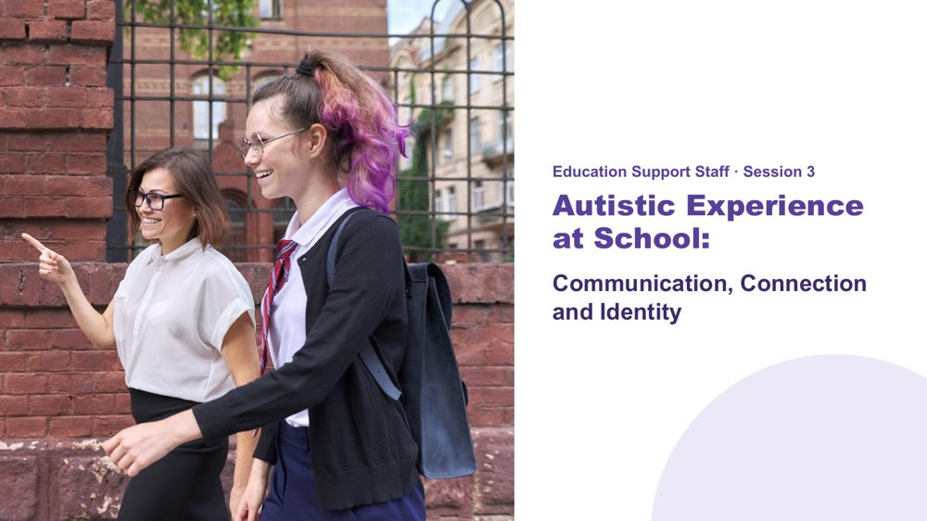 | Autistic Experience at School  SUGGESTED TIME  2 min  CLOCK  11:00 - 11:02  PARTICIPANT GUIDE  Page 10 - Session 3 summary

Welcome participants back and introduce communication, connection and capacity across the school day, seen from the support staff role.
WHAT TO DO  - Welcome participants back from the break.  - Explain that Sessions 1 and 2 were shared across all workshops. From this session, the content starts to focus on the support staff role.  - Ask participants to bring back the two or three students they have in mind.  - Acknowledge that support staff often see a student's day more closely than anyone else, across many rooms and spaces.  - Explain that the session moves from communication and connection into a day map, then observing and sharing, support in the moment, and an audit across settings.  - Keep examples within education practice and avoid discussing identifiable incidents. | KEY MESSAGES  - The school day is experienced through more than the timetable.  - Communication, connection, demand and belonging interact across the day.  - Support staff bring careful observations and practical knowledge to shared planning, working within agreed roles and plans.

KEEP IN MIND
- Close observation is valuable, but it does not make one person responsible for interpreting, planning or responding alone.
- Encourage participants to stay curious about the students' experience rather than making assumptions about what behaviour may mean.

Thread Builds on the picture of the students started in Sessions 1 and 2, and leads into the design work in Session 4 after lunch.

SESSION 3 | Autistic Experience at School | SLIDE 2 of 27

 | Communication  SUGGESTED TIME  1 min  CLOCK  11:02 - 11:03

Open the communication section.
WHAT TO DO  - Introduce the communication section: multimodal communication, understanding and expressing, and AAC.  - Set the frame: speech is not the only valid way to communicate, and the amount of speech does not tell us how much a student understands.  - Ask participants to think about where, across the day, the students they support need to understand or be understood: asking for help, making a choice, joining in, saying no, saying something is wrong, or understanding a change. | KEY MESSAGES  - Communication access belongs across the whole school day.  - Students may need different ways to understand, respond, ask, pause or decline.  - Follow the student's agreed communication approach, and take specialist questions to the teacher or the relevant team member.

KEEP IN MIND
- Keep examples suitable for both primary and secondary settings.
- Avoid presenting one communication approach as suitable for every student.

SESSION 3 | Autistic Experience at School | SLIDE 3 of 27

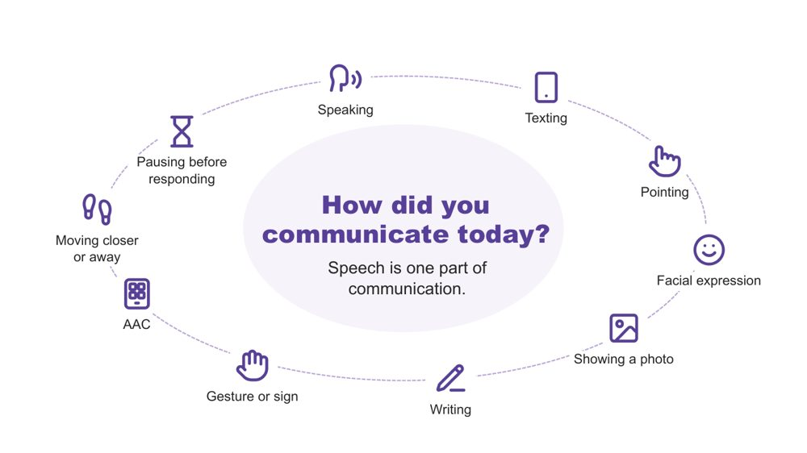 | How did you communicate today?  SUGGESTED TIME  2 min  CLOCK  11:03 - 11:05

A quick warm-up showing that everyone communicates in many ways, every day.
WHAT TO DO  - Invite a quiet think: three ways participants have communicated since waking.  - Pause for about 20 seconds.  - Invite two or three people to share one. Sharing is optional.  - Reflect back the variety you hear, for example a text message, a wave, a look, or taking a moment before answering. | KEY MESSAGES  - Everyone communicates in many ways, every day. Speech is one part of communication.

YOU MIGHT SAY
Let's start with a quick, quiet think. Since you woke up this morning, how have you communicated? See if you can think of three different ways.
Would two or three people be happy to share one?
We all move between different ways of communicating, often without noticing. Every way on this slide is real communication. No way is more valid than another.

KEEP IN MIND
- Keep this brief (1 - 1.5 minutes). It is a warm-up, not a discussion.
- Do not use percentages or claims about how much of communication is spoken or non-spoken.

Background Many students hear "use your words" at school. This is a gentle reframe: pointing, a device, a look or moving away are all ways of communicating.

SESSION 3 | Autistic Experience at School | SLIDE 4 of 27

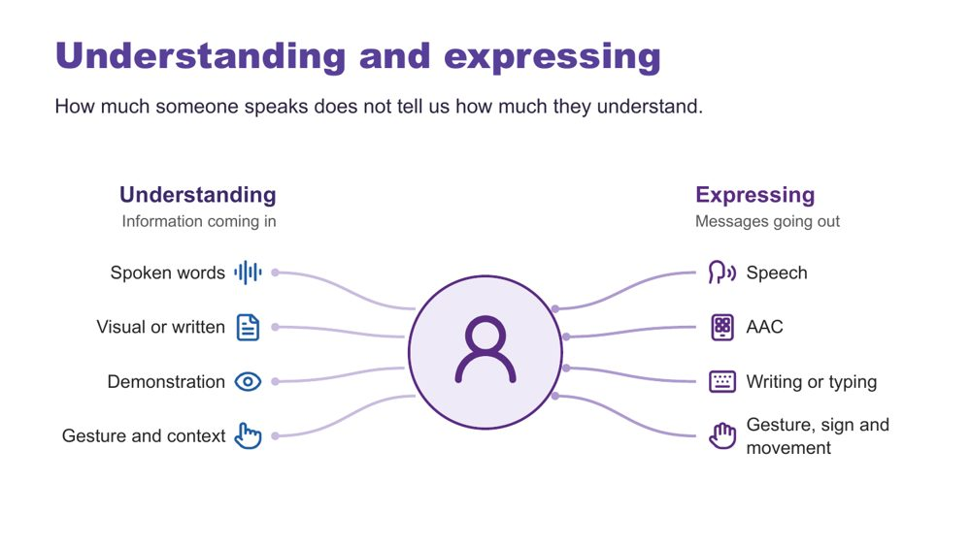 | Understanding and expressing  SUGGESTED TIME  2 min  CLOCK  11:05 - 11:07

Separate understanding (receptive) from expressing (expressive) communication.
WHAT TO DO  - Explain that Autistic people have varied communication profiles.  - Name that someone may express a great deal but need support to understand spoken information, and someone else may understand more than they can easily express.  - Note that communication can change depending on the person, place, demands and how someone is feeling.  - Give the plain AAC explanation.  - Ask participants to think about how much spoken information the students they support are expected to process across an ordinary day, and what makes it easier to follow. | KEY MESSAGES  - How much someone speaks does not tell us how much they understand.  - Do not assume fluent speech means full understanding. Do not assume limited speech means limited understanding.  - Expressive and receptive communication do not necessarily look the same.

KEEP IN MIND
- Do not teach gestalt language processing (GLP) or Natural Language Acquisition stages here. It is background only.
- Do not ask participants to identify or diagnose a student as a gestalt language processor.
- Refer individual assessment or intervention questions to the teacher, the student's speech pathologist or the relevant team.
- Encourage participants to stay curious about what a student may be communicating rather than treating repeated or scripted language as meaningless.

Background Receptive communication means how a person receives and makes sense of information. At school this includes teacher instructions, questions, class discussion, playground or yard language, changes to routines and information about what is happening next. Expressive communication means how a person shares messages, ideas, feelings and choices through any communication method. AAC (augmentative and alternative communication) may include gesture, signs, a communication board or book, typing or a communication device; some people use it alongside speech and some instead of speech. Echolalia means repeating words or phrases, immediately or later, and can have communicative meaning. Gestalt language processing is a term used in a proposed account of learning language through larger phrases or chunks; the two terms are not interchangeable. Hutchins et al. (2024) question the evidence for these categories and stages. This does not diminish the value of repeated or scripted language: consider the possible context, intent and meaning, listen before correcting the form, and notice when and where it occurs and what follows. A student does not need a GLP label before their communication is respected or supported.
RESOURCES
- Hutchins et al. (2024) - https://doi.org/10.1177/23969415241249944

SESSION 3 | Autistic Experience at School | SLIDE 5 of 27

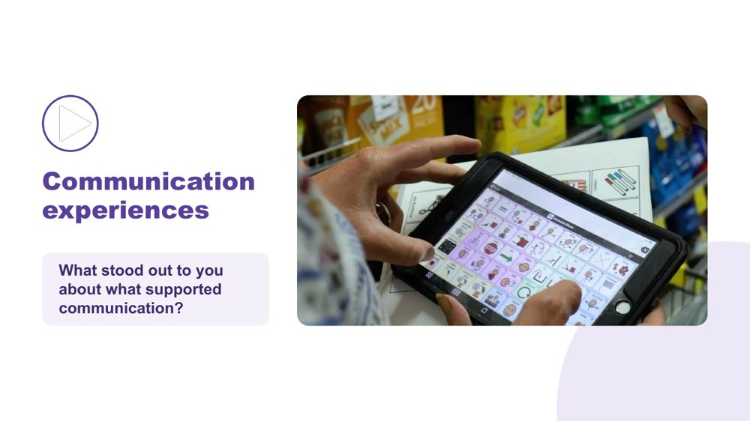 | Communication experiences  SUGGESTED TIME  4 min  CLOCK  11:07 - 11:11  GROUPING  Whole room

Hear Autistic people describe what helps them communicate.
WHAT TO DO  - Check captions are switched on.  - Read the prompt: "As you watch, notice what supports communication. Choose one idea that stands out to you."  - Play the video (around 2.5 minutes).  - Click once to reveal the question.  - Take one response, or two if time allows.  - Use the optional prompts only if the room is quiet. | KEY MESSAGES  - There is no single Autistic communication profile. Autistic people describe what helps them communicate in many different ways.  - A student's AAC needs to be available where communication happens, not only during a specific activity or therapy session.

YOU MIGHT SAY
As you watch, notice what supports communication. Choose one idea that stands out to you.
What stood out to you about what supported communication?

ACTIVITY | Video and brief whole-room response whole room · 4 minutes
What stood out to you about what supported communication?
- Watch the clip.
- Take one or two responses.
Bring the room back
- What communication strengths did you notice?
- What did another person do that helped?
- What difference did the environment or available communication method make?

KEEP IN MIND
- Let the voices in the video lead. Avoid summarising or generalising what speakers said.
- Use accurate, edited captions (not auto-generated only) and have a transcript available.
- If the video is set to play on click, the question appears on the following click.

Background AAC adds to or provides an alternative to speech. At school this may include signs, communication boards or books and speech-generating devices, and it may be used alongside speech. Support staff do not assess or prescribe AAC. The role is to recognise and support the student's ways of communicating, keep the agreed system available, and share what you notice with the teacher and relevant team.

SESSION 3 | Autistic Experience at School | SLIDE 6 of 27

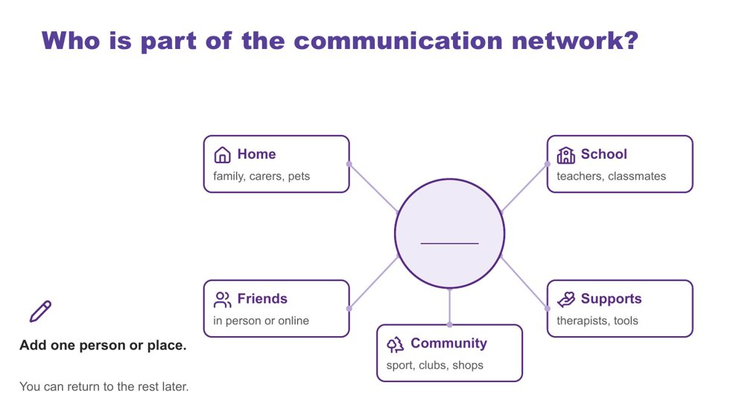 | Who is part of the communication network?  SUGGESTED TIME  3 min  CLOCK  11:11 - 11:14  GROUPING  On your own  PARTICIPANT GUIDE  Page 11 - Who is part of the communication network?

Map the people and places around one of the students participants have in mind.
WHAT TO DO  - Ask participants to put one of the students they have in mind in the centre of page 11 of the Participant Guide or a sheet of paper.  - Invite them to add one person or place, using roles rather than names.  - Allow about 1.5 minutes of quiet time.  - Offer to write for anyone who would like help.  - Share the points below while people write. | KEY MESSAGES  - Students communicate with many people in many places. Each person, at school and beyond, may see a different part of the communication picture.

YOU MIGHT SAY
Use your Participant Guide or a sheet of paper. Put one of the students you have in mind in the centre. Around them are home, school, friends, community and supports.
Think about who is part of this student's communication network. Use roles rather than names. Add one person or place now. You can return to the rest later.
You can write roles, draw or use dot points.

ACTIVITY | Quiet individual mapping on your own · about 1.5 minutes of writing
Who is part of this student's communication network? Add one person or place.
- Place the student in the centre.
- Add one person or place around home, school, friends, community or supports.
- Use roles, not names.
Close: You can return to the rest later.

KEEP IN MIND
- Networks can be small or changing. Normalise empty boxes.
- Keep the student anonymised. Use roles, not names.
- This activity is not about deciding who understands the student best.

Background You do not need to complete every box. A box can hold many people, one person, or nobody yet. Different people may see different parts of the student's communication, and the network may look very different for another of the students. A classroom teacher, a support staff member, a specialist teacher and a parent may each notice something different. The parts of the network participants know little about are questions to explore with the student and their family.

SESSION 3 | Autistic Experience at School | SLIDE 7 of 27

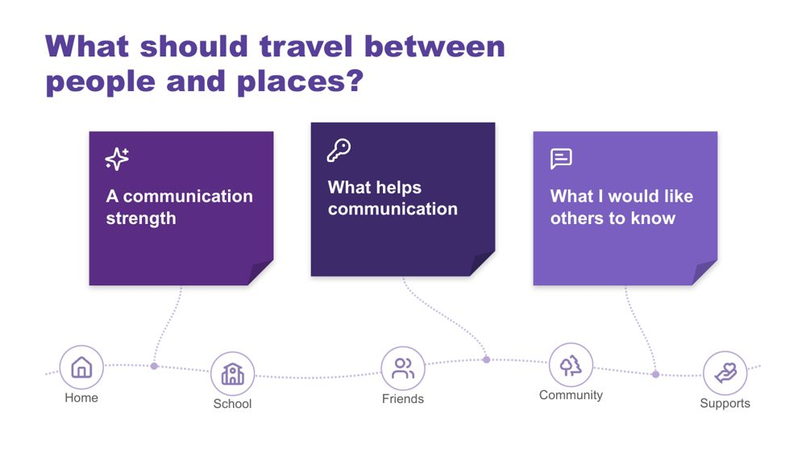 | What should travel between people and places?  SUGGESTED TIME  6 min  CLOCK  11:14 - 11:20  GROUPING  On your own  PARTICIPANT GUIDE  Page 11 - What should travel between people and places?

Name what a student's communication partners need to know so the student does not have to start again with every new person.
WHAT TO DO  - Check purple, blue and orange Post-it notes are on each table and a wall or board space is ready.  - Explain the colours.  - Allow about 3 minutes of writing.  - Invite optional sharing for about 3 minutes: add a note to the board or read one out.  - Group notes on the board by colour.  - Notice themes on the blue notes. You will return to them on the next slide. | KEY MESSAGES  - Educators, families and specialists each hold valuable knowledge about a student's communication.  - When that knowledge travels between classrooms, specialist lessons, the playground or yard, relief staff and home, students do not have to start again with every new person.

YOU MIGHT SAY
Let's think about what should travel with one of the students you have in mind between people and places.
Purple is a communication strength. Blue is something that helps communication. Orange is something you would like others to know.
You can write one note, two or all three. You can use one of the students you have in mind, anonymised, or a made-up example. You can keep your notes private if you prefer.
If you are comfortable, add a note to the board or read one out.

ACTIVITY | Colour-coded Post-it notes with optional sharing on your own · 6 minutes (about 3 writing, about 3 sharing)
What should travel with this student between people and places?
- Purple: a communication strength.
- Blue: something that helps communication.
- Orange: something you would like others to know.
- Write one, two or all three notes.
- Add to the board or read one out, if comfortable.
Bring the room back
- What similarities do you notice?
- What strengths might be missed if we look only for speech?
- Which supports change what other people do or provide?
- What would help a relief teacher, a specialist teacher, playground or yard staff, or another support staff member covering for you?
- Did another person's contribution prompt a new thought?
Close: Notice the themes on the blue notes and carry them into the next slide.

KEEP IN MIND
- Do not ask individuals to share. Sharing is optional.
- Thank every contribution without ranking it.
- If a note names a child or school, invite the writer to keep it.

SESSION 3 | Autistic Experience at School | SLIDE 8 of 27

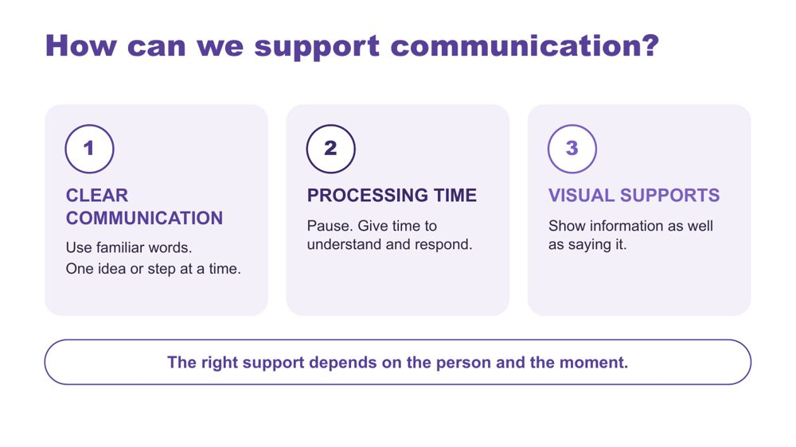 | How can we support communication?  SUGGESTED TIME  2 min  CLOCK  11:20 - 11:22

Introduce three ways to support communication across the school day.
WHAT TO DO  - Link back to the themes on the blue notes.  - Walk through the three strategies on the slide. | KEY MESSAGES  - The right support depends on the person and the moment.

YOU MIGHT SAY
There are three strategies we can use. Clear communication means using familiar words and giving one idea or step at a time. Processing time means pausing so the person has time to understand and respond. Visual supports mean showing information as well as saying it. Let's look at what these can look like.

KEEP IN MIND
- These are options to match to the person, not a checklist or a guarantee.
- Avoid filling every pause with more words.
- Keep AAC available and allow responses through the person's preferred methods, including refusal.
- Keep to the student's agreed communication approach. If something seems to help, share it with the teacher.

Background Processing time is time to make sense of information, organise a response and communicate it. Clear communication means familiar, specific language in a form and amount the person can access. Communication partner guidance includes adapting language and allowing response time, and AAC guidance also includes visual supports and access across settings (ASHA, n.d.; Brady et al., 2016). There is no activity on this slide.
RESOURCES
- ASHA (n.d.) - full reference in the facilitator guide references
- Brady et al. (2016) - full reference in the facilitator guide references

SESSION 3 | Autistic Experience at School | SLIDE 9 of 27

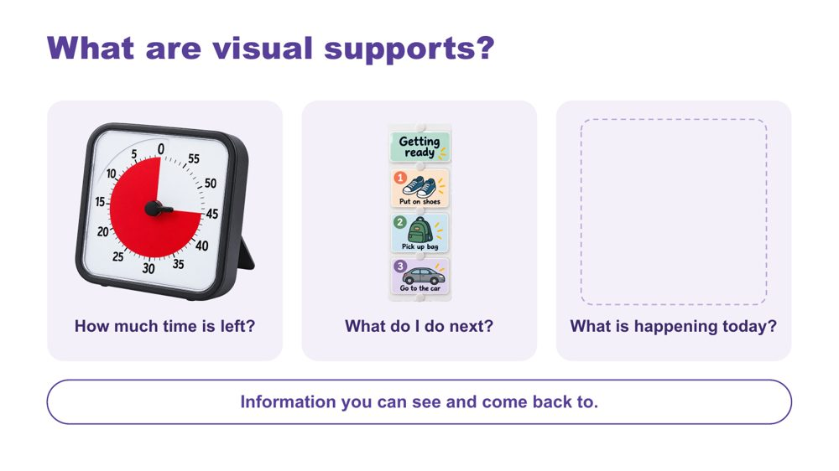 | What are visual supports?  SUGGESTED TIME  2 min  CLOCK  11:22 - 11:24

Help educators recognise what visual supports are through familiar examples.
WHAT TO DO  - Walk through the three examples: a timer, a sequence, a daily schedule.  - If time allows, ask the question and take one or two brief examples. | KEY MESSAGES  - Visual supports are information you can see and come back to.  - A visual support offers information, not a condition for access to a preferred activity.

YOU MIGHT SAY
Visual supports help make information clear. They give us something to look at and come back to. This timer shows how much time is left. A sequence shows what to do next. A daily schedule shows what is happening today. You might already use a calendar, shopping list or reminder on your phone. The useful format will be different for each person.
What visual information do you already see or use in the classes and spaces where you work?

KEEP IN MIND
- This is an introduction, not another task to complete.
- These images illustrate formats, not recommended products.
- Visual supports and AAC can overlap, but they are not interchangeable. Keep the person's communication methods available.
- Use the evidence to explain options, not to promise the same result for every person.
- Support staff often make or carry visual supports between settings. Keep the focus on using the agreed supports consistently and telling the teacher what you notice.

Background Visual supports can include objects, real photos, written words or symbols, on paper or a device. Check that the person understands the information and can access it when needed. The written sequence is an example of accessible information, not a test of compliance. Match the format to the person and invite their preferences. Optional prompts: What information would help each of these students? What format makes sense to them? Where could it stay available?
Thread Session 4 returns to visual supports as one design option, with the Visual Supports Checklist and webinar for further learning.
RESOURCES
- Avery et al. (2025) - review of caregiver-implemented visual supports; full reference in the facilitator guide references
- ASHA AAC Practice Portal - visual schedules and other visual supports; full reference in the facilitator guide references

SESSION 3 | Autistic Experience at School | SLIDE 10 of 27

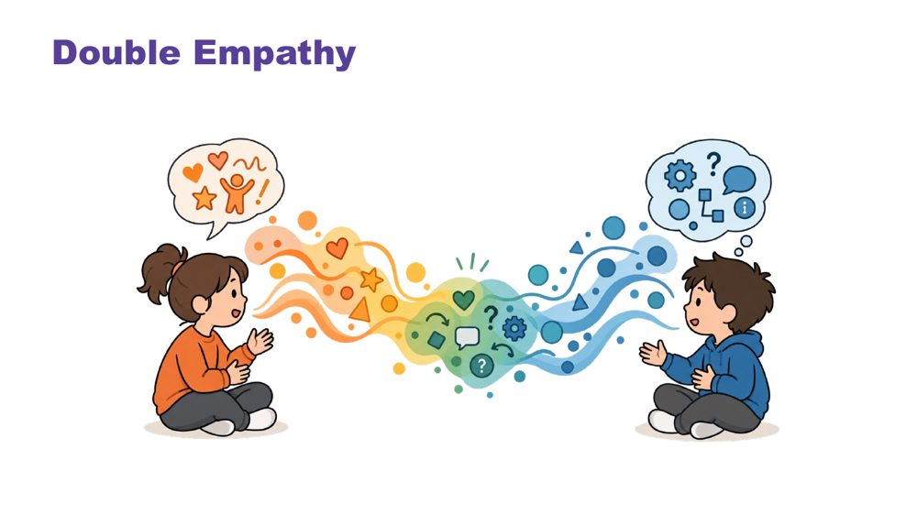 | Double empathy  SUGGESTED TIME  3 min  CLOCK  11:24 - 11:27

Explore interaction and connection without treating one social style as the standard.
WHAT TO DO  - Explain double empathy: when people have different experiences and ways of communicating, understanding one another can be more difficult in both directions.  - Ask whose expectations shape an interaction and what would make connection safer or clearer.  - Consider the expectations operating during class discussion, group work, time in the playground or yard, and interactions with adults and peers.  - Use "how each student connects" throughout the discussion. | KEY MESSAGES  - Connection does not need to look one way.  - Interaction is shaped by expectations and context as well as by the student.  - Social misunderstanding does not automatically sit within the Autistic student.

YOU MIGHT SAY
Whose expectations are shaping this interaction?

KEEP IN MIND
- Move away from locating every social misunderstanding within the Autistic student.

SESSION 3 | Autistic Experience at School | SLIDE 11 of 27

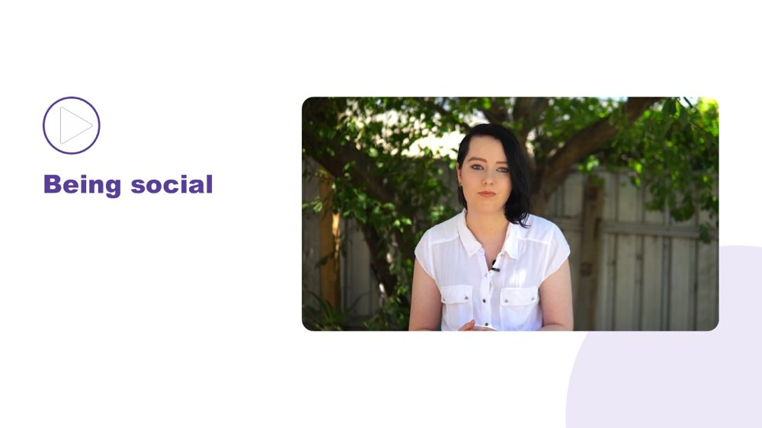 | Being social  SUGGESTED TIME  2 min  CLOCK  11:27 - 11:29

Open the section on how each student connects.
WHAT TO DO  - Introduce the move from double empathy to the many ways students connect.  - Invite participants to notice preferred people, places, activities and ways of joining without interpreting difference as absence of connection. | KEY MESSAGES  - Connection does not need to look one way.

SESSION 3 | Autistic Experience at School | SLIDE 12 of 27

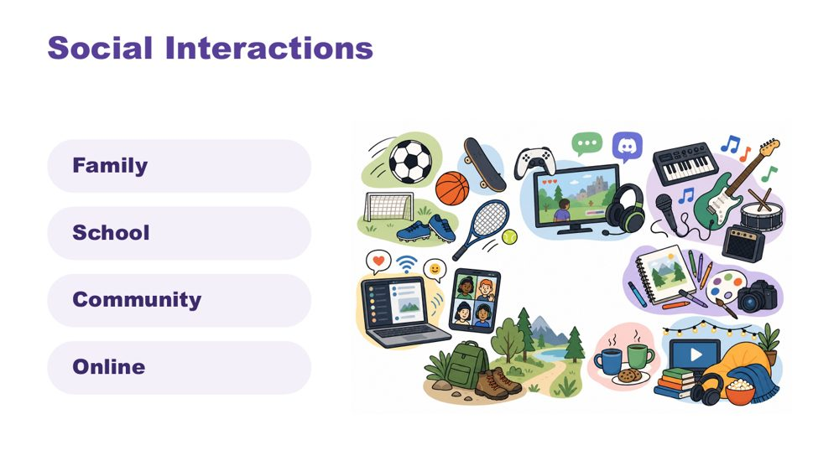 | Social interactions  SUGGESTED TIME  2 min  CLOCK  11:29 - 11:31

Widen the picture of how students interact, across family, school, community and online.
WHAT TO DO  - Identify a range of ways a student may interact, for example 1:1, parallel play or engagement, info dumping, irregular contact.  - Make connections to culture.  - Name in-person, online and third spaces without making assumptions about a student's communities. | KEY MESSAGES  - Connection can occur in person, online and in third spaces, and each student's experience is individual.

KEEP IN MIND
- Do not ask participants to disclose a student's online activity, identity or community membership.

SESSION 3 | Autistic Experience at School | SLIDE 13 of 27

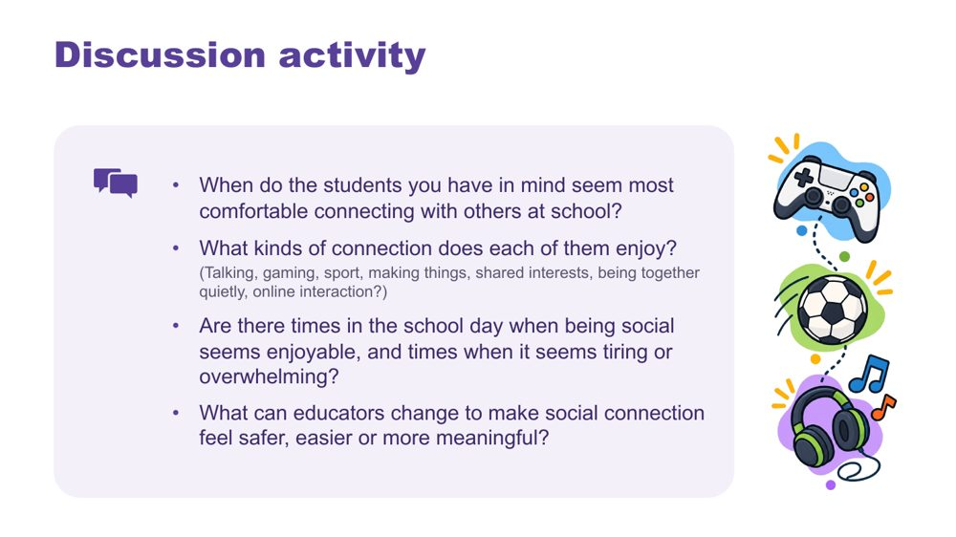 | Discussion activity: connection  SUGGESTED TIME  5 min  CLOCK  11:31 - 11:36  GROUPING  Pairs  PARTICIPANT GUIDE  Page 12 - Connection discussion

Apply the ideas of connection to the students participants have in mind.
WHAT TO DO  - Put participants in pairs.  - Work through the four questions on the slide.  - Bring the room back and take a few responses, focusing on what could change around the student. | KEY MESSAGES  - Connection does not need to look one way.  - What educators change around a student can make social connection feel safer, easier or more meaningful.

ACTIVITY | Guided discussion pairs · about 4 minutes
When do the students you have in mind seem most comfortable connecting with others at school?
- When do the students you have in mind seem most comfortable connecting with others at school?
- What kinds of connection does each of them enjoy? (Talking, gaming, sport, making things, shared interests, being together quietly, online interaction?)
- Are there times in the school day when being social seems enjoyable, and times when it seems tiring or overwhelming?
- What can educators change to make social connection feel safer, easier or more meaningful?
Bring the room back
- What could change around them to make social connection feel safer, easier or more meaningful?
- Which of these could you do in your role, and which would you suggest to the teacher?

KEEP IN MIND
- Do not ask participants to disclose a student's online activity, identity or community membership.
- Avoid interpreting difference as absence of connection.

SESSION 3 | Autistic Experience at School | SLIDE 14 of 27

 | Managing daily capacity  SUGGESTED TIME  1 min  CLOCK  11:36 - 11:37

Open the section on energy and capacity across the day.
WHAT TO DO
- Introduce the move from connection to how much energy the school day takes.

Thread Capacity language (battery, spoons) returns on the day map as what costs and what lightens.

SESSION 3 | Autistic Experience at School | SLIDE 15 of 27

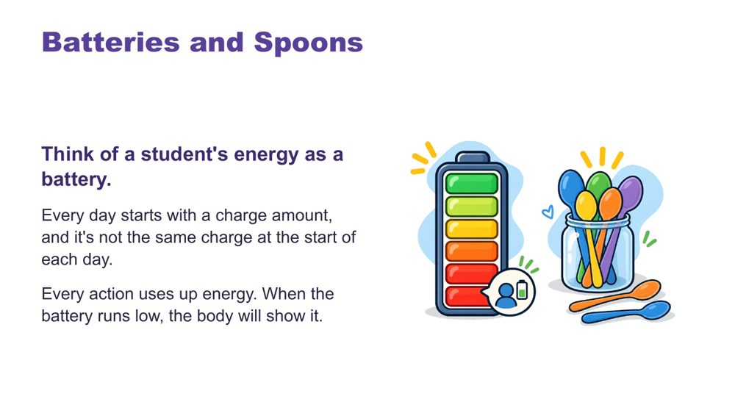 | Batteries and spoons  SUGGESTED TIME  2 min  CLOCK  11:37 - 11:39

Give a shared language for energy and capacity.
WHAT TO DO  - Talk through the battery image.  - Introduce spoons as language many in the Autistic community use.  - Close on recharging: the right supports can restore some capacity. | KEY MESSAGES  - Each day starts with a different charge.  - The right supports can recharge.

YOU MIGHT SAY
Think of a student's energy as a battery. Every day starts with a charge amount, and it's not the same charge at the start of each day. Every action uses up energy. When the battery runs low, the body will show it.
In the Autistic community, many like to describe this as having a set of spoons. Each action uses up one or some spoons. When "spoons are low", actions are hard to manage.
You can recharge! The right supports can regain some battery charge or extra spoons.

SESSION 3 | Autistic Experience at School | SLIDE 16 of 27

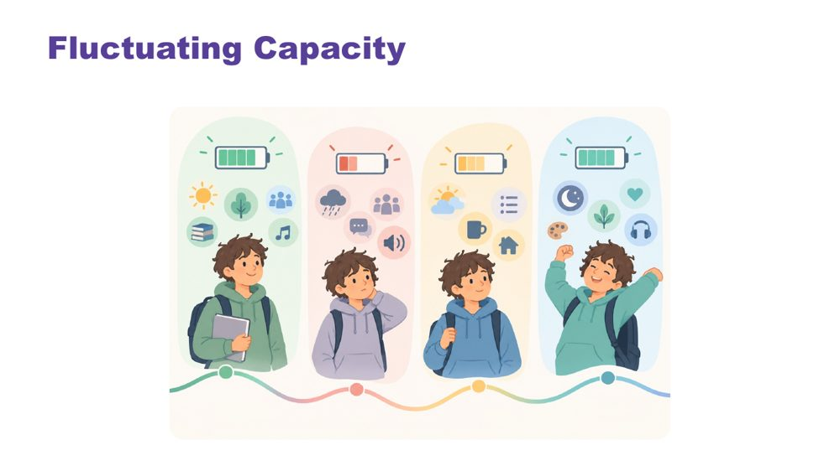 | Fluctuating capacity  SUGGESTED TIME  2 min  CLOCK  11:39 - 11:41

Name that capacity changes from day to day.
WHAT TO DO  - Explain that capacity changes with stress, energy, sensory demands and what else is happening. | KEY MESSAGES  - Capacity is not fixed. The same student may manage something one day and not the next.

YOU MIGHT SAY
Like all people, Autistic students have good days and harder days. Their ability to manage school, social situations, communication, or daily tasks may change depending on stress, energy levels, sensory demands, and what else is happening in their life.

SESSION 3 | Autistic Experience at School | SLIDE 17 of 27

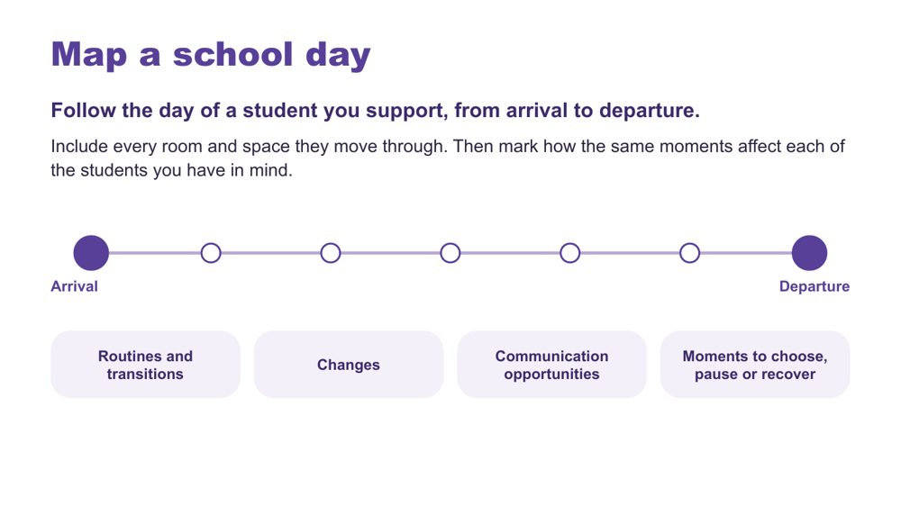 | Map a school day  SUGGESTED TIME  7 min  CLOCK  11:41 - 11:48  GROUPING  On your own  PARTICIPANT GUIDE  Page 13 - Map a school day

Follow the day of a student participants support through every room and space, then mark how the same moments affect each of the students they have in mind.
WHAT TO DO  - Ask participants to follow the day of a student they support, from arrival to departure.  - Ask them to include every room and space the student moves through, not only the classroom: for example specialist lessons, the playground or yard, the library, the canteen, corridors and the bus bay or pick-up area.  - Give a primary and a secondary example if it helps. In primary: the classroom, a library lesson, recess, a specialist lesson after lunch. In secondary: a different room and teacher each period, lockers, corridors between periods, lunch in the yard.  - Ask them to mark routines and transitions (R), changes (C), communication opportunities (T), and moments to choose, pause or recover (P).  - Ask them to mark how the same moments affect each of the students they have in mind.  - If participants only support a student for part of the day, ask them to map what they see and add questions for the rest.  - Link to cognitive load and capacity from the previous slides.  - Leave room to add costs and lighteners on the next slide. | KEY MESSAGES  - The map is a working picture to extend, not a judgement of the student or school.  - Support staff often see the moves between rooms and spaces that no single teacher sees.

ACTIVITY | Individual map with optional paired discussion on your own · about 6 minutes
Follow the day of a student you support, from arrival to departure. Include every room and space they move through. How do the same moments affect each of the students you have in mind?
- Draw a simple timeline from arrival to departure, or use the table on p. 13.
- Add the rooms, spaces, routines and transitions you see.
- Mark R, C, T and P where they apply.
- Mark how each of the students you have in mind experiences the same moments.
- Keep the map private unless you choose to discuss it.
Close: The map is a working picture to extend, not a judgement of the student or school.

KEEP IN MIND
- Avoid names, school identifiers or unique incidents.
- Include communication opportunities, sensory demands, task changes, waiting, movement, breaks and recovery only where participants identify them from their context.
- Remind participants that gaps in what they know about a student's experience are useful questions to carry forward.

Thread Session 4 builds on this map. The audit across settings later in this session returns to the same rooms and spaces.

SESSION 3 | Autistic Experience at School | SLIDE 18 of 27

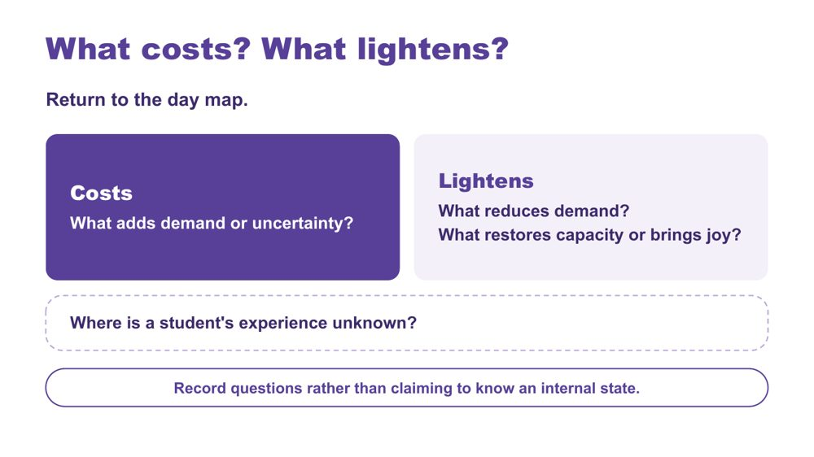 | What costs? What lightens?  SUGGESTED TIME  5 min  CLOCK  11:48 - 11:53  GROUPING  On your own  PARTICIPANT GUIDE  Page 14 - What costs? What lightens?

Extend the day map to show demand, relief and what is not yet known.
WHAT TO DO  - Ask participants to return to the day map.  - Ask them to mark what adds demand or uncertainty (costs).  - Ask them to mark what reduces demand, restores capacity or brings joy (lightens).  - Ask them to add questions where a student's experience is unknown.  - Link back to the battery language: what drains, what recharges. | KEY MESSAGES  - A single moment sits within the demands and supports accumulated across the day.  - The map should include what lightens and restores as well as what costs.  - Record questions rather than claiming to know an internal state.

ACTIVITY | Extend the school-day map on your own · about 4 minutes
What costs? What lightens? Where is a student's experience unknown?
- Use one mark or colour for what costs.
- Use another for what lightens or restores.
- Add questions where the student's experience is not known.
Close: Look for patterns across the day and between settings. They will inform the audit across settings.

KEEP IN MIND
- Do not turn the map into a score or a claim about internal state.
- Do not infer a student's internal state from a single behaviour or moment.
- Include strengths, joy, safe connection and belonging alongside costs.

Background Something can be enjoyable, valued or successfully completed and still require considerable effort. What costs or lightens will differ between students, and may differ for the same student across contexts and days.

SESSION 3 | Autistic Experience at School | SLIDE 19 of 27

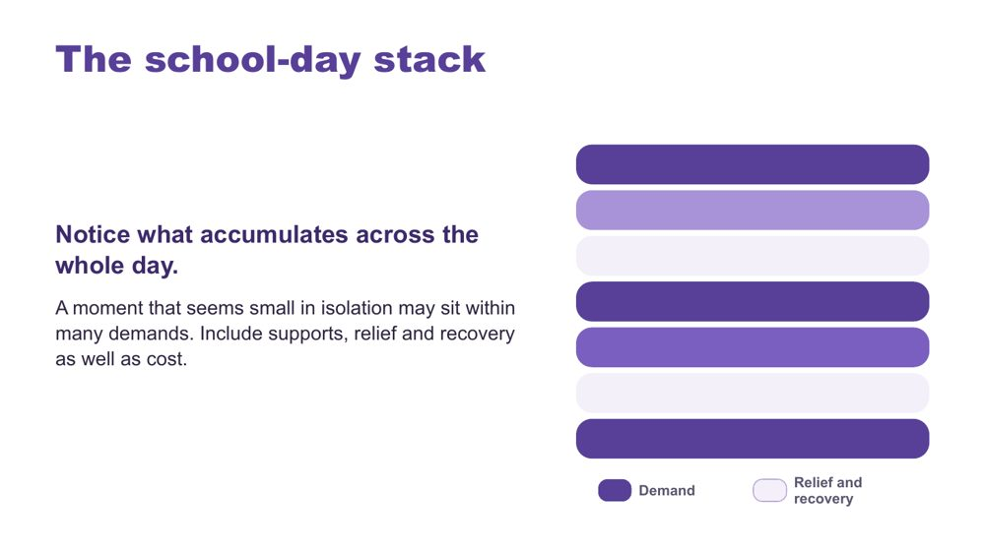 | The school-day stack  SUGGESTED TIME  2 min  CLOCK  11:53 - 11:55

Show how demand accumulates across the whole day.
WHAT TO DO  - Use the stack model as presented.  - Point out that darker bars show demand and lighter bars show relief and recovery.  - Keep the discussion qualitative. | KEY MESSAGES  - A moment that seems small in isolation may sit within many demands.  - Include supports, relief and recovery as well as cost.  - Support staff may be able to connect what happens in different parts of the day, because they see more of it.

KEEP IN MIND
- The stacked bars are a visual cue only. Do not score students.

SESSION 3 | Autistic Experience at School | SLIDE 20 of 27

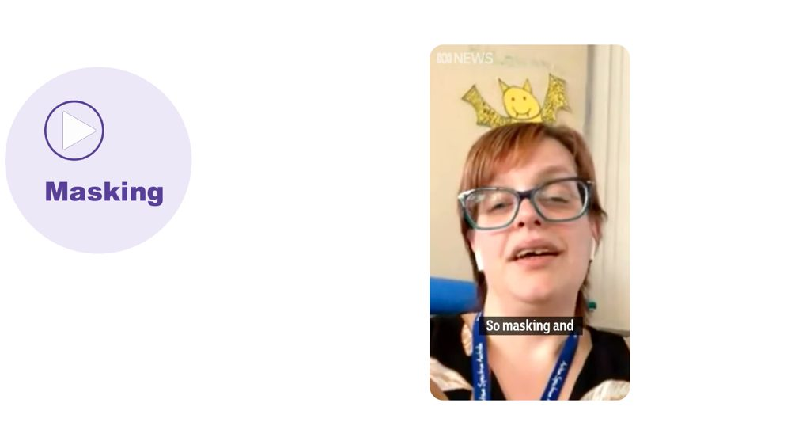 | Masking  SUGGESTED TIME  4 min  CLOCK  11:55 - 11:59

Introduce masking as another thing that draws on a student's battery.
WHAT TO DO
- Link from the stack: there are other things that can affect batteries or spoons.
- Play the masking video.

YOU MIGHT SAY
There are other things that can affect our batteries or spoons. Let's watch a video about masking.

SESSION 3 | Autistic Experience at School | SLIDE 21 of 27

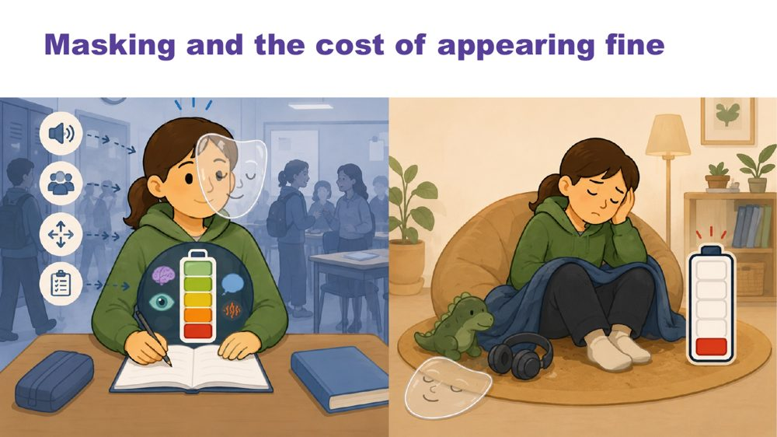 | Masking and the cost of appearing fine  SUGGESTED TIME  2 min  CLOCK  11:59 - 12:01

Name what may be missed if educators look only at outward behaviour.
WHAT TO DO  - Introduce masking in relation to identity and belonging.  - Pose the four questions to the room to think about.  - Ask what may be missed if we look only at outward behaviour or task completion. | KEY MESSAGES  - Outward behaviour does not show everything a student is managing.  - What is visible does not give a complete account of capacity, identity or belonging.

KEEP IN MIND
- Avoid assuming that a student is coping because they are quiet, compliant or completing work.
- Include strengths, joy, safe connection and belonging alongside costs.

Background Prompts to pose: What might the student be working hard to manage or hide? Where can they be recognised and included? What supports belonging without requiring them to appear less Autistic? What does the student want others to understand?

SESSION 3 | Autistic Experience at School | SLIDE 22 of 27

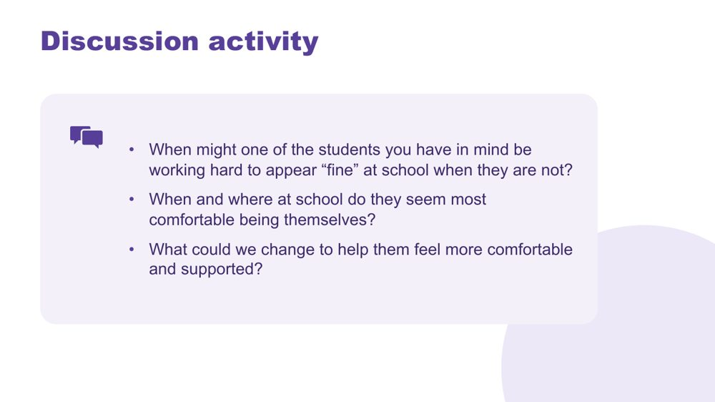 | Discussion activity: masking  SUGGESTED TIME  4 min  CLOCK  12:01 - 12:05  GROUPING  Pairs  PARTICIPANT GUIDE  Page 12 - Masking discussion

Apply masking to the students participants have in mind.
WHAT TO DO
- Put participants in pairs.
- Work through the three questions on the slide.
- Bring the room back and take one or two responses on what could change.

ACTIVITY | Guided discussion pairs · about 3 minutes
When might one of the students you have in mind be working hard to appear "fine" at school when they are not?
- When might one of the students you have in mind be working hard to appear "fine" at school when they are not?
- When and where at school do they seem most comfortable being themselves?
- What could we change to help them feel more comfortable and supported?
Bring the room back
- What could we change to help them feel more comfortable and supported?
- Which of these is within your role, and which would you raise with the teacher?

KEEP IN MIND
- Avoid assuming that a student is coping because they are quiet, compliant or completing work.
- Keep examples anonymised.
- Support staff sometimes see a student relax in one space and hold it together in another. That difference is useful to share with the teacher.

SESSION 3 | Autistic Experience at School | SLIDE 23 of 27

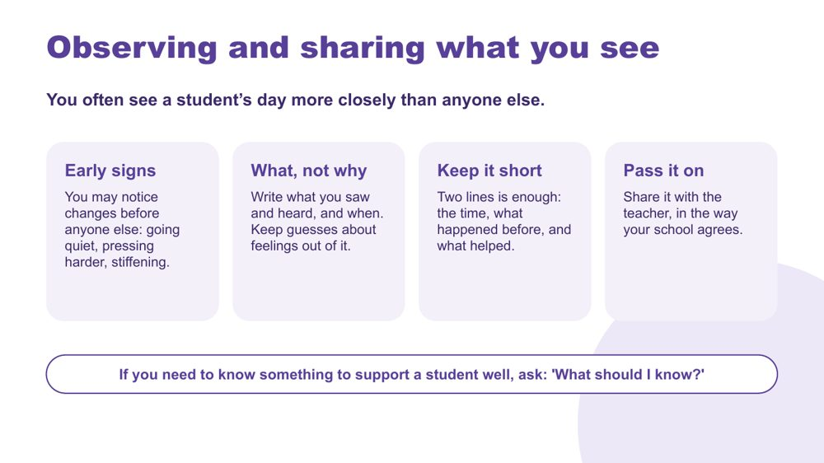 | Observing and sharing what you see  SUGGESTED TIME  6 min  CLOCK  12:05 - 12:11  GROUPING  On your own, then pairs  PARTICIPANT GUIDE  Page 10 - Session 3 summary: Observing and sharing what you see

Recognise support staff observations as valuable information, and practise turning one observation into a short note for the teacher.
WHAT TO DO  - Acknowledge that support staff often see a student's day more closely than anyone else, from one hour to the next and across different rooms.  - Walk through the four cards: early signs, what not why, keep it short, pass it on.  - Link early signs back to internal signals and early signs of overwhelm from Session 2.  - Ask participants to think of one moment from a recent day with one of the students they have in mind, and write a two-line note about it on a sticky note or scrap paper.  - Give 2 minutes to write, then 1 minute to compare with a partner. Ask: is it what you saw and heard, and when? Is there a guess about feelings you could take out?  - Read out the professional ask at the bottom of the slide: "What should I know to support them well?" Ask participants to say it in their own words to their partner.  - Take one or two responses. | KEY MESSAGES  - Support staff observations are valuable information for planning.  - Keep what you saw and heard separate from what you think it meant.  - A short note is more likely to be read and used than a long one.  - Share observations with the teacher in the way your school agrees.

YOU MIGHT SAY
You often see a student's day more closely than anyone else. You may be the first to notice a change: going quiet, pressing harder on the pencil, stiffening. That makes what you see useful information for the teacher.
Write what you saw and heard, and when. Keep guesses about feelings out of it. Two lines is enough: the time, what happened before, and what helped.
You may not be told everything about a student, and that is often appropriate. If you need to know something to support a student well, you can ask: "What should I know to support them well?"

ACTIVITY | Two-line note, then compare in pairs on your own, then pairs · about 4 minutes
Think of one moment from a recent day with one of the students you have in mind. Write a two-line note for the teacher on a sticky note or scrap paper.
- Write the time and where it was.
- Write what happened before, what you saw and heard, and what helped.
- Take out any guesses about feelings. Keep questions as questions.
- Compare with a partner.
Bring the room back
- What made the note useful to a teacher?
- What was hard to leave out?
Close: Share observations through the process your school uses.

KEEP IN MIND
- Keep all examples de-identified. Use a composite if easier.
- Refer participants to their school's own recording and communication process. Do not present a universal form.
- Never encourage participants to seek confidential information. The ask is about what they need to know to do their role well. They do not need a diagnosis or history to support the needs they observe.
- Some participants may feel they are not told enough to do their job well. Acknowledge this. If information sharing regularly leaves them without what they need, suggest they raise it through their school's usual pathway.
- The teacher plans adjustments. Support staff observations help the teacher plan and review them.

Background An example of a two-line note: "Period 3, after the move from the science room. Put head down and stopped writing at 11:20. Back to work after 5 minutes at the side desk with headphones." A note that says "was anxious all morning" gives the teacher a conclusion but not the information behind it. Include what helped as well as what was hard.
Thread Session 5 returns to how information travels between staff, families and the student. The observation habits from this slide feed the audit across settings.

SESSION 3 | Autistic Experience at School | SLIDE 24 of 27

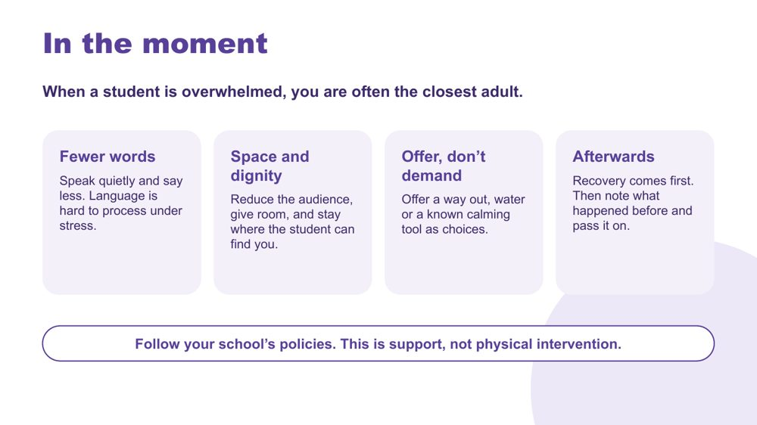 | In the moment  SUGGESTED TIME  6 min  CLOCK  12:11 - 12:17  PARTICIPANT GUIDE  Page 10 - Session 3 summary: In the moment

Share practical, low-demand ways to support a student who is overwhelmed, within the support staff role and school policy.
WHAT TO DO  - Acknowledge that support staff are often the closest adult when a student becomes overwhelmed.  - Link to the early signs on the previous slide and in Session 2.  - Walk through the four cards: fewer words, space and dignity, offer don't demand, afterwards.  - Try one quick wording example with the room. Read a typical long adult response, then ask the room to cut it to a few words.  - Ask participants to think quietly about one of the students they have in mind: What does the student's plan ask you to do? What is unclear? Who do you contact?  - Read the line at the bottom of the slide: follow your school's policies; this is support, not physical intervention. | KEY MESSAGES  - Fewer words, a quieter voice and more space reduce demand.  - Protect the student's dignity: reduce the audience and do not crowd.  - Offer choices rather than giving instructions.  - Recovery comes before any talk about what happened. Then note what came before and pass it on.  - This is support, not physical intervention. Follow the student's plan and your school's policies.

YOU MIGHT SAY
When a student is overwhelmed, you are often the closest adult. What you do in those first moments matters.
Speak quietly and say less. Language is hard to process under stress.
Reduce the audience, give room, and stay where the student can find you.
Offer a way out, water or a known calming tool, as choices.
Afterwards, recovery comes first. Talking about what happened can wait. Then note what happened before and pass it on.
Everything here sits inside your school's policies and the student's plan.

KEEP IN MIND
- This content is support only. Do not discuss restraint or physical intervention. Refer participants to their school's policies and the student's plan.
- Do not teach a universal script, position or sequence. What helps is individual to the student.
- Do not role-play distress or ask participants to describe a student's distress in detail.
- Some participants may have had difficult experiences. Acknowledge this and keep the focus on what helps.
- If a participant raises an immediate safety or wellbeing concern, follow the host organisation's process.
- Questions about safety or what to do when the plan is unclear belong with the appropriate person in the participant's school.

Background Wording example to use with the room. Long: "Hey, what's going on? You need to take some deep breaths and tell me what's wrong, because I can't help you unless you talk to me." Shorter: "I'm here. Water?" or "Quiet room or stay here?" The shorter version gives less to process and offers a choice. Stay where the student can find you means staying nearby and available without crowding or standing over them.
Thread The note taken afterwards is the same kind of short, factual observation practised on the previous slide.

SESSION 3 | Autistic Experience at School | SLIDE 25 of 27

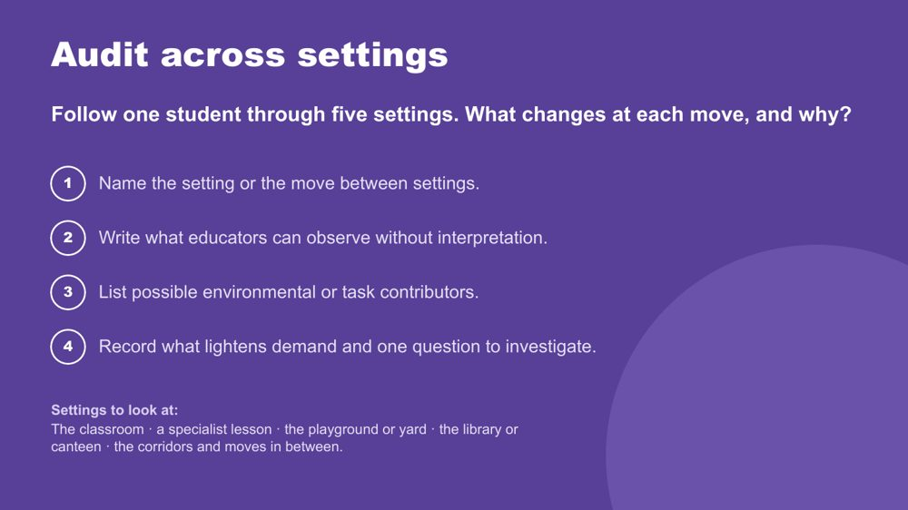 | Audit across settings  SUGGESTED TIME  7 min  CLOCK  12:17 - 12:24  GROUPING  On your own  PARTICIPANT GUIDE  Page 15 - Audit across settings

Follow one student through five settings and look at what changes at each move, and why.
WHAT TO DO  - Ask participants to choose one of the students they have in mind and use their day map.  - Read the settings at the bottom of the slide: the classroom, a specialist lesson, the playground or yard, the library or canteen, and the corridors and moves in between.  - Walk through the four steps on the slide.  - Ask them to look closely at each threshold, the point where the student moves from one setting to the next. What changes in noise, people, instructions, expectations and the support available? Does the student's visual schedule or communication system travel with them?  - Ask them to write what they can observe without interpretation, then look at the environment, task, timing and communication before the student.  - Ask participants to identify one thing worth sharing with the teacher. | KEY MESSAGES  - A student's experience can change when the setting, task, people or support changes.  - Thresholds and handovers between settings are useful places to observe and ask questions.  - Support staff often see the moves between settings that no single teacher sees.  - Consistency across settings depends on communication across the team.

YOU MIGHT SAY
Follow one student through five settings. What changes at each move, and why?
A difference in how a student takes part may tell us something about the setting as well as the student.

ACTIVITY | Audit across settings on your own · about 6 minutes
Follow one student through five settings. What changes at each move, and why?
- Name the setting or the move between settings.
- Write what educators can observe without interpretation.
- List possible environmental or task contributors.
- Record what lightens demand and one question to investigate.
Close: Choose one setting or move to carry into design before lunch.

KEEP IN MIND
- Keep all examples anonymised.
- Look at the environment, task, timing, communication and expectations before the student.
- Keep examples setting-neutral, or offer both: in primary, the walk from the classroom to the library; in secondary, the change between periods and the corridor at the bell.
- Participants may not see every setting. Ask them to record a question for the settings they do not see.

Background Participants do not need to fill in all five settings. Two or three settings with a clear threshold between them is enough for the activity.
Thread Feeds the Reduce item on the Carry into design card, and the design work in Session 4.

SESSION 3 | Autistic Experience at School | SLIDE 26 of 27

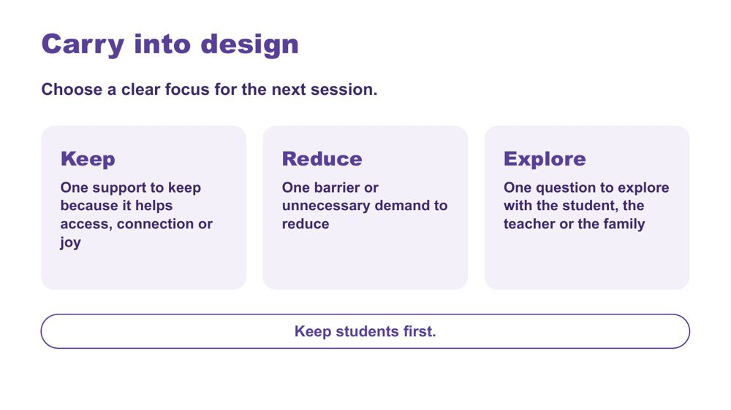 | Carry into design  SUGGESTED TIME  3 min  CLOCK  12:24 - 12:27  GROUPING  On your own  PARTICIPANT GUIDE  Page 16 - Carry into design

Consolidate the school-day inquiry and choose a focus for Session 4.
WHAT TO DO  - Invite participants to identify one support to keep, one barrier to reduce and one question to explore.  - Ask participants to tick whether their Reduce item is in class, between settings, or in breaks and play. They will use this to find a corner in Session 4.  - Keep responses private unless participants choose to share.  - Ask participants to keep their map and audit for the design activity.  - Explain that after lunch, participants will look at support that builds independence, working within what the teacher has planned.  - Point out lunch at 12:30 - 1:00 and the 1:00 return. | KEY MESSAGES  - Design should protect what supports access, connection and joy as well as reduce barriers.  - Unanswered questions can guide conversations with the student, the teacher and the family.  - Small changes to the environment, communication or the day can make a real difference to access.  - Keep students first.

ACTIVITY | Carry into design card (Keep, Reduce, Explore) on your own · about 3 minutes
Choose a clear focus for the next session.
- Keep: one support to keep because it helps access, connection or joy.
- Reduce: one barrier or unnecessary demand to reduce.
- Tick: in class, between settings, or breaks and play.
- Explore: one question to explore with the student, the teacher or the family.
Close: Keep your map and audit for the design activity after lunch.

KEEP IN MIND
- If participants ask how to decide what counts as an unnecessary demand, suggest a demand that is not needed for the learning or for the student to take part, for example copying a long task from the board when a printed copy would do the same job.
- Keep the Reduce item within what support staff can do or suggest to the teacher.

Thread Leads directly into the Session 4 design brief. The three tick boxes match the three corners in Session 4.

SESSION 3 | Autistic Experience at School | SLIDE 27 of 27

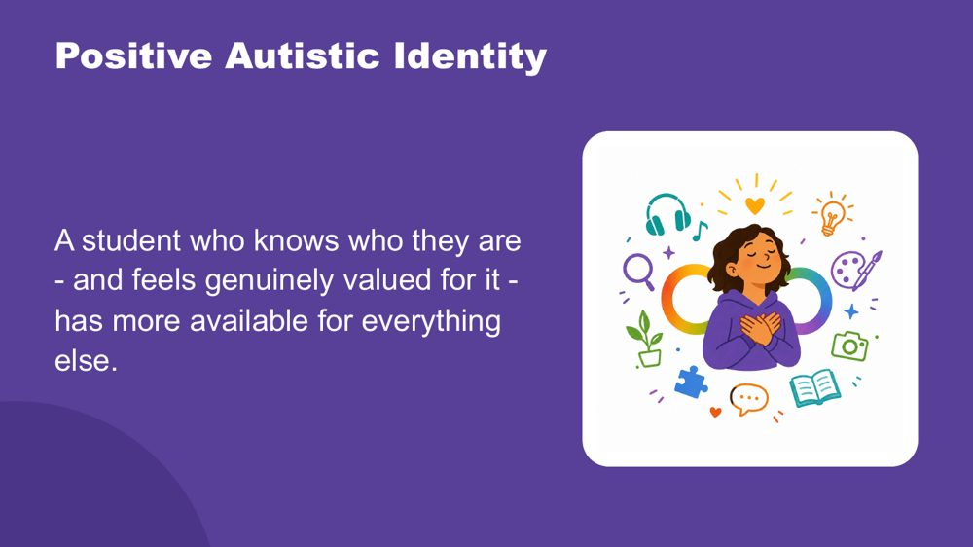 | Positive Autistic identity  SUGGESTED TIME  3 min  CLOCK  12:27 - 12:30

Close the morning by returning to the students participants have in mind, seen now with a fuller picture.
WHAT TO DO  - Wait for the room to settle before you begin.  - Read the spoken close slowly, with the image on the screen.  - The opening paragraph draws together what Sessions 2 and 3 covered.  - Pause briefly at the end before speaking again.  - Release to lunch. | KEY MESSAGES  - The cost is wider than masking. Students are managing the whole of their Autistic experience in a world that was not designed for it.  - Positive Autistic identity is a research-supported protective factor for mental health and wellbeing.  - Belonging is the precondition. When identity does not need to be managed on top of everything else, those resources become available for learning and connection.  - Agency is protective. Genuine choice over their own environment reduces cost directly.  - Autistic community connection is itself protective. Knowing other Autistic people share your experience matters.  - Identity, belonging and agency are the conditions that make learning and connection possible.

YOU MIGHT SAY
This morning, across Sessions 2 and 3, you have been building a picture of the students you have in mind.
How the world arrives through their senses, more fully, more specifically, less filtered. How their brain builds understanding from the detail up, focuses deeply, and thinks in ways that produce real and specific strengths. How their internal world works. How they reach toward other people, and what that costs when the conditions are not designed for them.
Managing all of that, every day, in a world that was largely built for a different nervous system, takes resources. Sensory management. Social interpretation. Executive effort. Communication across a gap. Holding it together when the signals inside are not arriving clearly. And sometimes, performing fine when fine is not what is happening.
A student who knows who they are - and feels genuinely valued for it - has more of those resources available for everything else.
Research supports what many Autistic adults already know: a positive sense of Autistic identity is connected to better mental health, less anxiety, and greater wellbeing. Belonging is the precondition for all of it. When a child does not need to spend resources managing their identity on top of everything else, those resources become available for learning, connection, and self-knowledge.
Agency matters too: genuine choice over how they communicate, where they sit, when they step back. And knowing that other Autistic people share their experience, that Autistic adults have found belonging and purpose, is protective in its own right.
These students are not alone. Other Autistic people share their experience.
You can help them know themselves, and know that who they are is valued.

KEEP IN MIND
- The opening paragraph draws together what Sessions 2 and 3 covered. Let participants make the connections themselves rather than telling them what to conclude.
- Some participants may need a moment after the final sentence. Give them that time before releasing to lunch.

Background Research on Autistic identity and wellbeing consistently shows that positive Autistic identity, knowing yourself as Autistic and valuing that, is associated with better mental health outcomes, reduced anxiety and greater resilience. This is distinct from general self-esteem: it is specifically the sense of Autistic identity as something to know and value, not manage or minimise, that provides protection. Belonging to Autistic peer networks amplifies this effect. The goal is for each student to know who they are, and to find the people and places where that is valued.
Thread Echoes the opening image of Session 2: the child coming into focus, piece by piece. The facilitator does not need to name this.

SESSION  4 | 1:00 - 2:15 · 75 MINUTES · 22 SLIDES  Learning Design  Support that builds independence

SESSION INTENT
Participants move from understanding to design by working on one support moment they give. Using the independence ladder (doing for, helping, prompting, coaching, on their own), each person writes a brief, chooses from a short options menu, checks the design for accessibility and plans one step up the ladder, with help from a trio. Each person then privately tests the plan against the two or three students they have in mind, which opens the continuum of support, before a gallery walk and a personal commitment that includes a conversation with the teacher.
PARTICIPANTS LEAVE WITH
- place a support they give on the independence ladder and write a brief for one step more independence, free from blame or deficit labels
- choose one or two options, including designed distance and the five moves within their role, that help that step
- check the plan against the students they have in mind and locate where targeted or individual support begins on the continuum
- leave with one support to fade, one thing to notice and one conversation to have with the teacher

RUN SHEET
Clock | Segment | Slides | Minutes
1:00 - 1:04 | Welcome and Students come first | 1-2 | 4
1:04 - 1:14 | Start: Scaffold, don't substitute, session map and regroup | 3-6 | 10
1:14 - 1:20 | Brief | 7 | 6
1:20 - 1:34 | Options | 8-13 | 14
1:34 - 1:41 | Universal first | 14-15 | 7
1:41 - 1:53 | Design | 16 | 12
1:53 - 1:59 | Check | 17 | 6
1:59 - 2:06 | Continuum | 18-20 | 7
2:06 - 2:15 | Gallery and commit | 21-22 | 9

PREPARE
☐ Signs for three corners of the room: In class, Between settings, Breaks and play.
☐ A3 Independence ladder sheet (PL Support Staff - Session 4 - Independence ladder sheet): one per person, sections 1 - 4 on page 1 and the "My students" cards on page 2.
☐ Printed option cards on each table (Five moves that belong to you, Predictability, Designed distance, Visual supports and social stories).
☐ Post-it notes and wall space to display A3 designs for the gallery walk.
☐ Ask participants to bring their Session 3 Carry into design card (PL Support Staff - Session 3 - Carry into design card), school-day map and audit across settings.
☐ Visual Supports Checklist and details of the visual supports webinar.
☐ Current official NCCD information to point participants to.

SESSION 4 | Learning Design | SLIDE 1 of 22

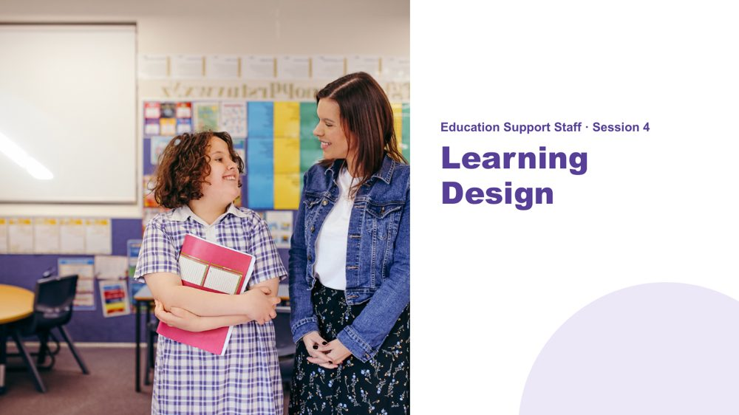 | Session 4 / Learning Design  SUGGESTED TIME  2 min  CLOCK  1:00 - 1:02  PARTICIPANT GUIDE  Page 17 - Session 4 summary

Shift from understanding the student's day to designing support that builds independence.
WHAT TO DO  - Welcome participants back from lunch.  - Ask them to have their Session 3 Carry into design card, school-day map and audit across settings to hand.  - Name the focus of the session: the support you give, and how it can help a student do a little more on their own.  - Explain that each person will leave with one support moment planned one step towards independence.  - Keep the focus on how support is given and on the environment, task and routine, rather than on changing the student. | KEY MESSAGES  - What we know about students informs design; it is not a list of deficits.  - The session works on the part of the day support staff shape most directly: how support is given.

Thread Picks up the school-day map, audit across settings and Carry into design card from Session 3.

SESSION 4 | Learning Design | SLIDE 2 of 22

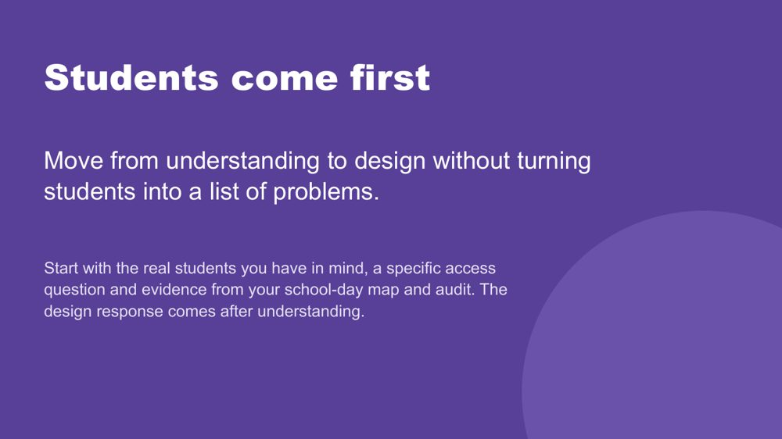 | Students come first  SUGGESTED TIME  2 min  CLOCK  1:02 - 1:04

Set the principle that understanding real students comes before any design response.
WHAT TO DO  - Point to the students participants have in mind and their school-day map from Session 3.  - Name that each person designs one change to a support they give, then checks it against the two or three students they have in mind.  - Remind participants to include only what is known, and to hold unknowns as questions.  - Ask participants to separate an observation from an interpretation, and a question from a conclusion. | KEY MESSAGES  - Understand the student before choosing a strategy.  - A design brief connects what matters for the student with what can change in the support, task or routine.  - Unknowns remain questions for the student, the teacher or the family.

KEEP IN MIND
- Do not use what is known about students to diagnose, rank or reduce them to support needs.

Thread Draws on the school-day map from Session 3.

SESSION 4 | Learning Design | SLIDE 3 of 22

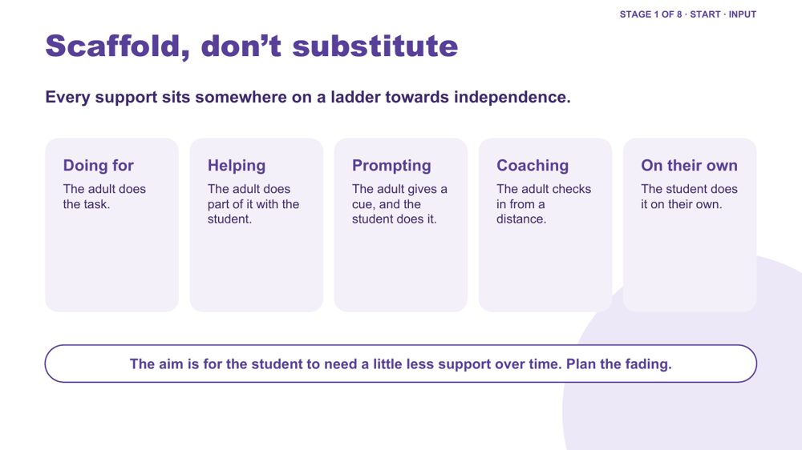 | Scaffold, don't substitute  SUGGESTED TIME  4 min  CLOCK  1:04 - 1:08

Introduce the independence ladder as the central model for this session: every support sits somewhere on it, and fading is planned.
WHAT TO DO  - Walk the five rungs on the slide: doing for, helping, prompting, coaching, on their own.  - Run one worked example up the ladder using the background below. Choose the primary or secondary example to suit the room, or give both briefly.  - Ask participants to think of one support they gave this week and where it sat on the ladder. Take 2-3 responses.  - Name that the aim is for the student to need a little less support over time, and that this fading is planned and agreed with the teacher and the student.  - Acknowledge that many support staff have been thanked for being the person a student relies on. Name the care in that, then say that this session points that care towards the student needing you a little less. | KEY MESSAGES  - Every support sits somewhere on a ladder towards independence.  - The aim is for the student to need a little less support over time. Plan the fading.  - The ladder is a prompt for planning and reflection. It is not an automatic timetable for removing support.  - A student may need different levels of support across tasks, settings and days.

YOU MIGHT SAY
Every support you give sits somewhere on this ladder. The question for any moment is whether what I am doing is helping the student move up a step, or keeping them where they are.
Fading support is a skill. It often takes more thought to prompt less than to do more.

KEEP IN MIND
- This can sting for staff who have been praised for being indispensable. Honour the care in that work while redirecting the goal.
- Do not present the ladder as a judgement of the student or an instruction to remove support. Needed support can stay, change or return.
- Changes to support are agreed with the teacher and the student, not made by one person alone.

Background Primary example, starting a writing task. Doing for: the adult gets the book out, finds the page and writes the date. Helping: the adult finds the page and the student writes the date. Prompting: the adult points to the book and the first step on the board, and the student starts. Coaching: the adult checks in from across the room once the student has started. On their own: the student starts from the first-step card on their desk. Secondary example, starting a task in a computer-based lesson: the adult logs in and opens the file; then the adult logs in and the student opens the file; then the adult points to the written steps; then the adult checks in after five minutes; then the student works from the steps without the adult.
Thread The ladder returns in Stage 5 (One step up the ladder) and the commitment at the end of the session.

SESSION 4 | Learning Design | SLIDE 4 of 22

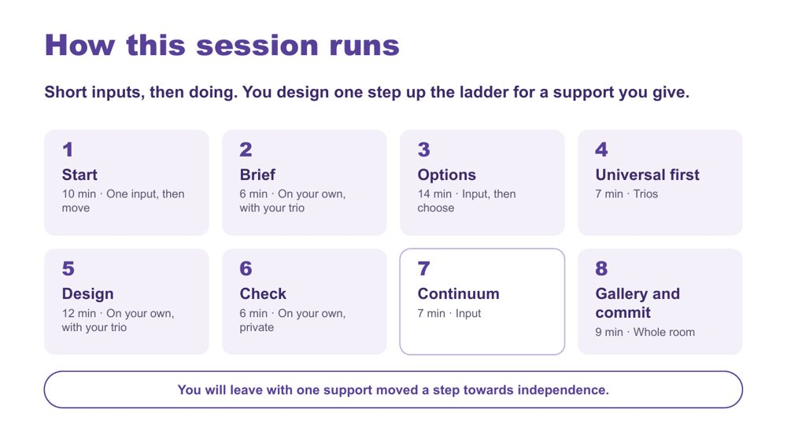 | How this session runs  SUGGESTED TIME  1 min  CLOCK  1:08 - 1:09

Show the rhythm of the session: short inputs, then doing, with each person designing for a support they give.
WHAT TO DO  - Walk the eight stages briefly: Start, Brief, Options, Universal first, Design, Check, Continuum, Gallery and commit.  - Name that each person works on their own support moment, and the trio helps them sharpen it.  - Name the end point: one support moved a step towards independence, checked against real students, and one thing to try. | KEY MESSAGES  - Short inputs, then doing.

YOU MIGHT SAY
We move, we each write a brief about one support we give, we listen briefly for options, we design one step up the ladder, we check the plan against our own students, and we finish with a gallery and a commitment.

Background The eight stages total 71 minutes; the title and Students come first slides take the other 4 minutes.

SESSION 4 | Learning Design | SLIDE 5 of 22

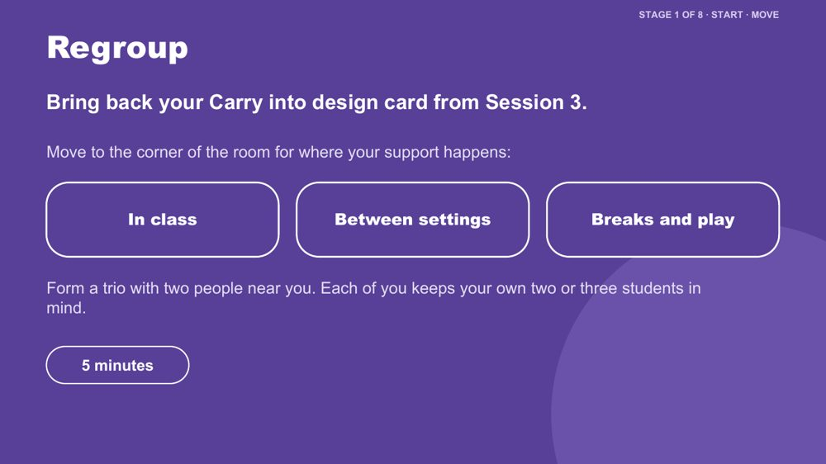 | Regroup  SUGGESTED TIME  4 min  CLOCK  1:09 - 1:13  GROUPING  Trios  PARTICIPANT GUIDE  Page 16 - Carry into design (from Session 3)

Get the room moving after lunch and form trios around where support happens.
WHAT TO DO  - Ask participants to find their Session 3 Carry into design card, and the "Reduce" box they ticked: in class, between settings, or breaks and play.  - Point to the three corners: In class, Between settings, Breaks and play.  - Ask people to move to the corner that matches where their support happens.  - Ask them to form trios with people nearby.  - Split a crowded corner; fold anyone on their own into the nearest trio.  - Hand out one A3 Independence ladder sheet per person. | KEY MESSAGES  - Each person designs for a support they give; the trio helps each person sharpen their thinking.

ACTIVITY | Corners-of-the-room regroup trios · 5 minutes (including the slide 6 reminder)
Move to the corner for where your support happens and form a trio.
- Bring back your Carry into design card from Session 3.
- Move to the corner for where your support happens: in class, between settings, or breaks and play.
- Form a trio with two people near you.
- Each person keeps their own two or three students in mind.
Close: Every person has an A3 Independence ladder sheet and is in a trio.

KEEP IN MIND
- Participants who work across several classes or settings can choose the corner for the support they most want to work on.

Thread Uses the Session 3 Carry into design card.

SESSION 4 | Learning Design | SLIDE 6 of 22

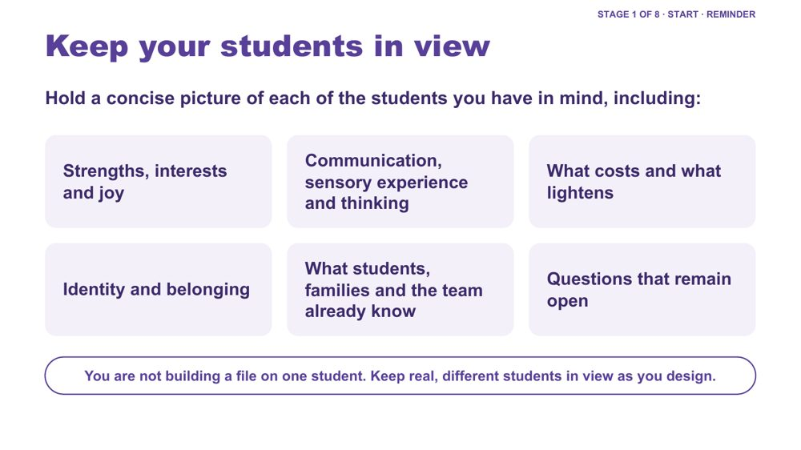 | Keep your students in view  SUGGESTED TIME  1 min  CLOCK  1:13 - 1:14

A quick reminder to hold a concise picture of each student in mind while designing.
WHAT TO DO  - Keep this to about one minute, inside the Start stage.  - Run through the areas on the slide as prompts, not a form to fill in.  - Name that participants will use these students in Stage 6, the private check.  - Remind participants that support staff often see a student across many rooms and spaces of the day. That view is useful here. | KEY MESSAGES  - You are not building a file on one student. Keep real, different students in view as you design.  - Include strengths, interests and joy, communication, sensory experience, thinking, costs, what lightens, identity and belonging only where these are known or framed as questions.

KEEP IN MIND
- Do not use this to diagnose, rank or reduce students to support needs.
- Participants only need what they already know to do their role. This is not a prompt to seek out confidential information.

SESSION 4 | Learning Design | SLIDE 7 of 22

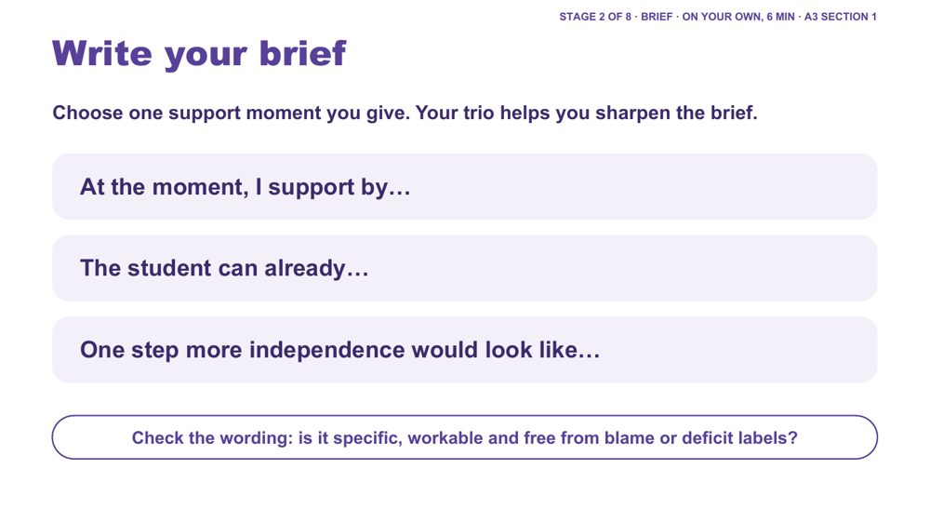 | Write your brief  SUGGESTED TIME  6 min  CLOCK  1:14 - 1:20  GROUPING  On your own, with your trio  PARTICIPANT GUIDE  Page 18 - My brief

Each person chooses one support moment they give and writes a short brief for one step more independence.
WHAT TO DO  - Ask each person to choose one support moment they give. It can start from the "Reduce" box on their Carry into design card: think of a demand the student currently meets with your help, and the support you give there.  - Ask them to complete the three stems on their A3 sheet, section 1.  - Give 4 minutes on their own, then 2 minutes for each person to read their brief to the trio and take one suggestion.  - Give an example if needed, using the background below.  - Check that the brief describes what the student can already do, not only what they cannot.  - Prompt people to remove any wording that blames or labels the student. | KEY MESSAGES  - A good brief starts from what the student can already do.  - Keep it to one step. Fading works best when it is small and planned.

ACTIVITY | Individual brief on the A3 sheet, section 1, with trio help on your own, with your trio · 6 minutes
Choose one support moment you give. Your trio helps you sharpen the brief.
- Choose one support moment you give.
- Tick where it happens: in class, between settings, or breaks and play.
- Complete: "At the moment, I support by..."
- Complete: "The student can already..."
- Complete: "One step more independence would look like..."
- Read your brief to your trio and take one suggestion.
- Check the wording: is it specific, workable and free from blame or deficit labels?
Close: Keep this one brief active for the rest of the session.

KEEP IN MIND
- Watch for observation drifting into interpretation, or questions presented as conclusions.
- Keep student details to initials or roles; the trio does not need identifying information.

Background Example (between settings): "At the moment, I support by walking beside the student from class to the library and telling them what happens next. The student can already find the library and follow the class line. One step more independence would look like the student walking with a peer while I follow a little behind, with the change shown on their visual timetable first."

SESSION 4 | Learning Design | SLIDE 8 of 22

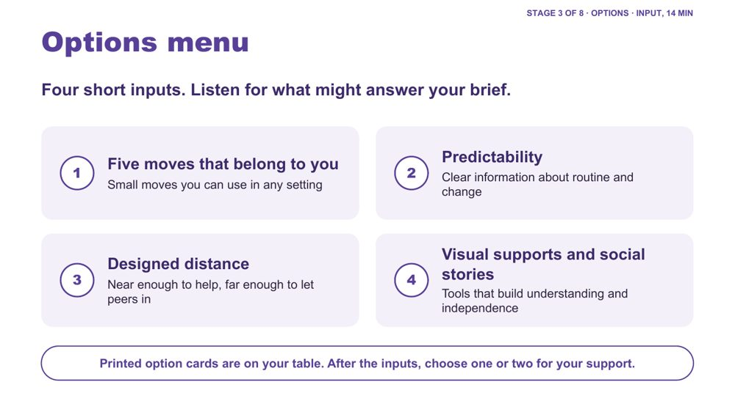 | Options menu  SUGGESTED TIME  1 min  CLOCK  1:20 - 1:21

Frame the four short inputs as a menu that people listen to with their brief in front of them.
WHAT TO DO  - Ask participants to put their brief in front of them.  - Ask them to listen for which option might help with "One step more independence would look like..."  - Point to the printed option cards on each table: they repeat the four headings so people can hold and sort them.  - Keep each of the four inputs to two or three minutes. | KEY MESSAGES  - Listen for what might answer your brief.

SESSION 4 | Learning Design | SLIDE 9 of 22

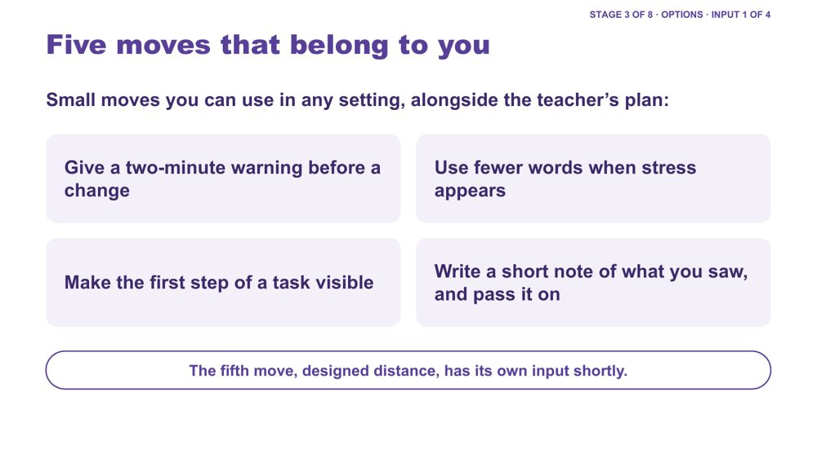 | Five moves that belong to you  SUGGESTED TIME  3 min  CLOCK  1:21 - 1:24

Option 1 of 4: small, practical moves support staff can use in any setting as part of their everyday role.
WHAT TO DO  - Keep this input to about three minutes.  - Take the four moves on the slide one at a time, with one example each from the background below.  - After each move, ask for a quick show of hands: already do it, or could start next week.  - Name that the fifth move, designed distance, has its own input shortly.  - Link the moves to the ladder: each one helps a prompt from a person become something the student can use without the person. | KEY MESSAGES  - These moves are small and within the everyday support role.  - They can be used at any age and in any setting.  - A visible prompt, such as a card or a written first step, is easier to fade than a spoken one.

KEEP IN MIND
- Keep to the moves on the slide rather than expanding into a long list.
- The moves sit alongside the teacher's plan and the student's agreed supports, never instead of them.
- A short observation note records what was seen. Follow the school's usual way of recording and sharing information, and pass notes to the teacher.

Background Two-minute warning: "Two minutes, then we pack up", given even when nobody else has given one, and shown on a timer or card where that helps. Fewer words under stress: when stress appears, shorten sentences, give one instruction at a time and wait. Visible first step: primary, the first step written on a sticky note on the desk; secondary, the first question highlighted or the first step written at the top of the page. Short observation note: two or three lines on what happened, when, what came before and what helped, written as observation rather than interpretation, and passed on to the teacher.
Thread These moves draw on the morning: transitions and change (Session 3), overwhelm and processing (Session 2), and communication across settings (Session 3).

SESSION 4 | Learning Design | SLIDE 10 of 22

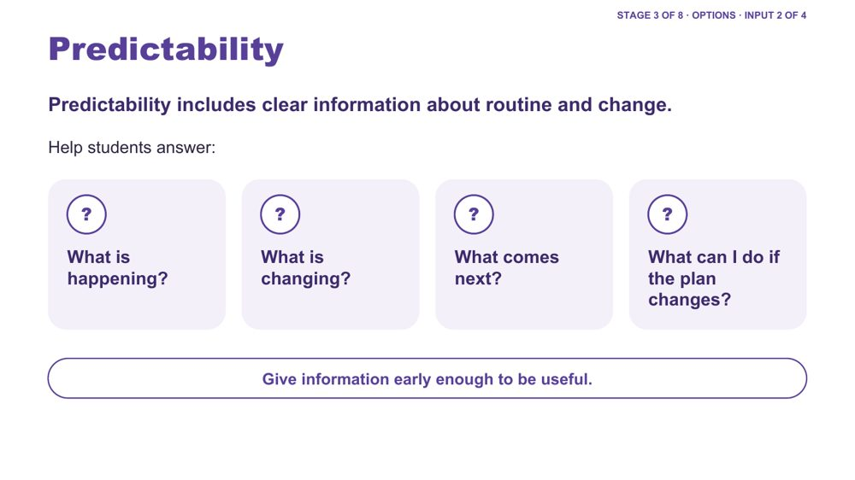 | Predictability  SUGGESTED TIME  2 min  CLOCK  1:24 - 1:26

Option 2 of 4: predictability as access to information about routine and change.
WHAT TO DO  - Keep this input to about two minutes.  - Frame predictability as access to information, not making every day the same or removing unexpected change.  - Draw attention to how much information in a school day is spoken, implied or held by adults.  - Ask: when something in the day changes, how does the student you support find out? Is it usually from you?  - Use the four questions on the slide to examine what information is available to students.  - If needed, use the examples below. | KEY MESSAGES  - Predictability is access to information, not a promise that nothing will change.  - Clear information about change can be just as important as information about routine.  - Information given early enough to be useful helps the student rely less on an adult to explain each change.

YOU MIGHT SAY
If I couldn't rely on remembering what someone had told me, how would I know what was happening today?
Predictability is not the absence of change. It includes having accessible information when change happens.

Background Primary example: assembly is moved earlier than usual. Secondary example: a relief teacher is taking a class, or a lesson moves to a different room. How will the student know the plan has changed? Is the change on their schedule or support? Can they return to that information? Can they see what happens next? Do they have an accessible way to ask a question or say they need more information or support? Students may otherwise be expected to listen, remember, infer or ask in order to know what is happening.
Thread Links back to the Session 3 audit across settings.

SESSION 4 | Learning Design | SLIDE 11 of 22

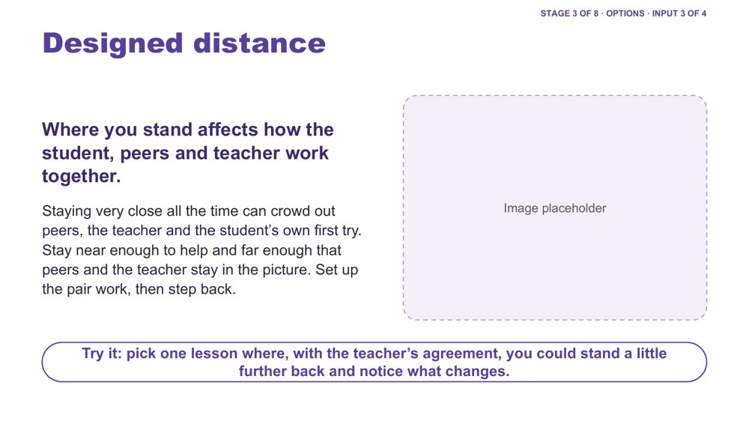 | Designed distance  SUGGESTED TIME  3 min  CLOCK  1:26 - 1:29

Option 3 of 4: where support staff stand is a design choice that affects peers, the teacher and the student's own first try.
WHAT TO DO  - Keep this input to about three minutes.  - Describe the pattern that can build up without anyone choosing it: an adult is always beside the student, peers talk to the adult or go around them, and the teacher passes things through the adult. Over time the student's contact with peers and the teacher can shrink to one adult.  - Describe it without blame. It often grows from care and from being asked to stay close.  - Explain designed distance: near enough to help, far enough that peers and the teacher stay in the picture.  - Give one example from the background below.  - Read the "Try it" line on the slide and ask participants to note one lesson where they could try it. | KEY MESSAGES  - Positioning is a choice that can be planned.  - Near enough to help, far enough to let peers in.  - Set up the interaction, then step back.

YOU MIGHT SAY
Where you stand affects how the student, peers and teacher work together. Staying a little further back can give the student room for their own first try, and give peers and the teacher room to come in.

KEEP IN MIND
- Some students need close support at times, for example for safety, distress, personal care or health needs. The message is designed distance, not withdrawal.
- Follow the student's agreed plan and school policy. Talk with the teacher about any change to how close you stay.

Background Primary example: set up a partner reading task with the student and a peer, then move to the next table and check in from there. Secondary example: in a practical lesson, help the student and their partner get started at the bench, then step to the side of the room. In the playground, stay within sight while a peer game gets going, rather than joining in as the student's partner.
Thread This is the fifth of the Five moves that belong to you. It connects back to connection and belonging in Session 3.

SESSION 4 | Learning Design | SLIDE 12 of 22

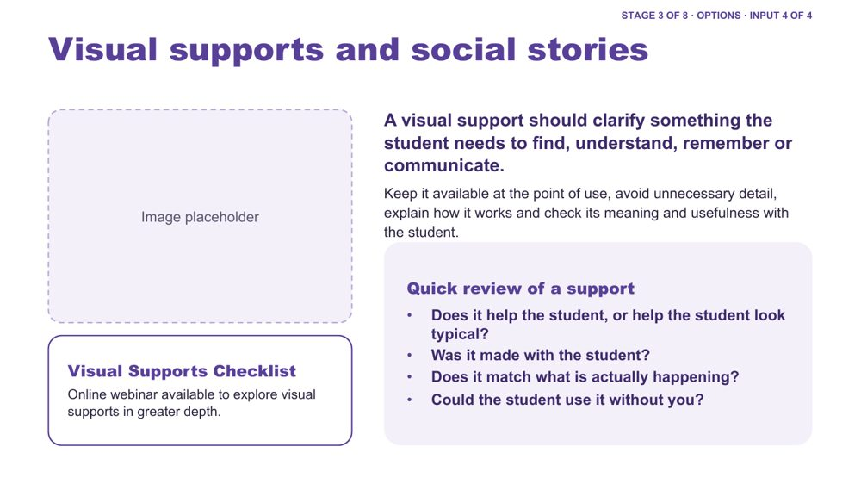 | Visual supports and social stories  SUGGESTED TIME  3 min  CLOCK  1:29 - 1:32  PARTICIPANT GUIDE  Page 19 - Quick review of a support

Option 4 of 4: visual supports and social stories that build understanding and independence, reviewed with a simple set of questions.
WHAT TO DO  - Keep this input to about three minutes.  - Start with what information the student needs, not with a particular visual tool.  - Note that a support is not automatically accessible because it is visual: check the student understands what it represents and can use it.  - Introduce social stories using the background below: the same tool can do two different jobs.  - Use the four quick-review questions on the slide. Ask the room to try them on one support they use. Take 1-2 responses.  - For students who use AAC, ask how information is made accessible and how they can respond; keep their communication system available during routines, transitions and changes.  - Point participants to the Visual Supports Checklist and the online webinar for further learning. | KEY MESSAGES  - A visual support should clarify something the student needs to find, understand, remember or communicate.  - A support made with the student, in their interests and words, is more likely to be understood and used.  - A support the student can use without you is a step up the ladder.

YOU MIGHT SAY
We're introducing some key principles around visual supports here, but this is a much bigger area than we can cover in this part of the session. You'll have access to a Visual Supports Checklist to help you think through supports in your own setting. There is also an online webinar that explores visual supports in greater depth if you'd like to extend your learning.
One question to ask of any support: does it help the student, or help the student look typical?

KEEP IN MIND
- Many support staff have written or used social stories with care. Honour that care while reviewing what the story is for.
- Do not ask participants to write or rewrite a social story here. Changes to a student's supports go through the teacher and school processes.
- Avoid prescribing one format for all Autistic students.
- Do not read the absence of a spoken response as absence of understanding, preference, opinion or a response.

Background Social stories: one kind of story aims to make the student act in a more typical way, for example a story telling the student to look at people when they talk. Another kind makes a situation predictable for the student, for example a story about what happens in a fire drill or on an excursion, written with the student in their interests and words. The first measures how typical the student looks; the second supports understanding, safety and access. Examples of visual supports include objects, photographs, symbols, written words, checklists, maps, choice supports and visual schedules. The checklist prompts: Purpose, Meaning, Access, The real day, Communication and agency, Review.
Thread Links back to communication and masking in Session 3.
RESOURCES
- Visual Supports Checklist - referenced in the notes (no link given)
- Online webinar on visual supports - referenced in the notes (no link given)

SESSION 4 | Learning Design | SLIDE 13 of 22

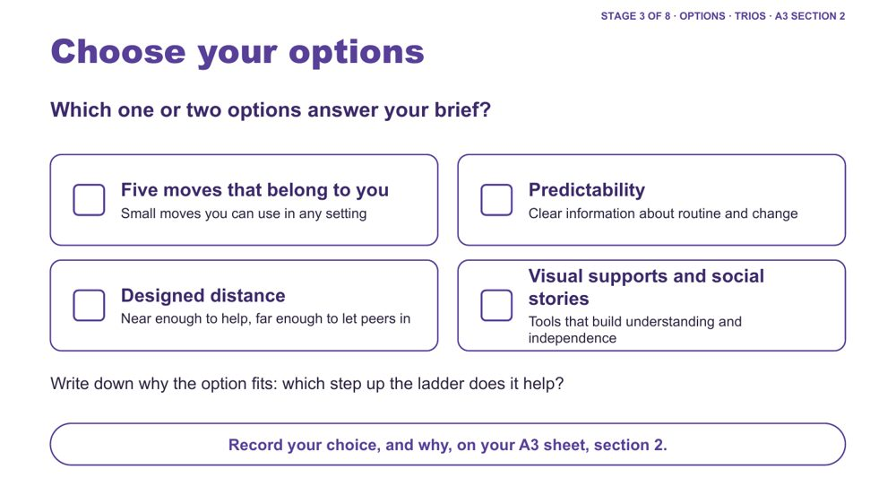 | Choose your options  SUGGESTED TIME  2 min  CLOCK  1:32 - 1:34  GROUPING  On your own, with your trio  PARTICIPANT GUIDE  Page 18 - Options I chose

Each person chooses one or two options that help their brief move a step up the ladder.
WHAT TO DO  - Ask each person to pick one or two options, not all four.  - Ask them to write down why each option fits: which step up the ladder it helps.  - Ask them to record the choice, and why, on the A3 sheet, section 2.  - Invite the trio to help if someone is stuck. | KEY MESSAGES  - The point is matching support to the brief, not collecting strategies.

ACTIVITY | Individual choice on the A3 sheet, section 2, with trio help on your own, with your trio · about 2 minutes
Which one or two options answer your brief?
- Sort the printed option cards against your brief.
- Choose one or two options, or something else that fits.
- Write down which step up the ladder each option helps.
- Record your choice, and why, on the A3 sheet, section 2.

KEEP IN MIND
- Discourage choosing all four options.

SESSION 4 | Learning Design | SLIDE 14 of 22

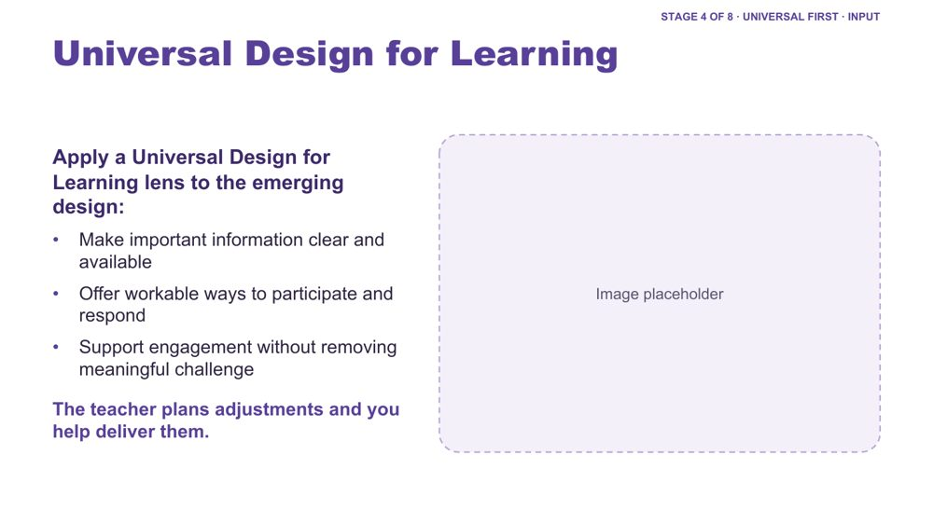 | Universal Design for Learning  SUGGESTED TIME  2 min  CLOCK  1:34 - 1:36

Frame a Universal Design for Learning lens before the accessibility check, and name the role of support staff in delivering adjustments.
WHAT TO DO  - Keep this input to about two minutes.  - Introduce Universal Design for Learning using the three points on the slide.  - Read the last line: "The teacher plans adjustments and you help deliver them."  - Explain that a staff member's presence is not, by itself, the adjustment. The adjustment is the change that improves access, such as clearer information, a visual support, a different way to respond or a change to the environment.  - Name that the teacher plans adjustments; support staff help deliver them, notice how they work and feed back. | KEY MESSAGES  - The teacher plans adjustments and you help deliver them.  - Universal design and individual knowledge can inform each other.  - The presence of a resource, or a person, does not guarantee access.

YOU MIGHT SAY
Access should not depend on one person always being beside the student.

KEEP IN MIND
- Avoid implying that individual support is never needed, or that support staff should make adjustment decisions on their own.

SESSION 4 | Learning Design | SLIDE 15 of 22

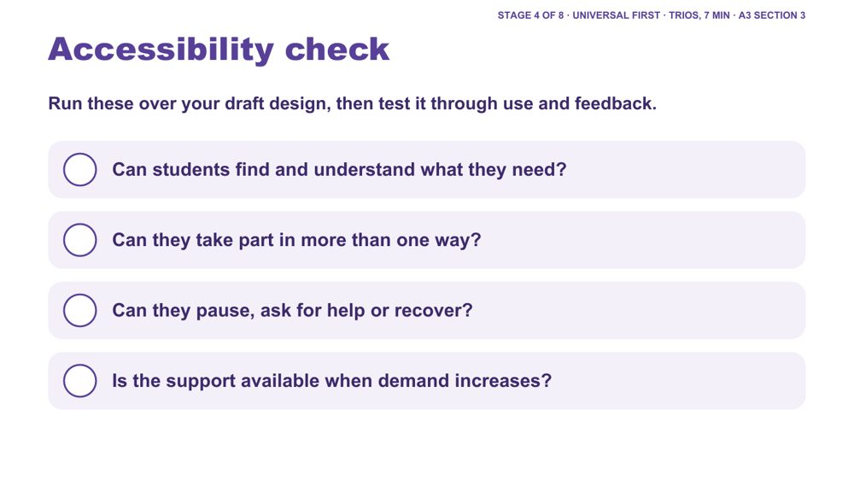 | Accessibility check  SUGGESTED TIME  5 min  CLOCK  1:36 - 1:41  GROUPING  Trios  PARTICIPANT GUIDE  Page 19 - Universal first

Trios help each person test their draft design against the accessibility questions.
WHAT TO DO  - Ask each person to run the four questions over their draft design, with the trio's help.  - Ask them to tick each on the A3 sheet, section 3. The Participant Guide adds a fifth: is there more than one way to access, engage and respond?  - Where the answer is "not yet", ask them to adjust the design and note what they changed.  - Ask whether the design still works when the support staff member is not there. | KEY MESSAGES  - Accessibility is tested through use and feedback, not assumed from the presence of a resource.

ACTIVITY | Trio check on the A3 sheet, section 3 trios · about 5 minutes (7 minutes with the UDL input)
Run these over your draft design, then test it through use and feedback.
- Can students find and understand what they need?
- Can they take part in more than one way?
- Can they pause, ask for help or recover?
- Is the support available when demand increases?
- Where the answer is "not yet", adjust the design and note what you adjusted.

SESSION 4 | Learning Design | SLIDE 16 of 22

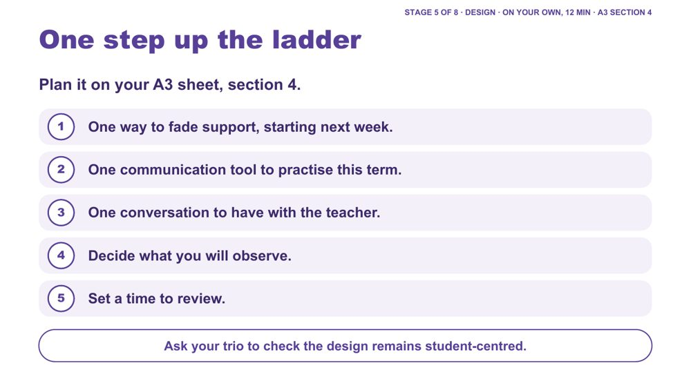 | One step up the ladder  SUGGESTED TIME  12 min  CLOCK  1:41 - 1:53  GROUPING  On your own, with your trio  PARTICIPANT GUIDE  Page 20 - One step up the ladder

Each person plans one support moment moved one step towards independence, ready to discuss with the teacher and review.
WHAT TO DO  - Ask each person to work through the five parts on the A3 sheet, section 4.  - Keep it to one step up the ladder, not several.  - For the fading step, ask them to name exactly what they will do less of, and what will take its place (a card, a gesture, a peer, a visual).  - For the communication tool, ask them to choose one the student already uses or that is in the student's agreed supports, and practise it consistently.  - For the teacher conversation, ask them to write one thing they have noticed and one question for the teacher.  - Name that the fading step is agreed with the teacher, and the student where possible, before it starts. The teacher conversation may need to come first.  - Near the end, ask each person to have their trio check the plan remains student-centred and builds independence. | KEY MESSAGES  - Keep it to one step. Small, planned changes are easier to keep going.  - The teacher conversation connects your plan to the teacher's plan for the student.  - Fading is not automatic or permanent. Support can stay, change or return through the agreed process.

YOU MIGHT SAY
Plan one next step to talk through with the teacher, not a change to make on your own.

ACTIVITY | Individual plan on the A3 sheet, section 4, with a trio check on your own, with your trio · 12 minutes
Plan one step up the ladder for your support moment.
- One way to fade support, starting next week.
- One communication tool to practise this term.
- One conversation to have with the teacher.
- Decide what you will observe.
- Set a time to review.
- Ask your trio to check the design remains student-centred.
Close: Prepare a one-sentence description of your step up the ladder.

KEEP IN MIND
- Avoid making the student's compliance the success measure.
- Do not ask participants to change or remove a student's support on their own. Changes are agreed with the teacher and follow school processes.

Background Examples of one step: swapping a spoken prompt for a pointing gesture; a first-step card replacing sitting beside the student at the start of a task; standing a little further back in one lesson; a peer walking with the student between settings while the adult follows. Communication tools could include a first-then card, a choice board, a help card or break card, or the student's own AAC system.
Thread The teacher conversation is developed in Session 5. The fading step can become the Start on the Session 6 Start, Continue, Reconsider card.

SESSION 4 | Learning Design | SLIDE 17 of 22

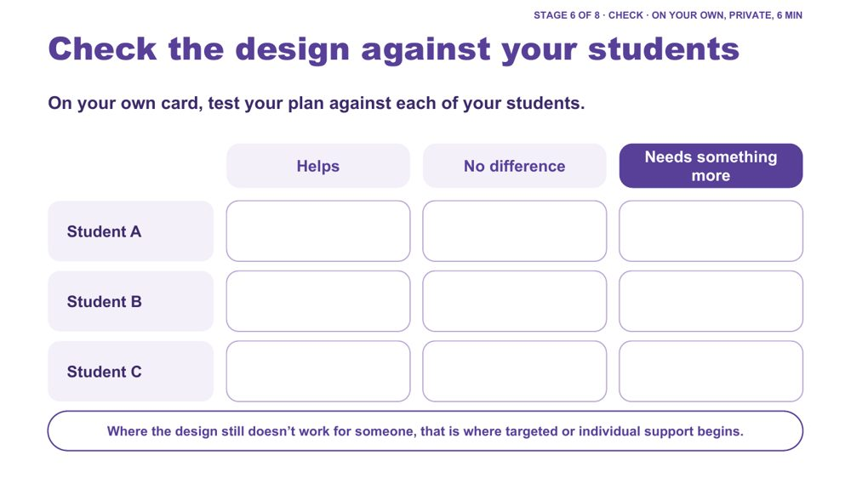 | Check the design against your students  SUGGESTED TIME  6 min  CLOCK  1:53 - 1:59  GROUPING  On your own  PARTICIPANT GUIDE  Page 21 - My students check

Each person privately tests their plan against each of the students they have in mind.
WHAT TO DO  - Ask each person to use the "My students" cards on page 2 of their A3 sheet, privately.  - Ask them to mark each student (Student A, B, C) as Helps, No difference or Needs something more.  - Name that the students may be in different classes or settings, and the plan may work differently for each.  - Invite trios to share only what they choose, for example how many "needs something more" marks the plan collected, without describing students.  - Invite one or two examples of "needs something more" to open the continuum discussion. | KEY MESSAGES  - Where the design still doesn't work for someone, that is where targeted or individual support begins.  - One design will work differently for different Autistic students.

ACTIVITY | Private check on the "My students" cards on your own · 6 minutes
On your own card, test your plan against each of your students.
- List your students as Student A, B and C.
- Mark each: Helps, No difference or Needs something more.
- Share with your trio only what you choose.
Bring the room back
- How many "needs something more" marks did your plan collect?
Close: Where it helps, the design is doing its job. Where it makes no difference or a student needs something more, that leads into the continuum of support.

KEEP IN MIND
- Keep it private: no names or identifying details, initials or letters only.

Background This keeps individual students in view without building a profile of one child.
Thread Leads straight into the continuum of support (Stage 7).

SESSION 4 | Learning Design | SLIDE 18 of 22

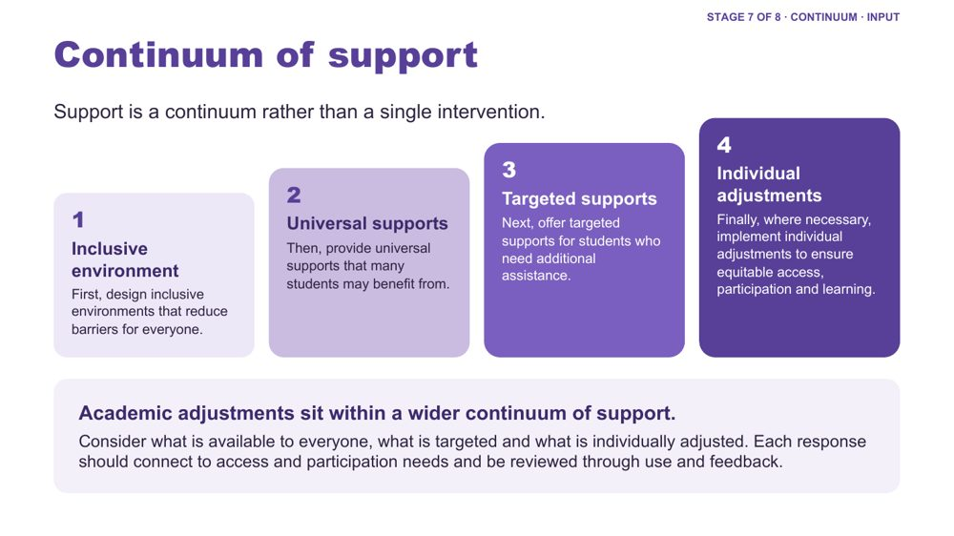 | Continuum of support  SUGGESTED TIME  3 min  CLOCK  1:59 - 2:02

Show what happens when the check shows "needs something more": a continuum from inclusive environment to individual adjustments.
WHAT TO DO  - Open from the "needs something more" examples just shared.  - Walk the four layers: inclusive environment, universal supports, targeted supports, individual adjustments.  - Use one example per layer from the background below.  - Ask where the supports participants give sit on the continuum, and what is available to everyone, what is targeted and what is individually adjusted.  - Connect adjustments to evidence from the school-day map, the audit across settings and the observations support staff pass on. | KEY MESSAGES  - Support is a continuum rather than a single intervention.  - Each response should connect to access and participation needs and be reviewed through use and feedback.  - Support staff often deliver supports at every layer, and see how they work across the day.

KEEP IN MIND
- Do not imply that diagnosis alone determines an adjustment.

Background Inclusive environment: predictable routines, visual schedules, clear expectations, and a school culture where different ways of participating are accepted and valued. Universal supports: instructions in verbal, written and visual forms, flexible ways to demonstrate learning, movement breaks, sensory tools available to any student. Targeted supports: a small group receives pre-teaching of key vocabulary, a structured organisation checklist or additional executive functioning supports during independent work. Individual adjustments: a personalised adjustment plan, for example a quieter workspace during assessments, additional processing time, a visual task breakdown and alternative ways to demonstrate learning.

SESSION 4 | Learning Design | SLIDE 19 of 22

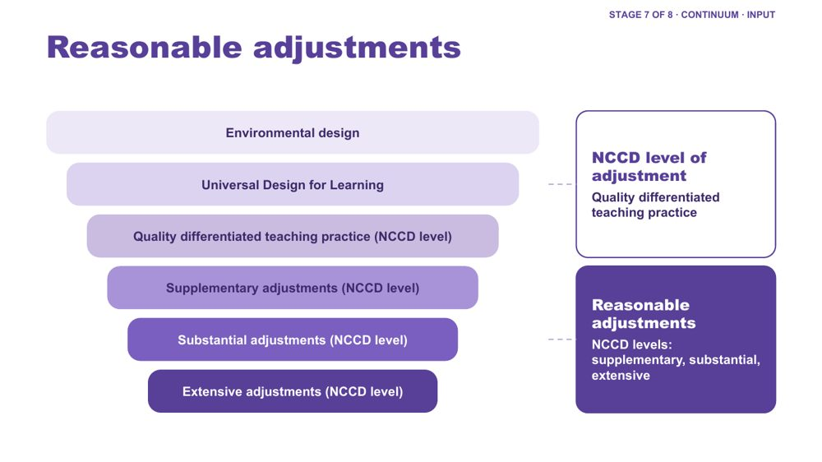 | Reasonable adjustments  SUGGESTED TIME  2 min  CLOCK  2:02 - 2:04

Place reasonable adjustments and NCCD levels of adjustment within the layers of inclusive design.
WHAT TO DO  - Walk the funnel from environmental design and UDL through quality differentiated teaching practice (an NCCD level of adjustment) to supplementary, substantial and extensive adjustments (the other three NCCD levels of adjustment).  - Give the definition of reasonable adjustments from the background below.  - Distinguish reasonable adjustments (the support actions) from the NCCD (the process for collecting information about them).  - Name that the teacher and school plan adjustments; support staff help deliver many of them day to day. | KEY MESSAGES  - Adjustments are individualised, strengths based, remove barriers, practical and effective, based on informed decision making, and empowering and enabling.  - Supports and adjustments build student capability, confidence, self-advocacy and independence, not dependence on adults.

YOU MIGHT SAY
Reasonable adjustments are changes or supports that help students access and participate in education in a way that works for them.

KEEP IN MIND
- Do not give legal advice or present the workshop as a substitute for school or system processes.

Background Adjustments align to the curriculum. Schools consider the needs of the student as well as the impact on staff, other students and available resources. A student is included in the NCCD when they have a disability as defined under the Disability Discrimination Act (DDA), the school has provided reasonable adjustments to address their educational needs, and evidence exists that the adjustments have been provided and monitored. The NCCD helps schools demonstrate compliance with the DSE, monitor the effectiveness of adjustments, ensure students receive appropriate support, and inform planning and resource allocation.

SESSION 4 | Learning Design | SLIDE 20 of 22

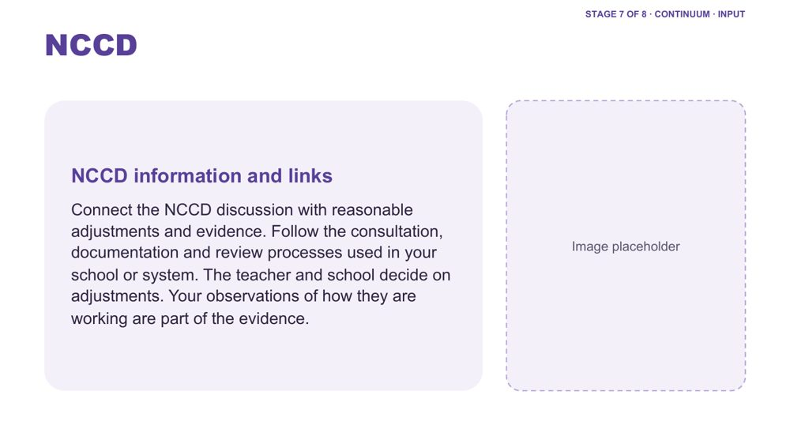 | NCCD  SUGGESTED TIME  2 min  CLOCK  2:04 - 2:06

Direct participants to current official NCCD information and name the support staff contribution.
WHAT TO DO  - Direct participants to current official NCCD information.  - Connect the NCCD discussion with reasonable adjustments and evidence.  - Name the support staff role: support staff contribute observations about how adjustments are working; the teacher and school decide on adjustments and NCCD levels.  - Invite participants to follow the consultation, documentation and review processes used in their school or system, and to know who they pass observations to. | KEY MESSAGES  - Support staff contribute observations; the teacher and school decide.  - Use current official NCCD information.  - Follow school and system requirements for local processes.

KEEP IN MIND
- Do not give legal advice or present the workshop as a substitute for school or system processes.
- Do not imply that diagnosis alone determines an adjustment.
- Participants do not need access to NCCD records to do their role. Keep the focus on what they observe and pass on.

Thread The short observation note from the Five moves is one way support staff contribute. Partnership with the teacher and family is developed in Session 5.

SESSION 4 | Learning Design | SLIDE 21 of 22

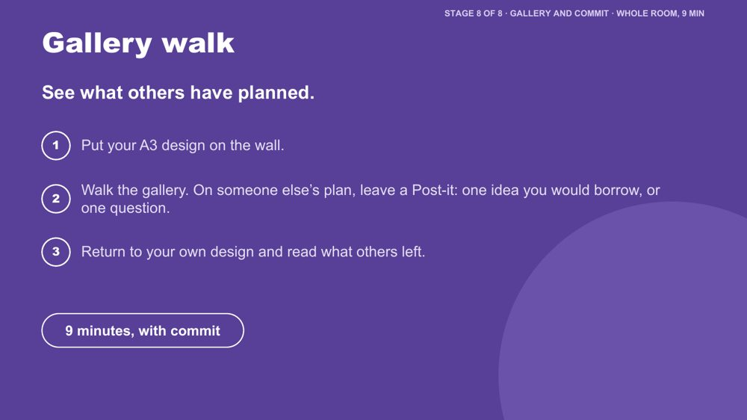 | Gallery walk  SUGGESTED TIME  5 min  CLOCK  2:06 - 2:11  GROUPING  Whole room

Everyone sees other people's plans and can borrow ideas from them.
WHAT TO DO  - Ask each person to put their A3 design on the wall.  - Ask people to walk the gallery and leave a Post-it on someone else's plan: one idea they would borrow, or one question.  - Allow about 4 minutes for the walk.  - Ask people to return to their own design and read what others left.  - Move to the commit slide. | KEY MESSAGES  - People can borrow ideas from each other.

ACTIVITY | Gallery walk with Post-its whole room · about 5 minutes
See what others have planned.
- Put your A3 design on the wall.
- Walk the gallery. On someone else's plan, leave a Post-it: one idea you would borrow, or one question.
- Return to your own design and read what others left.

KEEP IN MIND
- Keep designs anonymised: no student names or identifying details on the wall.

Thread Echoes the Session 3 Post-it wall ("What should travel between people and places?").

SESSION 4 | Learning Design | SLIDE 22 of 22

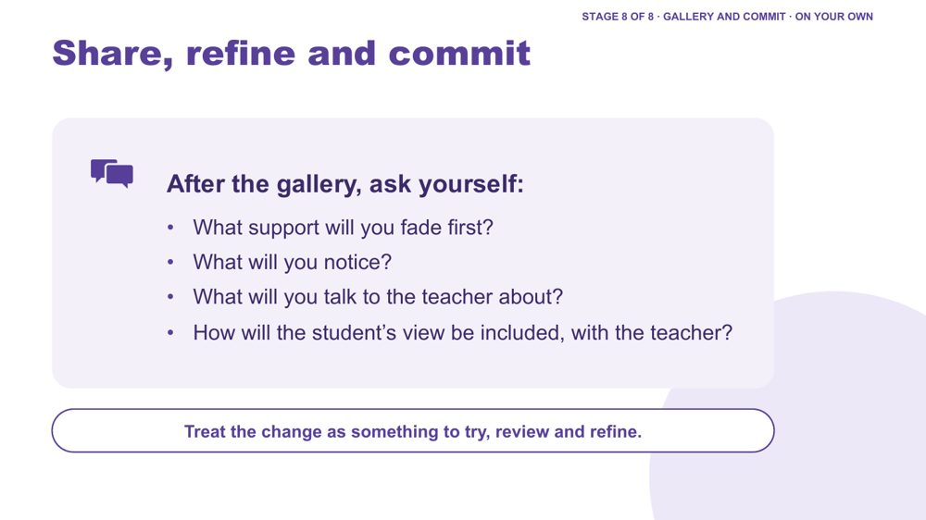 | Share, refine and commit  SUGGESTED TIME  4 min  CLOCK  2:11 - 2:15  GROUPING  On your own  PARTICIPANT GUIDE  Page 21 - Commit

Refine the plan and commit to a realistic next step within the support role.
WHAT TO DO  - Ask participants to complete the Commit box in the Participant Guide, p. 21: the support I will fade first, what I will notice, what I will talk to the teacher about.  - Ask them to add the same on the "My students" cards on their A3 sheet: one way I will fade support, and who I will talk with.  - Invite optional sharing in pairs or with the whole group.  - Encourage them to take the plan to the teacher first, and to include the student and family through the teacher and school processes.  - Transition to partnership and preview Session 5. | KEY MESSAGES  - A change to support is something to try, review and refine.  - Student and family knowledge can refine what support staff notice and try.

ACTIVITY | Personal commitment in the Participant Guide and on the "My students" cards on your own · about 4 minutes
What support will you fade first? What will you notice? What will you talk to the teacher about? How will the student’s view be included, with the teacher?
- Write the support you will fade first.
- Write what you will notice.
- Write what you will talk to the teacher about.
Close: Treat the change as something to try, review and refine.

KEEP IN MIND
- Keep any public example anonymised.
- Keep commitments within the role: fading is agreed with the teacher before it starts.

Thread Leads into Session 5, Working in Partnership, where the teacher conversation is developed. The fading step can become the Start in Session 6.

Session 4 · Hidden slides
These slides stay in the deck but are hidden, so they do not show when presenting. Unhide one in PowerPoint (right-click the slide, then Unhide Slide) if you want it back.
Slide | Title | Why it is hidden
23 | Design one change | Replaced by the Regroup corners and the brief about one support moment each person gives.
24 | Identifying and reducing barriers in practice | Folded into the options menu to keep inputs short; its questions also suit the accessibility check.
25 | Inclusive Design | The fuller Reasonable adjustments funnel in Stage 7 covers the same layers.
26 | Differentiation | Cut for time in the workshop version; UDL carries this idea.
27 | Designing inclusive learning environments | Cut for time in the workshop version.
28 | A continuum of support example | Condensed: its examples are in the Continuum of support notes (slide 18).
29 | What are reasonable adjustments? | Condensed: its definition and notes are on the Reasonable adjustments slide (slide 19).
30 | Environmental / Audits | Overlaps the audit across settings, which sits at the end of Session 3.
31 | Let's discuss - Inclusive Checklist for Supporting Autistic Students | A second activity competing with the main design task; the printed checklist could still be offered as a resource.
32 | Supporting Frameworks/Guidance | Cut for the support staff workshop. DSE information is in the Connections that continue resources in the Participant Guide.
33 | Disability Standards for Education (DSE) 2005 | Cut for the support staff workshop. DSE information is in the Connections that continue resources in the Participant Guide.
34 | Activity: Determining supports and adjustments | Cut for the support staff workshop. Adjustments are decided by the teacher and school.
35 | Record - Monitor - Review | Appendix reference on reviewing adjustments; not in the workshop flow.
36 | Student Consultation | Appendix reference on consulting students; not in the workshop flow (fits Session 5).
37 | Parent/Carer Consultation | Appendix reference on consulting families; not in the workshop flow (fits Session 5).

SESSION  5 | 2:15 - 3:15 · 60 MINUTES · 19 SLIDES  Working in Partnership  Who should I involve in this journey?

SESSION INTENT
Strengthen partnership around the student by keeping the student at the centre, recognising that student, family, teacher and support staff knowledge each hold part of the picture, and examining how power shapes consultation. For support staff this includes a regular communication rhythm with the teacher and what to do when families tell you first. Participants leave with practical consultation moves and a question ready for their Session 6 conversation plan.
PARTICIPANTS LEAVE WITH
- explain why the student sits at the centre of every partnership, and name the collaboration principles all partners share
- plan a regular, brief communication point with the teacher they work with, working from the teacher's plan
- respond when a family tells them something first: acknowledge it, use the school's pathway and bring the teacher in
- identify where power sits in home-school meetings and use practical ways to consult students and families, including discussing capacity without blame
- prepare the opening question and shared purpose for one purposeful conversation with a family or student

RUN SHEET
Clock | Segment | Slides | Minutes
2:15 - 2:24 | Opening: the student at the centre | 1-4 | 9
2:24 - 2:34 | Working with the teacher and with families | 5-6 | 10
2:34 - 2:42 | Power dynamics | 7-8 | 8
2:42 - 2:47 | Student voice video | 9 | 5
2:47 - 3:01 | Partnership activity and what works | 10-11 | 14
3:01 - 3:08 | Consulting well | 12-15 | 7
3:08 - 3:11 | Tools and supports | 16-18 | 3
3:11 - 3:15 | Bridge to Session 6 | 19 | 4

PREPARE
☐ Post-it notes and pens for every participant (slide 8).
☐ Butcher's paper on the wall headed Home, School and Solutions, if using the wall option (slide 8).
☐ Participant Guide p. 24 (Partnership activity grid) ready for each table (slide 10).
☐ Student voice video (Adon) cued and sound checked (slide 9).
☐ Know the general shape of information-sharing and child protection pathways in the participants' system, so you can point to them without giving local detail you cannot confirm (slide 6).
☐ Phone numbers and services on slide 18 checked as current.
☐ Participant Guide pp. 22 - 25 ready to point to.

SESSION 5 | Working in Partnership | SLIDE 1 of 19

 | Working in Partnership  SUGGESTED TIME  1 min  CLOCK  2:15 - 2:16

Open the partnership session and connect it to the support design work in Session 4.
WHAT TO DO  - Name the shift from the support you help deliver to how the people around the student understand and act together.  - Pick up the last line of the Session 4 commit: "What will you talk to the teacher about?", and the "I will talk with" line on the 'My students' card.  - Keep the student at the centre of the conversation.  - Acknowledge that participants may bring both productive and difficult partnership experiences, with families and with colleagues.  - Remind the room that sharing is voluntary and examples stay anonymised (initials or roles only). | KEY MESSAGES  - Partnership is part of understanding and support, not an additional task after decisions are made.  - The student, family, teacher and support staff may each hold different parts of the picture.

Thread Picks up the Session 4 commit ("What will you talk to the teacher about?") and the "I will talk with" line on the 'My students' card (Participant Guide p. 21).

SESSION 5 | Working in Partnership | SLIDE 2 of 19

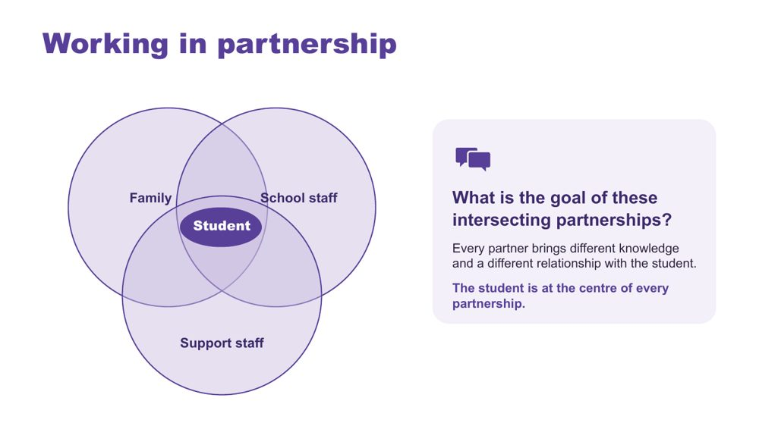 | Working in partnership  SUGGESTED TIME  3 min  CLOCK  2:16 - 2:19  PARTICIPANT GUIDE  Page 22 - Session 5 summary

Show where the partnerships around a student intersect, with the student at the centre of every one.
WHAT TO DO  - Introduce the Venn: family, school staff and support staff, with the student at the centre.  - Name that support staff are the people in this room. Support staff often hold the closest hour-by-hour view of a student's day, across every room and space.  - Explain that every partner brings different knowledge and a different relationship with the student and with each other.  - Ask the group: What is the goal of these intersecting partnerships? Take 2-3 responses.  - Steer the discussion so the point is made that the student is at the centre of all partnerships.  - Ask who is missing from the picture and how the student's communication can be included.  - Point participants to Where partnerships converge in the Participant Guide (p. 22). | KEY MESSAGES  - Positive partnership keeps the student at the centre.  - No single person holds the complete picture.  - Every partner brings different knowledge and a different relationship with the student.  - Support staff knowledge of the student's day is part of that picture.

YOU MIGHT SAY
What is the goal of these intersecting partnerships?

KEEP IN MIND
- Use the elements as discussion prompts rather than a complete definition.

Background With session time limited, this slide is a chance to see where all the partnerships converge and what is needed for success across all of them.
Thread Draws on Autistic experience (Sessions 2 and 3) and the Session 4 support design and ladder.

SESSION 5 | Working in Partnership | SLIDE 3 of 19

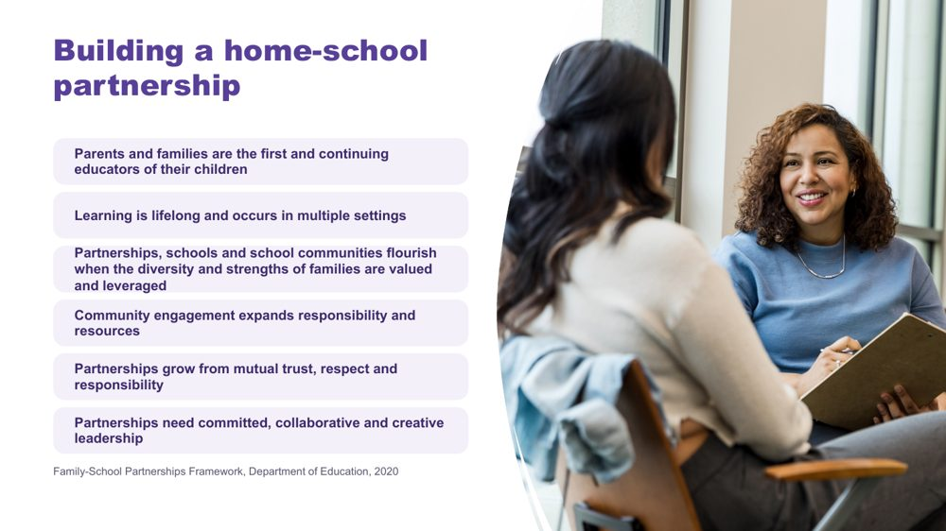 | Building a home-school partnership  SUGGESTED TIME  2 min  CLOCK  2:19 - 2:21

Make positive partnership concrete in everyday practice using the Family-School Partnerships Framework principles.
WHAT TO DO  - Walk through the six Framework principles briefly.  - Position family knowledge and school knowledge as different, useful perspectives.  - Name what makes partnership visible in practice: a shared purpose, respectful listening, student voice and communication, clear accessible information, and agreed next steps, responsibilities and follow-up.  - Note that support staff are often part of the everyday contact that builds this trust: drop-off, pick-up, the playground, the bus bay. | KEY MESSAGES  - The student, family and school may each see different parts of experience. Partnership helps these perspectives inform understanding, design, action and review from the beginning.  - Listening, clarity and shared next steps can be observed in practice.

KEEP IN MIND
- Avoid implying that agreement is required before listening or respect are possible.

RESOURCES
- Family-School Partnerships Framework - Department of Education, Australian Government - https://www.education.gov.au/supporting-family-school-community-partnerships-learning/family-school-partnerships/family-school-partnerships-framework

SESSION 5 | Working in Partnership | SLIDE 4 of 19

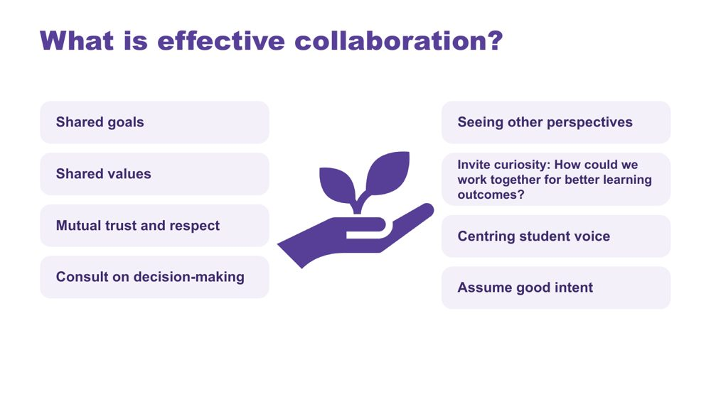 | What is effective collaboration?  SUGGESTED TIME  3 min  CLOCK  2:21 - 2:24

Name the collaboration principles that strong partnerships share, whoever is at the table.
WHAT TO DO  - Introduce the importance of collaboration: for Autistic students there are many collaboration points across many partnerships, and support staff sit in several of them.  - Explain that the key collaboration skills are the same across all groups, including between support staff and teachers.  - Ask the group: What are some of the key principles for effective collaboration to occur?  - Build the discussion to cover: shared goals, shared values, mutual trust and respect, consulting on decision-making, seeing other perspectives, inviting curiosity, centring student voice, assuming good intent.  - Click to reveal the points on the slide once the room has contributed. | KEY MESSAGES  - The collaboration skills needed are the same across every partnership around the student, including the working relationship with the teacher.

YOU MIGHT SAY
What are some of the key principles for effective collaboration to occur?
How could we work together for better learning outcomes?

Background This slide works well with all parties and helps shift perspectives.
Thread Leads into the next slide: a communication rhythm with the teacher.

SESSION 5 | Working in Partnership | SLIDE 5 of 19

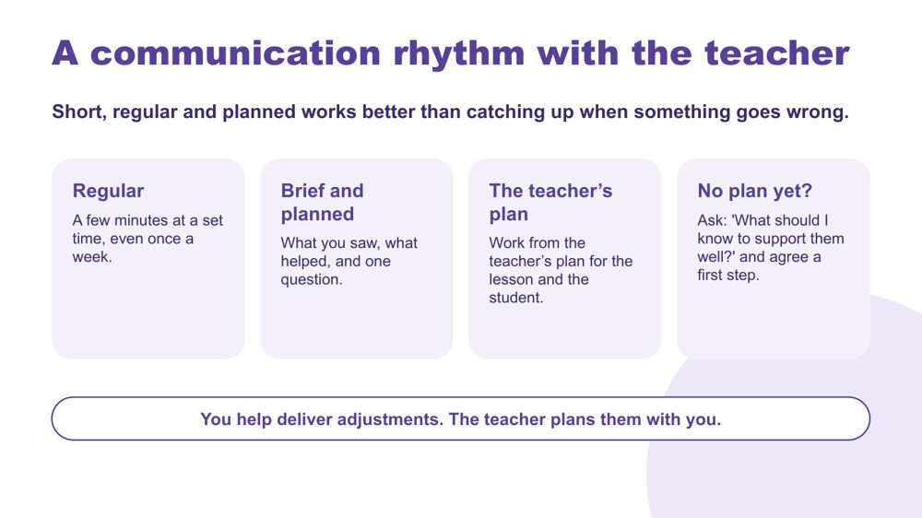 | A communication rhythm with the teacher  SUGGESTED TIME  4 min  CLOCK  2:24 - 2:28  PARTICIPANT GUIDE  Page 22 - Session 5 summary

Build a regular, brief and planned communication rhythm with the teacher, working from the teacher's plan.
WHAT TO DO  - Direct people to the slide and read the top line: short, regular and planned works better than catching up when something goes wrong.  - Walk through the four cards.  - Regular: a few minutes at a set time, even once a week. Primary example: five minutes at the end of a set lesson each week. Secondary example: a quick check with a subject teacher at the start of a set lesson.  - Brief and planned: what you saw, what helped, and one question. Keep what you saw separate from what you think it means.  - The teacher's plan: work from the teacher's plan for the lesson and the student.  - No plan yet: pause before making up a new support. Ask: 'What should I know to support them well?' and agree a first step.  - Give 1 minute: note one realistic time in your week for a check-in, and one question you would bring to it.  - Read the bottom line aloud. | KEY MESSAGES  - A short, planned rhythm is more useful than waiting for a problem or relying on a rushed chat in the doorway.  - Specific observations help the teacher plan.  - No plan yet is a reason to ask and agree a first step, not to change the approach alone.  - You help deliver adjustments. The teacher plans them with you.

YOU MIGHT SAY
What should I know to support them well?
You help deliver adjustments. The teacher plans them with you.

KEEP IN MIND
- Time for this is not always built into support staff hours. Acknowledge that, and keep the rhythm to what is realistic.
- In secondary settings, support staff may work with many teachers. Suggest starting with one.
- Keep the tone collegial: a missing plan is a reason to ask, not a criticism of the teacher.

Thread Builds on the Session 4 commit ("What will you talk to the teacher about?"). The Session 6 action card asks participants to share one thing with the teacher they work with.

SESSION 5 | Working in Partnership | SLIDE 6 of 19

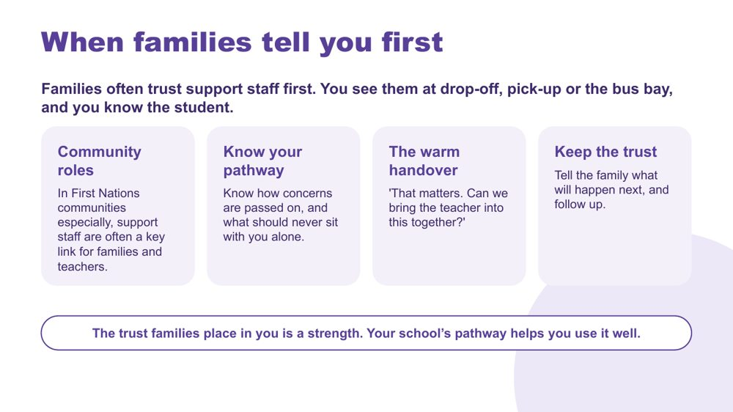 | When families tell you first  SUGGESTED TIME  6 min  CLOCK  2:28 - 2:34  PARTICIPANT GUIDE  Page 22 - Session 5 summary

Recognise that families often trust support staff first, and practise receiving what they share and bringing the teacher in through the school's pathway.
WHAT TO DO  - Read the top line: families often trust support staff first. You see them at drop-off, pick-up or the bus bay, and you know the student.  - Ask: Where do families talk to you? Take 2-3 responses (for example the gate, pick-up, the playground, the bus bay, the community).  - Community roles: say this directly and give it time. In First Nations communities especially, support staff are often a key link for families and teachers. That link is part of how the school works well for those families and students.  - If Aboriginal and Torres Strait Islander education officers or other staff in the room want to add to this, make space. Do not ask anyone to speak for their community.  - Know your pathway: ask participants to think about how concerns are passed on in their school, and what should never sit with them alone. Anything that raises a safety concern follows the school's child protection procedures straight away.  - The warm handover: read the sentence, then ask the room to say it aloud together or to the person next to them.  - Keep the trust: tell the family what will happen next, and follow up.  - Give 1 minute: note who you would go to first in your school, and one part of the pathway you need to check.  - Read the bottom line aloud. | KEY MESSAGES  - The trust families place in support staff is a strength. The school's pathway helps you use it well.  - Receive what the family shares, acknowledge it, and bring the teacher in. You do not have to carry it alone.  - Tell the family what will happen next, and follow up.  - In First Nations communities especially, support staff are often a key link for families and teachers.

YOU MIGHT SAY
That matters. Can we bring the teacher into this together?

KEEP IN MIND
- Never frame a family's trust in support staff as a problem. It is something the school should value and build on.
- Do not generalise about First Nations families, communities, staff roles or protocols. Follow local, culturally informed guidance.
- Do not invite real family stories or identifiable details. Use general or made-up examples.
- Do not promise families an outcome or confidentiality you cannot keep.
- Keep to what support staff need to know to do their role. Participants should not go looking for more information than the family offers.

Background The First Nations point is meant to be delivered with weight, not as an aside. Information-sharing and child protection pathways differ between schools and systems, so the slide asks participants to know their own pathway rather than teaching one.
Thread The bridge activity (slide 19) and the Session 6 conversation plan can include bringing the teacher into a family conversation.

SESSION 5 | Working in Partnership | SLIDE 7 of 19

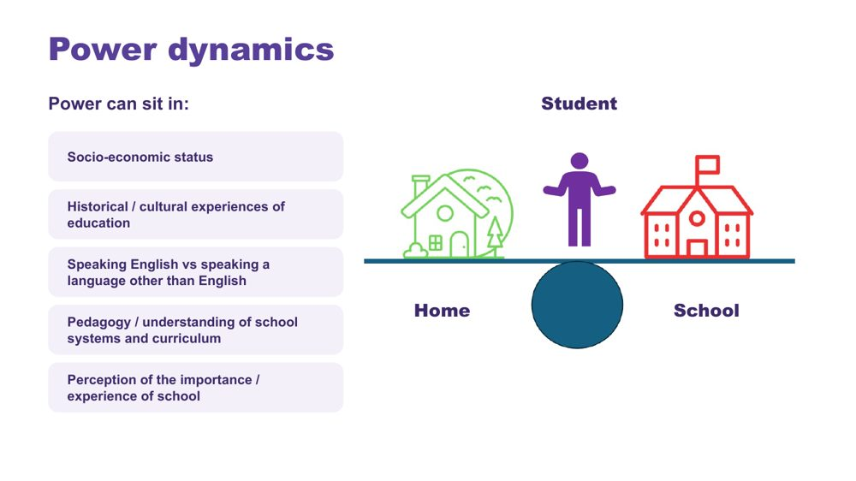 | Power dynamics  SUGGESTED TIME  2 min  CLOCK  2:34 - 2:36

Help participants notice how agendas, language, authority and decision-making shape consultation.
WHAT TO DO  - Introduce the seesaw: school, home and the student.  - Name where power can sit: socio-economic status, historical and cultural experiences of education, speaking English or another language, understanding of school systems and curriculum, and perceptions of the importance of school.  - Name that support staff can see power from both sides: families may see them as part of the school, and inside the school they may have less say in decisions.  - Ask the power questions below to examine practice, not to blame individual participants. | KEY MESSAGES  - Power is present in meeting structures, language and decision pathways.  - Support staff may notice power imbalances that others miss.

YOU MIGHT SAY
Who sets the agenda?
Whose knowledge is heard?
Who can make decisions?
Is the student included in a way that works for them?
What could the school change about the process?

KEEP IN MIND
- Avoid describing a family as difficult, disengaged or unrealistic without examining the context and process.

SESSION 5 | Working in Partnership | SLIDE 8 of 19

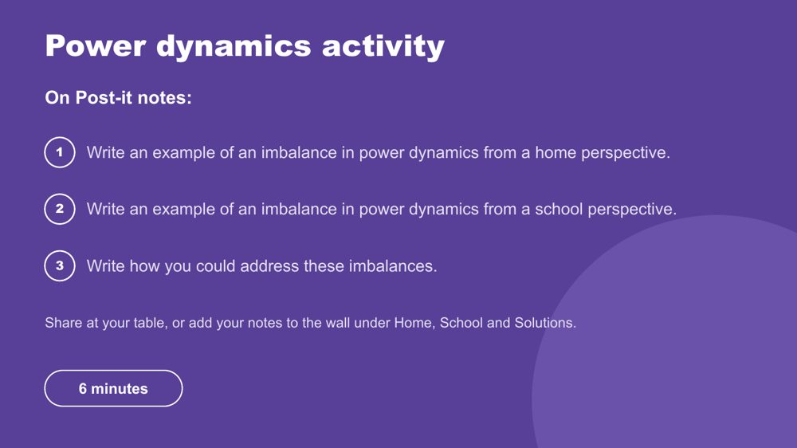 | Power dynamics activity  SUGGESTED TIME  6 min  CLOCK  2:36 - 2:42  GROUPING  Table groups  PARTICIPANT GUIDE  Page 23 - Power dynamics

Prompt participants to reflect on perceived and real power imbalances in the home-school relationship.
WHAT TO DO  - Make sure every participant has Post-it notes and a pen.  - Direct participants to the three instructions on the slide.  - Choose a sharing option that suits the room (see steps).  - Support tables to look for solutions rather than place blame.  - Take feedback from a few participants at the end. | KEY MESSAGES  - Power can be structural, historical, cultural, conscious and unconscious.  - Status can be perceived as an imbalanced power dynamic, regardless of intent.

ACTIVITY | Post-it note reflection table groups · 6 minutes
Where do power imbalances sit in the home-school relationship, and how could you address them?
- On one Post-it, write an example of an imbalance in power dynamics from a home perspective.
- On a second, write an example from a school perspective.
- On a third, write how you could address these imbalances.
- Option 1: share Post-it notes with your table.
- Option 2 (movement break): take your Post-it notes to another person in the room to share.
- Option 3: place Post-it notes on butcher's paper on the wall under Home, School and Solutions.
Bring the room back
- Who sets the agenda?
- Whose knowledge is heard?
- Who can make decisions?
- What could the school change about the process?
Close: Ask participants to keep one process change for their conversation plan.

KEEP IN MIND
- This may be challenging for some participants, who may have found themselves in positions of power or lack of power at different times in their work, including within the school. Guide individuals to seek solutions and not place blame.

Background Educators are immersed in the culture of education, including a shared understanding of acronyms (e.g. NAPLAN, NCCD, IEP) which families may not be able to access as easily. Some people will purposely and naturally endow teachers with higher status, which can be a cultural or personal attitude. External providers and professionals can also affect the power dynamic between those working with and supporting Autistic students. Support staff may be seen by families as closer to them than other school staff, which can make them a bridge.
Thread The process change chosen here carries into the bridge reflection (slide 19) and the Session 6 conversation plan.

SESSION 5 | Working in Partnership | SLIDE 9 of 19

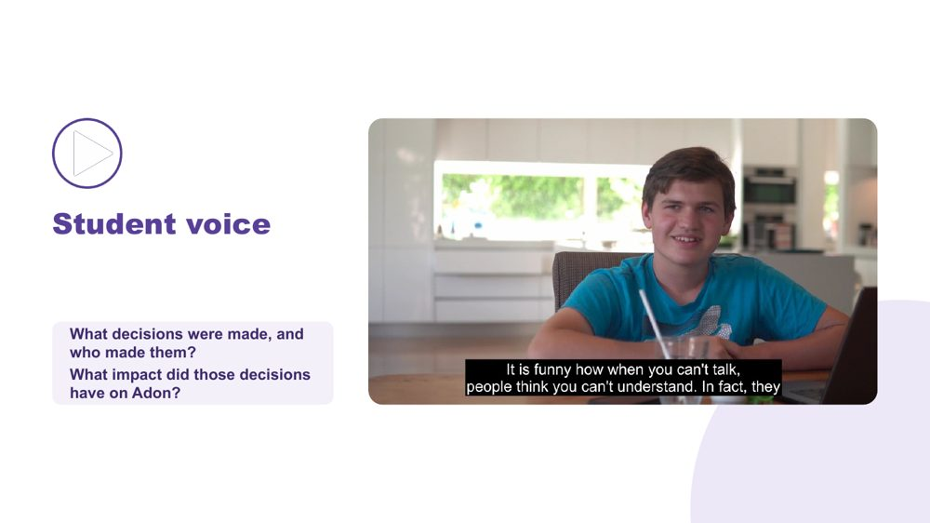 | Student voice  SUGGESTED TIME  5 min  CLOCK  2:42 - 2:47  PARTICIPANT GUIDE  Page 23 - Student voice

Show what happens when a student is not listened to or consulted.
WHAT TO DO  - Introduce the video as an example of a student who is not listened to or consulted.  - Ask participants, while watching, to pay attention to what decisions were made and who made them.  - Play the video.  - Ask the group: What impact did those decisions have on Adon?  - Connect to the students participants support: how are their preferences asked and heard? Support staff often hear a student's preferences during the day. How do those reach the teacher? | KEY MESSAGES  - Students should have a say in decisions about them, at their level and in the way they communicate.  - Even young children can show preferences: choices offered visually, reactions observed and honoured.  - Ask students in a way that works for them: what helps? what's hard? what should staff know?  - Pass on what students tell you in their own words, so the student's view is part of the record.  - This is an early step in building self-advocacy.

YOU MIGHT SAY
While watching, pay attention to what decisions were made and who made them.
What impact did those decisions have on Adon?

SESSION 5 | Working in Partnership | SLIDE 10 of 19

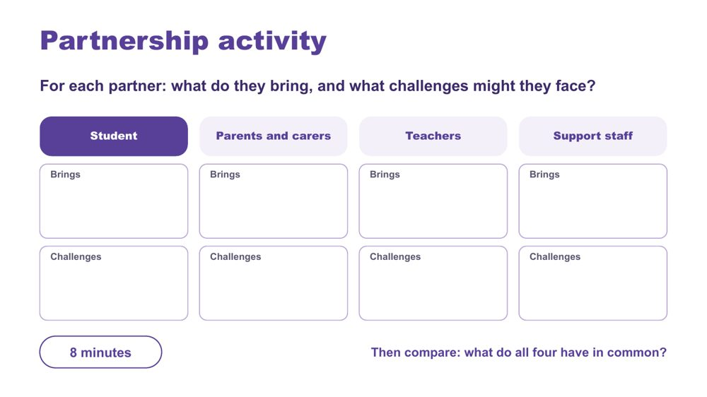 | Partnership activity  SUGGESTED TIME  8 min  CLOCK  2:47 - 2:55  GROUPING  Table groups  PARTICIPANT GUIDE  Page 24 - Partnership activity

Compare what each partner brings and the challenges they may face, and find what they share.
WHAT TO DO  - Make sure each table has the Partnership activity grid in the Participant Guide (p. 24).  - Ask table groups to record what each partner brings and what challenges they might face: student, parents and carers, teachers, support staff.  - Name that the support staff are the people in this room. Ask tables to give that row the same care as the others, and to be specific about what they bring.  - If a table is stuck on the Support staff row, prompt: the hour-by-hour view of the student's day, relationships with the student and often the family, knowledge of what works across settings, and the trust families place in them.  - Ask tables to compare: what do all four have in common?  - Take thoughts on similarities and differences, list the commonalities, and ask what would make the partnership more successful. | KEY MESSAGES  - Understanding the challenges and strengths of each partner can help build trust and confidence in the relationship.  - There are similarities and differences between what each partner brings to the partnership.  - Support staff bring knowledge no one else in the partnership holds.  - Everyone has the student at the centre and student voice is included.  - At the heart of all interactions there should be an assumption of good intent regarding the outcomes for the student.

ACTIVITY | Table group partnership grid table groups · 8 minutes
For each partner: what do they bring, and what challenges might they face?
- Work through the four partners: student, parents and carers, teachers, support staff.
- For each, note what they bring and what challenges they might face.
- Compare: what do all four have in common?
Bring the room back
- What did your table write in the Support staff row?
- What are the similarities and differences across the four partners?
- What would make the partnership more successful?
Close: List the commonalities the room names and link them to the collaboration principles on slide 4.

KEEP IN MIND
- Do not let the Support staff row become an afterthought, or only a list of challenges. Take feedback on it first.
- Keep the Teachers row respectful. Challenges are about workload and systems, not individuals.

SESSION 5 | Working in Partnership | SLIDE 11 of 19

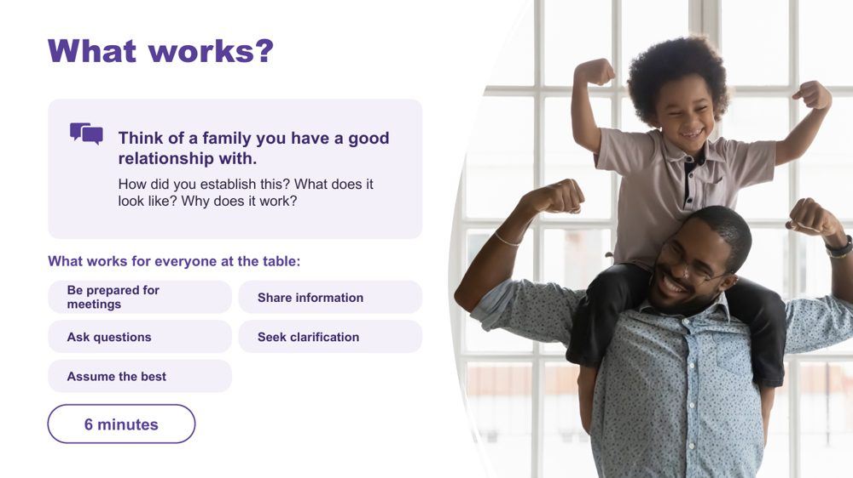 | What works?  SUGGESTED TIME  6 min  CLOCK  2:55 - 3:01  GROUPING  Small groups  PARTICIPANT GUIDE  Page 24 - What works?

Draw on relationships with families that already work, and name the moves that work for everyone at the table.
WHAT TO DO  - Ask participants, in small groups, to think of a family they have or have had a good relationship with.  - Discuss the prompts on the slide. Many support staff relationships with families are built in everyday moments, such as drop-off, pick-up and the playground.  - Ask groups to feed back some of the key ideas to the whole room.  - Point to the list of what works for everyone at the table, and add what each move can look like for support staff. | KEY MESSAGES  - Be prepared: before a meeting, agree with the teacher what observations you will share.  - Share information through the agreed pathway, so the teacher and family hear the same thing.  - Ask questions and seek clarification when a plan or a role is unclear.  - Open with a strength: support staff often know what went well in the day.  - Families may bring a support person. This is normal and allowed, and it can change the dynamic of the meeting.  - If it went wrong: acknowledge it, offer a reset, and bring the teacher in.

YOU MIGHT SAY
How did you establish this? What does it look like? Why does it work?

ACTIVITY | Small group reflection small groups · 6 minutes
Think of a family you have a good relationship with. How did you establish this? What does it look like? Why does it work?
- Think of a family you have or have had a good relationship with.
- Discuss the three prompts in your group.
- Keep examples anonymised.
Bring the room back
- What key ideas came up in your group?
Close: Connect the ideas shared to the list of what works for everyone at the table.

Background Parent and family engagement in learning happens when schools and educators support families, understanding and leveraging how they interact with their child's learning, and supporting them to do that in equal partnership with the school. Parents and families need to know how important their continued support for learning is, and that as the experts in their child they are an extremely valuable resource. Educators have a vital role to play here (Barker & Harris, 2020).
RESOURCES
- Barker, B., & Harris, D. (2020). Parent and Family Engagement: An Implementation Guide for School Communities. Canberra: ARACY
- Tett, L. & Macleod, G. (2020) Enacting home-school partnerships: the roles of headteachers, family-learning practitioners and parents, Cambridge Journal of Education, 50:4, 451-468 https://doi.org/10.1080/0305764X.2020.1722062

SESSION 5 | Working in Partnership | SLIDE 12 of 19

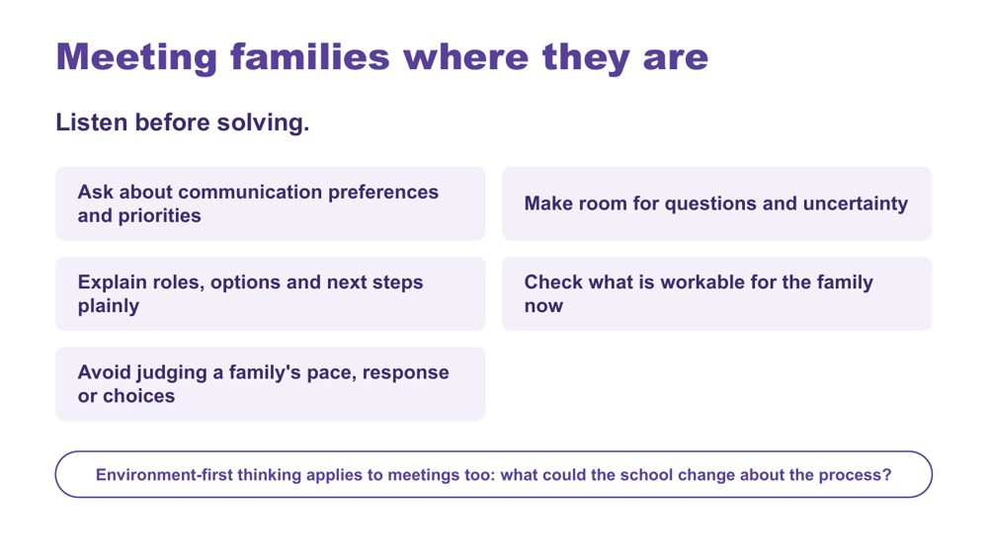 | Meeting families where they are  SUGGESTED TIME  1 min  CLOCK  3:01 - 3:02

Emphasise listening before solving, and making room for questions, uncertainty and different priorities.
WHAT TO DO  - Read the six practices briefly.  - Emphasise listening before solving.  - Make the key point: environment-first thinking applies to meetings too. | KEY MESSAGES  - Power is present in meeting structures, language and decision pathways.  - Meeting families where they are begins with listening and clarity.  - Environment-first thinking also applies to consultation processes.

YOU MIGHT SAY
What could the school change about the process?

KEEP IN MIND
- Avoid judging a family's pace, response or choices.
- Avoid describing a family as difficult, disengaged or unrealistic without examining the context and process.

SESSION 5 | Working in Partnership | SLIDE 13 of 19

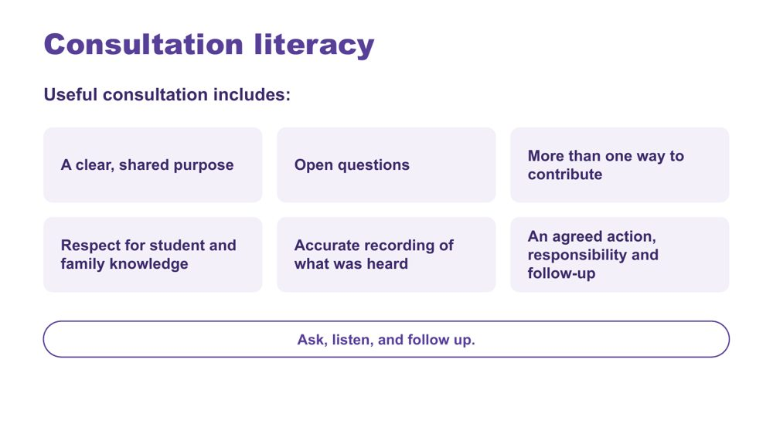 | Consultation literacy  SUGGESTED TIME  2 min  CLOCK  3:02 - 3:04  PARTICIPANT GUIDE  Page 25 - Consultation checklist

Introduce consultation literacy: asking, listening and following up.
WHAT TO DO  - Walk through what useful consultation includes.  - Frame the list as a check participants can use before and after a meeting or conversation they are part of.  - Note that accurate recording matters for support staff too: what the student or family said, in their words, passed on through the agreed pathway.  - Make the point: ask, listen, and follow up. | KEY MESSAGES  - Ask, listen, and follow up.  - Tools should support consultation rather than replace listening and student voice.

SESSION 5 | Working in Partnership | SLIDE 14 of 19

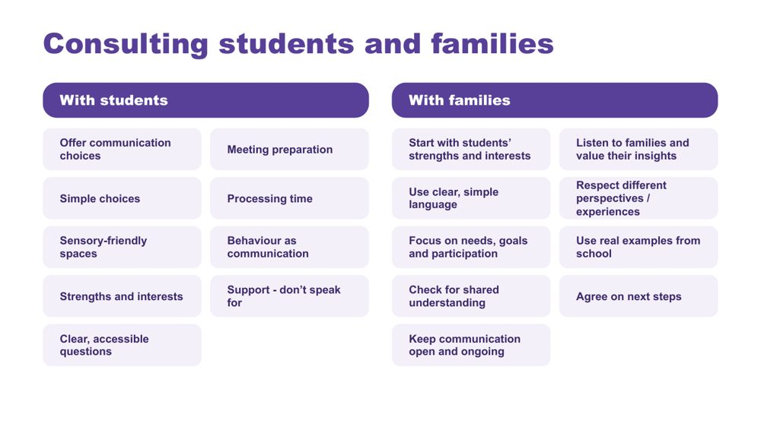 | Consulting students and families  SUGGESTED TIME  2 min  CLOCK  3:04 - 3:06

Give practical ways to consult students and families so every voice can be heard.
WHAT TO DO  - Take the two columns in turn: with students, then with families.  - With students: presume competence, provide communication supports, offer choices, allow time, and act on what students tell us.  - Point to 'Support - don't speak for'. Support staff often sit beside a student in a meeting. The role is to help the student communicate, not to answer for them.  - With families: start with the student's strengths, interests and what works well, and listen to families' knowledge of their child without making assumptions.  - Ask participants to pick one practice from each column to try with the students they support. | KEY MESSAGES  - Listen, adapt, give choices, and make it easy for every student to have a voice.  - Ensure trusted supporters assist communication without replacing the student's voice.  - Use plain language and explain educational terms clearly.  - Focus on the student's needs and goals, not just their diagnosis.  - Recognise that some parents will be neurodivergent themselves.

Background Student consultation: provide multiple communication options (AAC, visuals, writing, drawing, video, symbols); prepare students in advance with questions, agendas and meeting information; use supported decision-making with simple choices and extra processing time; create sensory-friendly environments; recognise that behaviour is communication and can indicate preferences; build on strengths, interests and preferences; use accessible, strengths-based questions. Family consultation: be respectful of different cultures, experiences and family perspectives; use real examples from school to discuss supports and adjustments; check everyone has the same understanding; agree clear next steps and how progress will be reviewed; keep communication open and ongoing.
Thread Picks up the consultation with the student and family touched on in the Session 4 commit.

SESSION 5 | Working in Partnership | SLIDE 15 of 19

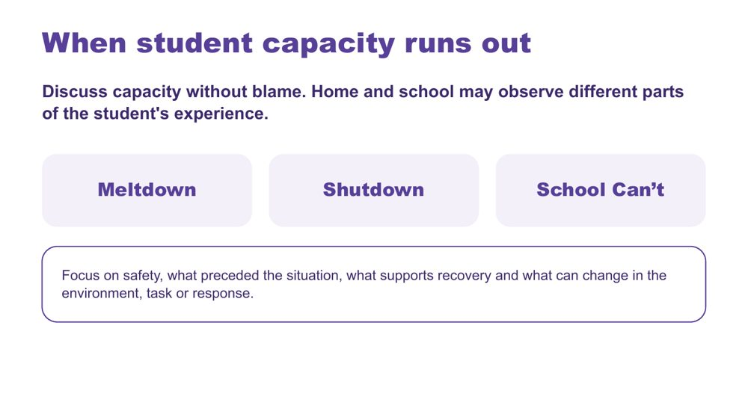 | When student capacity runs out  SUGGESTED TIME  2 min  CLOCK  3:06 - 3:08

Introduce meltdown, shutdown and School Can't within partnership discussion, without blame.
WHAT TO DO  - Introduce the three terms without presenting them as wilful behaviour.  - Note that support staff are often the first to see early signs, and are often with the student when capacity runs out.  - Connect discussion to accumulated demands, what may not be visible, and what home and school can learn from each other.  - Point to the focus line: safety, what preceded the situation, what supports recovery and what can change in the environment, task or response. | KEY MESSAGES  - Capacity should be discussed without blame.  - Home and school may observe different parts of the student's experience.  - Support staff observations of what came before and what helped recovery are useful to the teacher and family.  - Use non-blaming language and the workshop safety guidance.

KEEP IN MIND
- Do not frame meltdown, shutdown or School Can't as wilful misbehaviour or a failure of parenting.
- Do not offer clinical, diagnostic, legal or crisis guidance beyond the material.
- Keep this to support and recovery. Follow the student's plan and school policy. This slide is not about restraint or physical intervention.

Thread Builds on capacity and accumulated demands from Sessions 2 and 3.

SESSION 5 | Working in Partnership | SLIDE 16 of 19

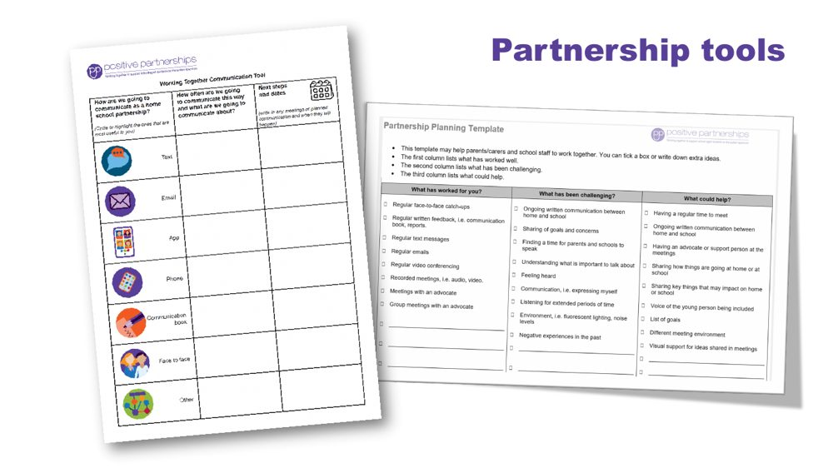 | Partnership tools  SUGGESTED TIME  1 min  CLOCK  3:08 - 3:09

Demonstrate the Partnership tools and explain how they are used.
WHAT TO DO  - Show the Partnership tools and explain how each is used.  - Frame the tools as supports for consultation, not replacements for listening. | KEY MESSAGES  - Tools should support consultation rather than replace listening and student voice.

SESSION 5 | Working in Partnership | SLIDE 17 of 19

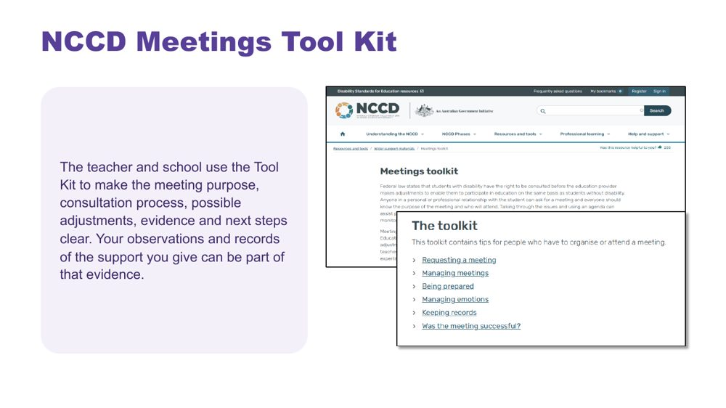 | NCCD Meetings Tool Kit  SUGGESTED TIME  1 min  CLOCK  3:09 - 3:10

Introduce the NCCD Meetings Tool Kit and direct participants to official NCCD information.
WHAT TO DO  - Explain how the Tool Kit makes the meeting purpose, consultation process, possible adjustments, evidence and next steps clear.  - Note that the teacher and school lead the NCCD process. Support staff observations and records of the support given can be part of the evidence the school keeps.  - Remind participants to follow the processes used in their school or system.  - Direct participants to official NCCD information. | KEY MESSAGES  - NCCD information must be current and official.

SESSION 5 | Working in Partnership | SLIDE 18 of 19

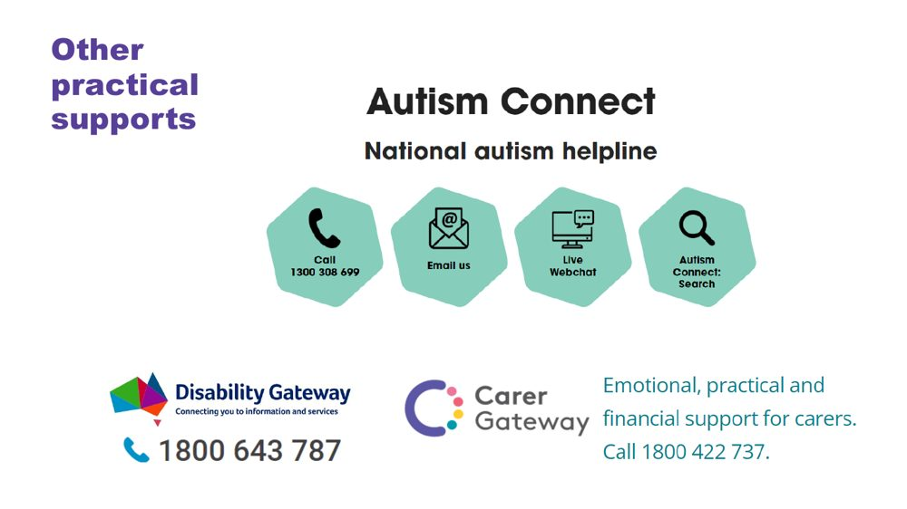 | Other practical supports  SUGGESTED TIME  1 min  CLOCK  3:10 - 3:11

Introduce the support pathways included in the workshop.
WHAT TO DO  - Briefly introduce the Positive Partnerships support options and other supports on the slide.  - Point participants to Participant Guide p. 30 for resources. | KEY MESSAGES  - Introduce the Positive Partnerships support options included with the workshop.

KEEP IN MIND
- Check phone numbers and services are current before delivery.

SESSION 5 | Working in Partnership | SLIDE 19 of 19

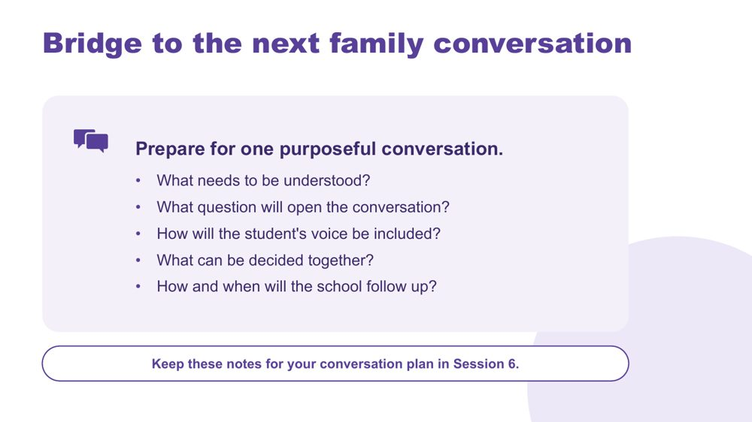 | Bridge to the next family conversation  SUGGESTED TIME  4 min  CLOCK  3:11 - 3:15  GROUPING  On your own  PARTICIPANT GUIDE  Page 25 - Bridge to the next family conversation

Identify the question and shared purpose participants will take into the Session 6 conversation plan.
WHAT TO DO  - Ask participants to return to the students they support and the support they plan to fade.  - Invite them to work through the prompts on the slide privately.  - The conversation can be with a family or with the student. If it is with a family, ask participants to plan how the teacher will be part of it.  - Keep the focus on preparation rather than scripting what the family should say.  - Ask participants to carry one process change from the power reflection into the plan.  - Preview the closing session on belonging, capacity, joy and practical next steps. | KEY MESSAGES  - Prepare for one purposeful conversation.

YOU MIGHT SAY
Keep these notes for your conversation plan in Session 6.

ACTIVITY | Private bridge reflection on your own · 4 minutes
Prepare for one purposeful conversation.
- What needs to be understood?
- What question will open the conversation?
- How will the student's voice be included?
- What can be decided together?
- How and when will the school follow up?
Close: Keep these notes available for the conversation plan in Session 6.

Thread Connects to the Session 4 commit and 'My students' card ("I will talk with"), the warm handover on slide 6, and the conversation plan in Session 6 (Participant Guide p. 28).

SESSION  6 | 3:15 - 4:00 · 45 MINUTES · 11 SLIDES  Flourishing & Full Circle  One change, one purposeful conversation

SESSION INTENT
Bring the day full circle through belonging, capacity and joy, then leave each participant with one next-day action within their role and one purposeful conversation with a family or student. Keep the close grounded: no new content, protected time for planning, resources and feedback.
PARTICIPANTS LEAVE WITH
- connect the day's lens, support design and partnership through belonging, capacity and joy
- name one strategy to start, one practice to continue and one approach to reconsider for their next day in school, each with a way to know it worked
- plan a real conversation with a student's family or a student, to happen within two weeks, with the teacher part of any family conversation
- know where continuing learning and community sit beyond the day

RUN SHEET
Clock | Segment | Slides | Minutes
3:15 - 3:19 | Opening and flourishing frame | 1-2 | 4
3:19 - 3:27 | Bringing it all together | 3 | 8
3:27 - 3:43 | Action card and conversation plan | 4-5 | 16
3:43 - 3:51 | Student voice and final reflection | 6-7 | 8
3:51 - 3:55 | Connections and resources | 8-9 | 4
3:55 - 4:00 | Feedback and farewell | 10-11 | 5

PREPARE
☐ Participant Guide p. 27 (Start · Continue · Reconsider action card) and p. 28 (Plan the next conversation)
☐ Participant Guides open to pp. 26 - 30; participants' Session 4 'My students' cards and Session 5 bridge notes
☐ Session 4 gallery wall still up, if possible
☐ Video queued and tested (Caitlin, or the fallback clip)
☐ Feedback link and QR code confirmed; accessible alternative ready

SESSION 6 | Flourishing & Full Circle | SLIDE 1 of 11

 | Flourishing & Full Circle  SUGGESTED TIME  1 min  CLOCK  3:15 - 3:16

Bring the day together and prepare for practical action.
WHAT TO DO  - Name the final session as a return to the students and questions participants began with this morning.  - Explain that participants will plan one action for their next day in school and one conversation with a family or student.  - Protect enough time for individual planning, resources and feedback.  - Keep the closing grounded rather than adding new content. | KEY MESSAGES  - The day closes by connecting understanding with action.  - One thoughtful next step is more useful than an unmanageable list.

SESSION 6 | Flourishing & Full Circle | SLIDE 2 of 11

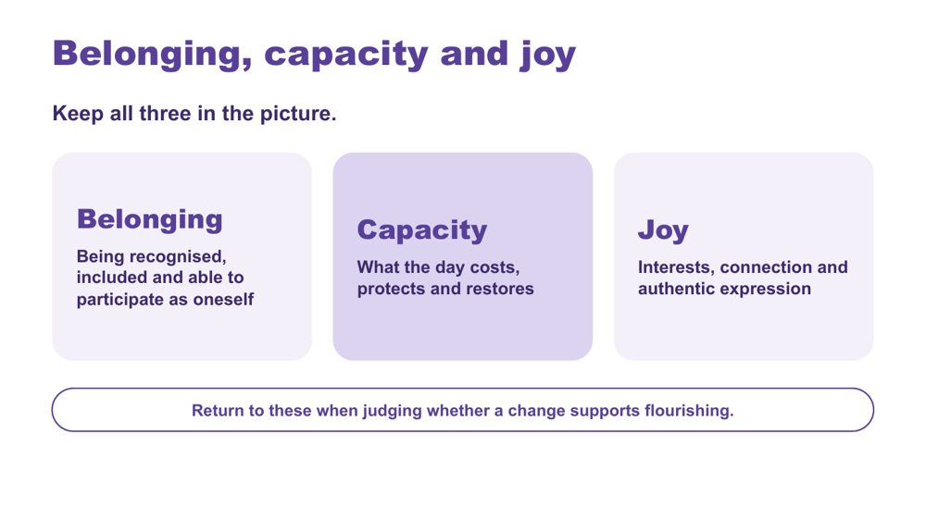 | Belonging, capacity and joy  SUGGESTED TIME  3 min  CLOCK  3:16 - 3:19

Bring together the workshop lens, support design and partnership through belonging, capacity and joy.
WHAT TO DO  - Present belonging, capacity and joy together, as connected ideas.  - Optionally link the day's three practical strands: a neurodiversity-affirming lens that begins with the person; support that builds independence, shaped by student experience; positive partnership that brings student, family, teacher and support staff knowledge together.  - Invite participants to notice whether the support they plan to fade, or change, supports belonging or joy as well as reducing a barrier.  - Point to the last line on the slide: return to these three when judging whether a change supports flourishing. | KEY MESSAGES  - Belonging, capacity and joy belong alongside access and participation.  - Support design and partnership should stay connected to each student's whole day.

YOU MIGHT SAY
Belonging, capacity and joy run through all three.

KEEP IN MIND
- Avoid presenting academic performance, quiet compliance or conventional independence as the only evidence of flourishing.

Thread Capacity picks up Session 3's 'What costs? What lightens?' thinking; the whole frame is the test for the Session 4 support design and the Session 5 partnership planning.

SESSION 6 | Flourishing & Full Circle | SLIDE 3 of 11

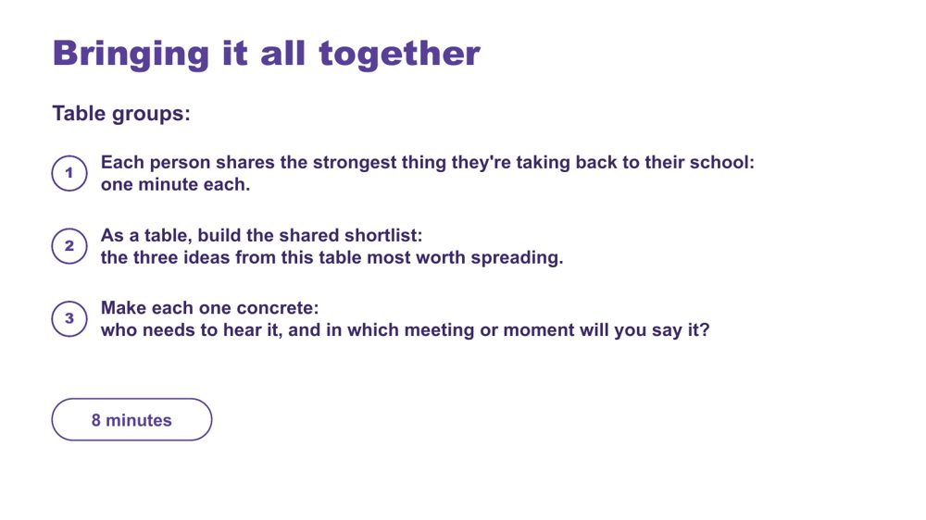 | Bringing it all together  SUGGESTED TIME  8 min  CLOCK  3:19 - 3:27  GROUPING  Table groups  PARTICIPANT GUIDE  Page 26 - Bringing it all together

Surface the strongest ideas at each table and make the most useful ones concrete enough to spread back at school.
WHAT TO DO
- Move participants into table groups.
- Keep time: one minute per person, then the shortlist.
- Remind tables they can draw on what they saw on the gallery wall in Session 4.
- Push each table to name a real person and a real meeting or moment for each shortlisted idea. For support staff this is often the teacher they work with, a learning support team meeting or a support staff meeting.

ACTIVITY | Table sharing and shortlist table groups · 8 minutes
What is the strongest thing you're taking back to your school?
- Each person shares the strongest thing they're taking back to their school: one minute each.
- As a table, build the shared shortlist: the three ideas from this table most worth spreading.
- Make each one concrete: who needs to hear it, and in which meeting or moment will you say it?

Thread The shortlist builds on the Session 4 gallery walk.

SESSION 6 | Flourishing & Full Circle | SLIDE 4 of 11

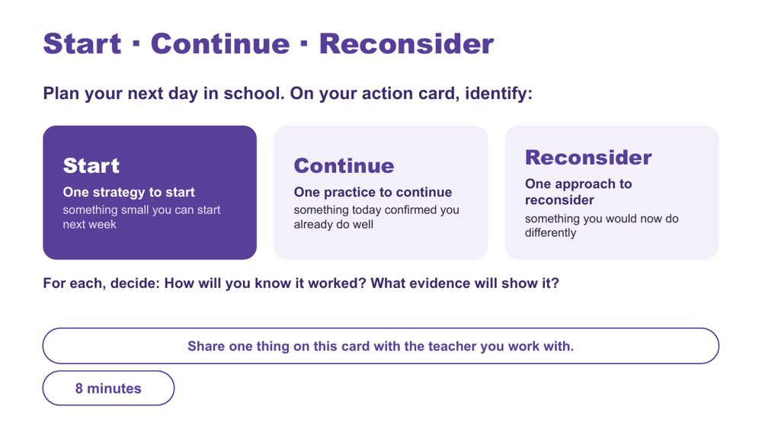 | Start · Continue · Reconsider  SUGGESTED TIME  8 min  CLOCK  3:27 - 3:35  GROUPING  On your own  PARTICIPANT GUIDE  Page 27 - Start · Continue · Reconsider

Turn the day into one specific action for the next day in school, alongside a practice to keep and one to rethink, all within the participant's role.
WHAT TO DO  - Ask participants to have their Session 4 'My students' card ('One way I will fade support') in front of them.  - Read the opening line: plan your next day in school.  - Suggest their Start can be the Session 4 fading step, now with how they will know it worked.  - Offer stems for the Start: I will... / The support or demand I am addressing is... / I will notice... / I will talk with the teacher about... / We will review this on...  - Check that each Start sits within the participant's role and the teacher's plan, and does not require a student to appear less Autistic. Bigger changes go to the teacher conversation.  - Give Continue real time. Much of what support staff already do is good practice, and today may have named it. Ask participants to write it down.  - Close by pointing to the footer: share one thing on this card with the teacher you work with. | KEY MESSAGES  - Use access, participation or experience as the measure, not outward compliance.  - Choose one action that is specific and small enough to start on the next day in school.  - Continue matters: name what you already do well.

ACTIVITY | Individual action planning on your own · 8 minutes
Plan your next day in school. What is one change you will take forward?
- On the action card, identify one strategy to start: something small you can start next week. Your Session 4 fading step can be your Start.
- Identify one practice to continue: something today confirmed you already do well.
- Identify one approach to reconsider: something you would now do differently.
- For each, decide: How will you know it worked? What evidence will show it?
- If time allows, note beside your Start what you will talk to the teacher about, and when you will review it together.
- This card is yours. Share one thing on this card with the teacher you work with.
Close: Ask participants to keep the action small, testable and open to revision with the teacher.

KEEP IN MIND
- Do not let 'what they will notice' become outward compliance.
- Keep commitments within the role: support staff help deliver adjustments, and the teacher plans them. A Start that changes the plan becomes a conversation with the teacher.
- Reconsider is professional reflection, not criticism of a teacher, colleague, family or school.
- The card is theirs: sharing with the teacher is the suggested step, and anything beyond that is optional.

Thread Picks up the Session 4 'My students' card and commit (p. 21 - My students check; Commit) and the Session 5 communication rhythm with the teacher.

SESSION 6 | Flourishing & Full Circle | SLIDE 5 of 11

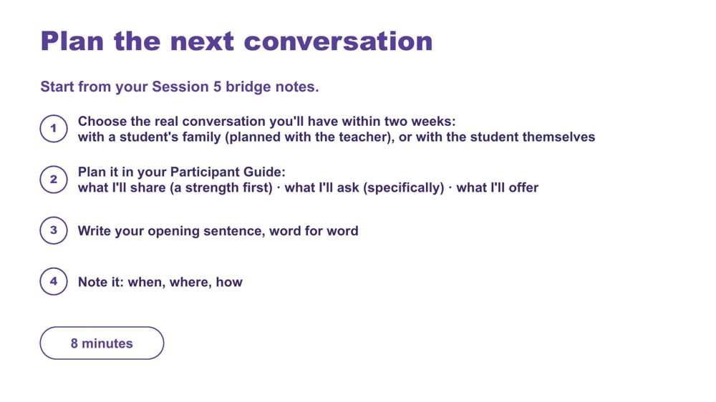 | Plan the next conversation  SUGGESTED TIME  8 min  CLOCK  3:35 - 3:43  GROUPING  On your own  PARTICIPANT GUIDE  Page 28 - Plan the next conversation

Prepare one purposeful, power-aware conversation with a student's family or the student themselves, within two weeks.
WHAT TO DO
- Ask participants to open their Session 5 bridge notes.
- Ask them to define the purpose before writing questions or next steps.
- Point back to the bridge prompts on p. 25: what needs to be understood, how student voice will be included, what can be decided together and how the school will follow up.
- If the conversation is with a family, ask participants to plan it with the teacher, or plan how the teacher will be part of it. The warm handover from Session 5 can be their opening.
- Ask participants to apply the process change they identified during the power-dynamics reflection.
- Keep all notes anonymised (initials or roles only) and sharing voluntary.

ACTIVITY | Individual conversation planning on your own · 8 minutes
Plan one real conversation you will have within two weeks.
- Choose the real conversation you'll have within two weeks: with a student's family, or with the student themselves.
- Write the purpose in one sentence: what you need to understand, rather than what you need the family to accept.
- If it is a family conversation, note how the teacher will be part of it.
- Plan it in your Participant Guide: what I'll share (a strength first), what I'll ask (specifically), what I'll offer.
- Plan how the student's communication and preferences will be included.
- Write your opening sentence, word for word.
- Note it: when, where, how.
Close: Invite participants to check that the plan is clear, respectful and genuinely open to family and student knowledge.

KEEP IN MIND
- Avoid scripting the family's response.
- What participants offer should sit within their role. Offers that change the plan are made with the teacher.
- Avoid treating the conversation as a way to secure agreement with a finished school plan.

Thread Starts from the Session 5 bridge notes (p. 25 - Bridge to the next family conversation), the warm handover and the power-dynamics reflection.

SESSION 6 | Flourishing & Full Circle | SLIDE 6 of 11

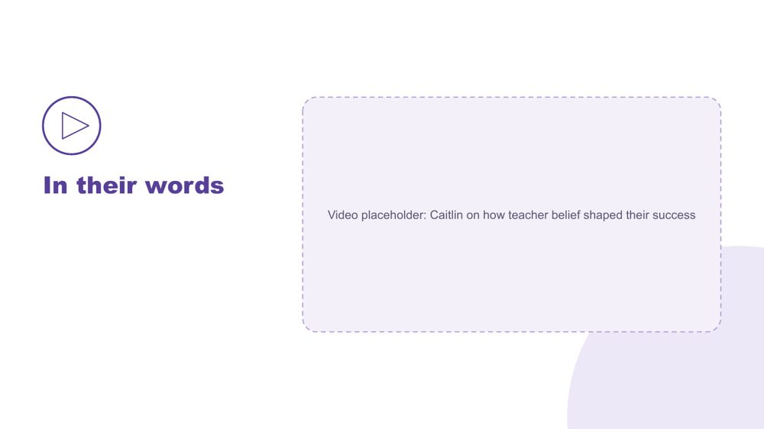 | In their words  SUGGESTED TIME  4 min  CLOCK  3:43 - 3:47

Hear, in a student's own words, how teacher belief shaped their success.
WHAT TO DO
- Play the video.
- Move to the final reflection after the video, without discussion.

SESSION 6 | Flourishing & Full Circle | SLIDE 7 of 11

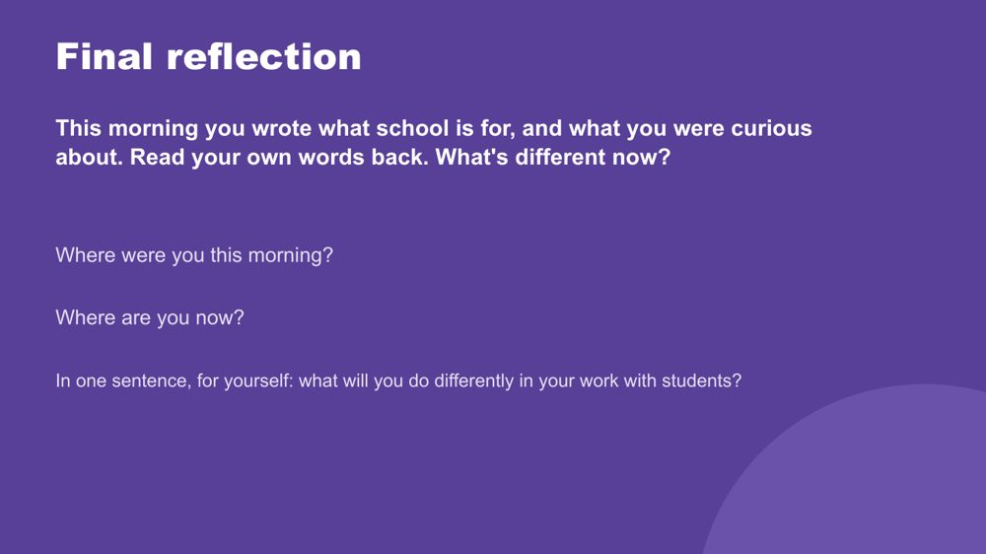 | Final reflection  SUGGESTED TIME  4 min  CLOCK  3:47 - 3:51  PARTICIPANT GUIDE  Page 29 - Final reflection

Return participants to where they started this morning and name, privately, what has shifted.
WHAT TO DO
- Ask participants to find what they wrote this morning (p. 5 - My starting point) and read their own words back.
- Ask: What's different now?
- Give quiet time for the two prompts: Where were you this morning? Where are you now?
- Ask each person to answer the last question in one sentence, to themselves, thinking about their work with students.
- Keep it private; no sharing is needed.

YOU MIGHT SAY
In one sentence, for yourself: what will you do differently in your work with students?

Thread Returns to Session 1 (p. 5 - My starting point).

SESSION 6 | Flourishing & Full Circle | SLIDE 8 of 11

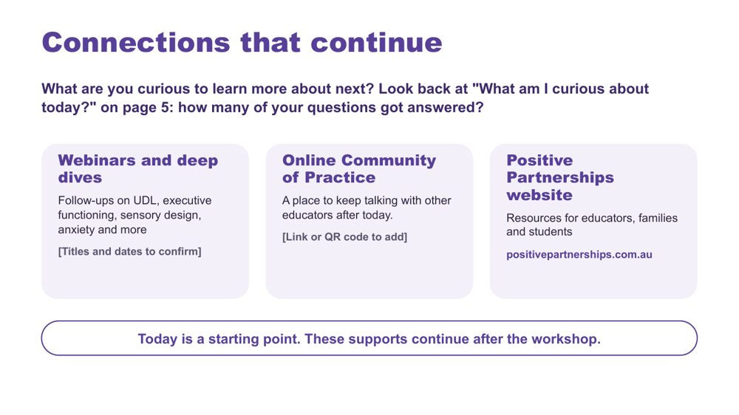 | Connections that continue  SUGGESTED TIME  3 min  CLOCK  3:51 - 3:54  PARTICIPANT GUIDE  Page 30 - Connections that continue

Introduce continuing professional learning and community pathways.
WHAT TO DO  - Ask: What are you curious to learn more about next?  - Point participants back to "What am I curious about today?" (Participant Guide p. 5, My starting point): how many of their morning questions got answered?  - Explain how to access each pathway: webinars and deep dives, the Online Community of Practice and the Positive Partnerships website.  - If photos of today's wall work are shared, check they hold no student details and tell participants where to find them.  - Keep this brief and practical. | KEY MESSAGES  - The workshop is one point in continuing professional learning, reflection and partnership.  - Choose the pathway that fits your next question.

YOU MIGHT SAY
Today is a starting point. These supports continue after the workshop.

RESOURCES
- Positive Partnerships website - positivepartnerships.com.au

SESSION 6 | Flourishing & Full Circle | SLIDE 9 of 11

 | Resources  SUGGESTED TIME  1 min  CLOCK  3:54 - 3:55

Show where to follow Positive Partnerships online.
WHAT TO DO
- Leave the slide up briefly so participants can note or photograph the handles.

RESOURCES
- Positive Partnerships website - positivepartnerships.com.au
- Facebook - facebook.com/PositivePartnershipsAU
- Instagram - @positivepartnerships
- Threads - @positivepartnerships
- LinkedIn - Positive Partnerships
- Pinterest - pinterest.com.au/PositivePartnershipsAustralia/

SESSION 6 | Flourishing & Full Circle | SLIDE 10 of 11

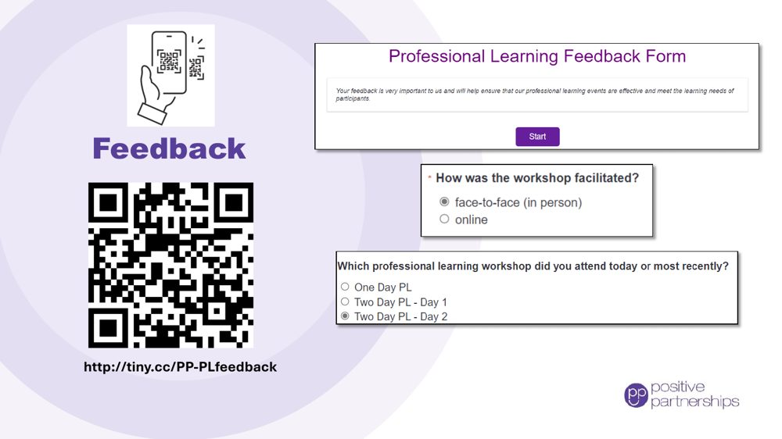 | Feedback  SUGGESTED TIME  4 min  CLOCK  3:55 - 3:59

Collect participant feedback.
WHAT TO DO
- Explain why feedback is being collected and how it is used.
- Show how to access the form (link and QR code).
- Allow protected time for completion in the room.
- Provide an accessible alternative if the process includes one.

RESOURCES
- Feedback form - http://tiny.cc/PP-PLfeedback

SESSION 6 | Flourishing & Full Circle | SLIDE 11 of 11

 | Good luck on your journey  SUGGESTED TIME  1 min  CLOCK  3:59 - 4:00

Close warmly and return participants to student-centred curiosity.
WHAT TO DO  - Thank participants for their attention, questions and the close knowledge of students they brought to the day.  - Invite them to stay curious and keep students at the centre.  - Remind participants to take their action card and conversation plan.  - State the relevant follow-up and contact arrangements. | KEY MESSAGES  - Stay curious.  - Keep students at the centre.  - Small, informed changes can be reviewed and refined in partnership.

